Name___________________________

NATS 102 – Sec 009, 010H ad 011
Final Exam – May, 2008
Test Form A

Answer all of the following questions on the bubble sheet provided using a #2 pencil. Make sure that your Name, Student ID Number and test form letter are on the answer sheet and that all answers are recorded in the correct position. Always select the BEST answer. Each question is worth 1 point. This is a closed-book, closed-note exam and you have approximately two hours to complete it. If you have questions, please raise your hand.

Be sure to write and bubble in your ID number and test form letter.
If your ID number begins with an ‘S’, write that in and bubble a ‘0’.

DO NOT START THE EXAM UNTIL YOU ARE TOLD TO DO SO!

NATS 102 Name ________________________________
Final Exam – May, 2008 Test Form A

Answer all of the following questions on the bubble sheet provided using a #2 pencil. Make sure that your Name, Student ID Number and test form letter are on the answer sheet and that all answers are recorded in the correct position. Always select the BEST answer. Each question is worth 1 point. This is a closed-book, closed-note exam and you have approximately two hours to complete it. If you have questions, please raise your hand.

Assume that you are viewing the sky from Tucson unless otherwise specified within a question.

--------------------------------------------------------------------------------------------------------------

The HR Diagram at right is provided to assist with answering the following two questions.
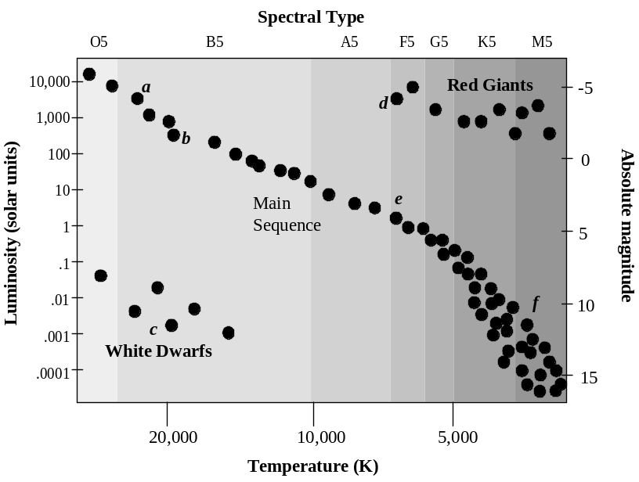
- Which is hotter, a main sequence star with an absolute magnitude of M= 8 or a white dwarf with a luminosity 100 times smaller than the Sun?
- the main sequence star
- the white dwarf
- They have the same temperature.
- There is insufficient information to determine this.

- Which statement is the most correct about the comparison between a spectral type G5 main sequence star and a spectral type O5 main sequence star?
- The G5 star is hotter, brighter, smaller, and will live longer than the O5 main sequence star.
- The G5 star is hotter, dimmer, larger, and will live longer than the O5 main sequence star.
- The G5 star is cooler, dimmer, smaller, and will not live as long as the O5 main sequence star.
- The G5 star is smaller, hotter, brighter, and will not live as long as the O5 main sequence star.
- The G5 star is dimmer, cooler, smaller, and will live longer than the O5 main sequence star.

------------------------------------------------------------------------------------------------------------

- COPIED How do we know where we are in the disk of the Milky Way Galaxy?
      - by measuring the redshift of stars in the galaxy
      - by determining the distribution of globular clusters in the halo
      - by determining how much dark mater exists in the galaxy
      - by measuring the size and speed of the spiral density wave in the disk

--------------------------------------------------------------------------------------------------------------------------
For the next two questions, use the two figures provided below, which show the motion of stars A and B in the sky. Note that Star A reaches its maximum height above the horizon at 9:00 pm.

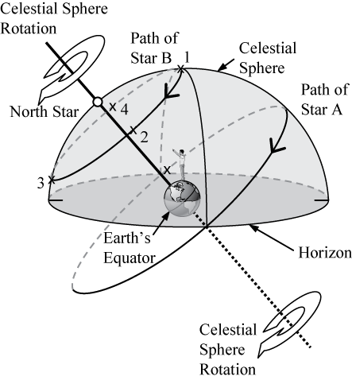

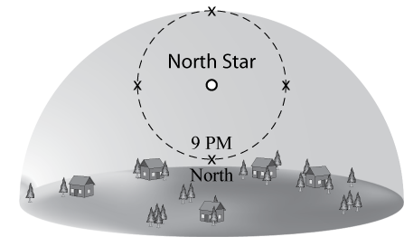

- At what time will Star B be located high in the Northwestern sky?
- 11:00 pm
- 11:00 am
- 6:00 am
- 6:00 pm

- At what time would you see Star A in the west?
  - 3:00 am
  - 9:00 am
  - 3:00 pm
  - 9:00 pm
------------------------------------------------------------------------------------------------------------------------------

- Based on the locations of the constellations described below, what would be the sign of a person born on this day?
- Taurus is high in the southern sky at sunset
- Aquarius is on the eastern horizon at sunrise.
- Scorpius is on the western horizon at noon.
- Leo is high in the southern sky at midnight.
- Taurus
- Aquarius
- Scorpius
- Leo

----------------------------------------------------------------------------------------------------------------------------
- COPIED Which lettered position (a-e), in the image below, best represents the location on Earth that is experiencing winter in the Southern Hemisphere?

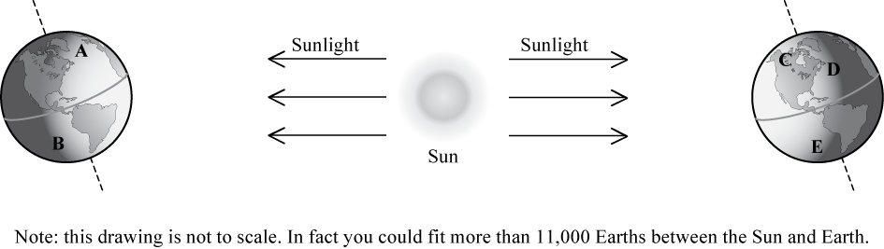
----------------------------------------------------------------------------------------------------------------------------

- If you were looking at four Energy Output versus Wavelength graphs that were all the same height, which of the graphs would be from an object giving off the largest amount of Indigo light?
  - A graph which peaks at UV wavelengths.
  - A graph which peaks in the red part of the visible spectrum
  - A graph which peaks at IR wavelengths.
  - The graph which peaks at Radio wavelengths.

- An important line in the absorption spectrum of stars occurs at a wavelength of 656nm for stars at rest. Imagine that you observe five stars (A-E) from Earth and discover that this absorption line is at the wavelength shown in the table below for each of the five stars.

1. STAR | 2. Wavelength of Absorption line
A | 649 nm
B | 660 nm
C | 656 nm
D | 658 nm
E | 647 nm

Based on the information in the table above, which of the following is the most accurate ranking of the speed of the stars from moving fastest away from Earth to moving fastest toward the Earth.
- B, D, C, A, E
- E, D, C, B, A
- C, E, A, D, B
- A, B, C, D, E
- E, A, C, D, B

- Imagine that you observe the Sun while in your space ship in orbit around the Moon. Which of the following spectra would you observe by analyzing the sunlight?
  - dark line absorption spectrum
  - bright line emission spectrum
  - continuous spectrum

- If an electron in an atom moves from an energy level of 5 to an energy level of 10,
- a photon of energy 5 is emitted.
- a photon of energy 15 is emitted.
- a photon of energy 5 is absorbed.
- a photon of energy 15 is absorbed.

-----------------------------------------------------------------------------------------------------------------
Use the four spectra for objects A-D, shown below, to answer the next question. Note that one of the spectra is from an object at rest (not moving relative to Earth) and the remaining spectra come from objects that are all moving toward the observer. [Assume that the left end of the spectrum corresponds with short wavelengths and the right end corresponds with long wavelengths.]
Object D
Object B
Object A
Object C

- Of the objects that are moving, which is moving with the fastest speed?
- Object A
- Object B
- Object C
- Object D
- They are moving the same speed, the speed of light.

-----------------------------------------------------------------------------------------------------------------

- If ten Jupiters can fit across the surface (width) of the Sun, then approximately how many Earth’s could fit across Jupiter?
- 2
- 5
- 10
- 50
- 100

--------------------------------------------------------------------------------------------------------------
Casper is a star with an apparent magnitude of +2.3 and an absolute magnitude of -1.1. Cutter is a star with an apparent magnitude of -3.7 and an absolute magnitude of -2.3. Answer the following three questions using this information.

- Which of the stars described above gives off more light?
- Casper
- Cutter
- They give off the same amount of light.
- There is insufficient information to determine this.

- Which of these stars is closer to Earth?
- Casper
- Cutter
- They are the same distance from Earth.
- There is insufficient information to determine this.

- If both of these stars are main sequence stars, which star is hotter?
  - Casper
  - Cutter
  - They would be the same temperature.
  - There is insufficient information to determine this.
--------------------------------------------------------------------------------------------------------------------

- A bright star is moving away from Earth. Which of the choices best completes the following statement describing the spectrum of this star?
A(n) ___________ spectrum that is _______ relative to an unmoving star.
- absorption; blueshifted
- emission; redshifted
- continuous; blueshifted
- absorption; redshifted
- continuous; redshifted

- Which of the following is part of the Earth’s natural greenhouse effect?
- Earth’s atmosphere continually becomes thicker with greenhouse gases.
- Infrared light becomes permanently trapped in our atmosphere by greenhouse gasses.
- The ozone hole causes significant increases in surface temperature.
- Earth’s surface and atmospheric gases absorb energy and then give off infrared light.
- Heat is transferred in the atmosphere through the circulation of greenhouse gasses.

- When would you receive the least amount of light from a binary star system consisting of a M5 Red Giant and an M5 main sequence star?
  - When the Red Giant is in front of the main sequence star.
  - When the main sequence star is in front of the Red Giant.
  - You would receive the same amount of light for both situations described in choices “a” and “b”.
  - None of the above.

- Consider three widely separated galaxies in an expanding universe. Imagine that you are located in galaxy 1 and observe that both galaxies 2 and 3 are moving away from you. If you asked an observer in galaxy 3 to describe how galaxy 2 appears to move, what would he or she say?
1
3
2
  - “Galaxy 2 is not moving.”
  - “Galaxy 2 is moving toward me.”
  - “Galaxy 2 is moving away from me.”

- The three spectral curves shown in the graphs below illustrate the energy output versus wavelength for three unknown stars X, Y, and Z.? Which of the following is the correct ranking for the temperature of the stars, from coolest to hottest.
Wavelength
Energy Output per second

Star Y
Energy Output per second

Wavelength
Star X
Energy Output per second

Wavelength
Star Z

- X,Y,Z
- Y,Z,X
- Z,Y,X
- X,Z,Y
- Y,X,Z

- Imagine that you are the head of a funding agency that can afford to build only one telescope. Which of the four proposed telescopes below would be best to support?
- An Infrared telescope in Antarctica
- A gamma ray telescope in orbit above the Earth
- An x-ray telescope located high on a mountain in Peru
- An ultraviolet telescope located in the Mojave desert

- Black holes are formed by
- a lack of any light in a region of space.
- supernovae from the most massive stars.
- supernovae from white dwarfs stars.
- collapsed dark nebulae.

- Observations of the microwave background radiation supports the idea that
  - the Universe was once much hotter.
  - there were times during the early universe when light could not freely travel through space.
  - the Universe began during an event we call the Big Bang.
  - the Universe is approximately 13.7 billion years old.
  - All of the above

-------------------------------------------------------------------------------------------------------------------------------

Consider the six different astronomical objects (A-F) shown below.

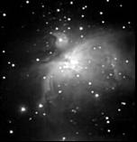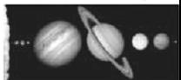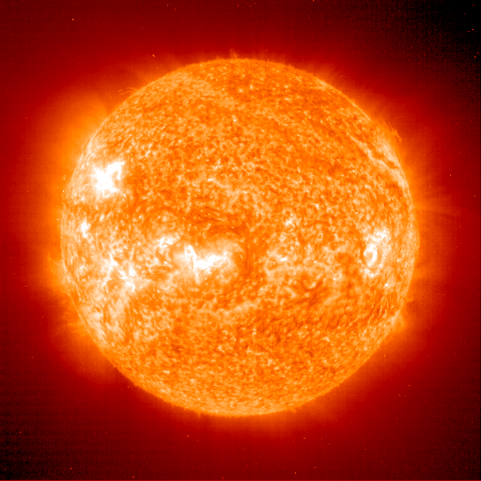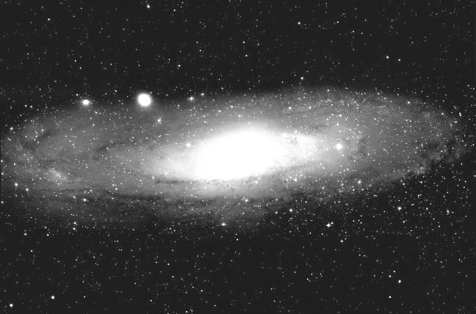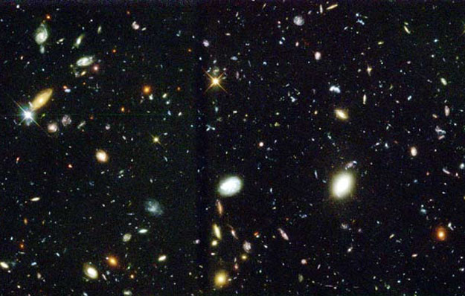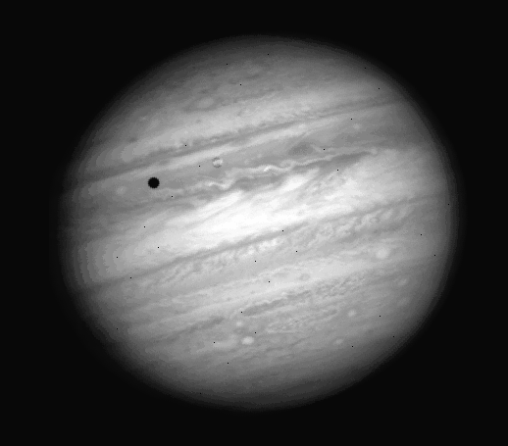
F. Nebula
A. The Solar System
B. The Sun
C. Jupiter
D. Andromeda Galaxy
E. Galaxy Cluster
- COPIED Which of the following is the best ranking (from smallest to largest) for the size of these objects?
- C<F<B<A<D<E
- E<D<F<A<B<C
- C<B<A<F<D<E
- F<C<B<A<D<E
- None of the above are correct.

- COPIED Hubble’s observation that galaxies farther away from us are moving faster implies that
- the universe is expanding.
- the universe is contracting.
- we are located at the center of the universe.
- our Galaxy repels other galaxies.

Imagine you are comparing the four stars shown at right. The temperature of each star is indicated by a shade of gray (as shown at right), such that the lighter the shade of gray, the higher the temperature of the star.

- How many of the stars could have the same luminosity as the star shown at right?
- only one
- two
- three or more
- none

- Imagine that you simultaneously receive two satellite images of two people that live on planets orbiting two different stars. Each image shows the people at their 21st birthday parties. Consider the following possible interpretations that could be made from your observations. Which do you think is the most plausible interpretation?
- Both people are the same age but at different distances from you.
- The people are actually different ages but at the same distance from you.
- The person that is closer to you is actually the older of the two people.
- The person that is farther from you is actually the older of the two people.

- The Sun appears to rise and set in our sky because _______________, and you are one year older each time _____________.
- Earth rotates on its axis; Earth completes one orbit of the Sun
- the Sun moves across the orbit of Earth; the Sun completes one rotation on its axis
- Earth’s rotational axis is tilted, Earth completes one rotation on its axis
- the Sun rotates on its axis; Earth completes one orbit of the Sun
- Earth rotates on its axis; the Sun completes one rotation on its axis

- The shape of our Galaxy’s rotation curve implies the existence of
- the distribution of globular clusters.
- dark matter.
- spiral arms.
- gas and dust.
- dark energy

- Why are the arms of spiral galaxies typically blue in color?
  - They are usually moving toward us and are Doppler shifted to blue wavelengths.
  - The gas and dust in the arms filter out all but the blue light from stars in the arms.
  - Stars are forming in the spiral arms so there are high mass, hot, blue stars in the arms.
  - Almost all the stars are in the arms of the disk of the galaxy and their light makes the arms appear blue.

- Enzo star gives off just as much energy as Ferdinand star. But Enzo star is much much hotter than Ferdinand star. Which star has the greater surface area?
- Enzo
- Ferdinand
- They have the same surface area
- There is insufficient information to answer this question.

-------------------------------------------------------------------------------------------------------------------------------

Answer the following two questions using the image at right, which represents the Milky Way Galaxy.

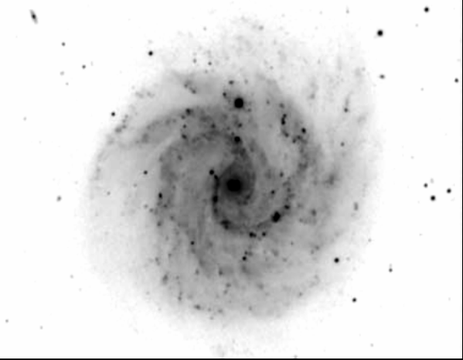
- Approximately how far is it from the white circle to the center of the Milky Way Galaxy?
  - 1,000 light years
  - 10,000 light years
  - 25,000 light years
  - 100,000 light years
  - 500,000 light years

- Approximately how large is the diameter of the white dot?
- 1,000 light years
- 10,000 light years
- 50,000 light years
- 100,000 light years
- 500,000 light years
-------------------------------------------------------------------------------------------------------------------------------

Use the drawing below to answer the next question.
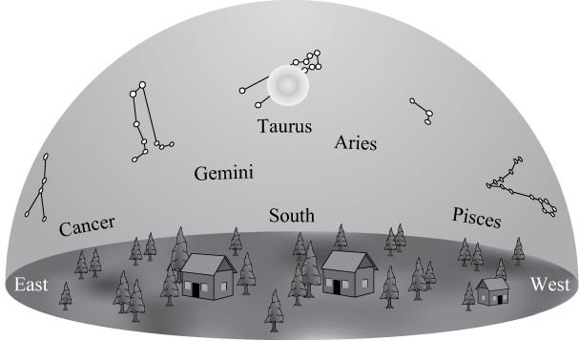
- If you could see stars during the day, the drawing above shows what the sky would look like at noon on a given day. The Sun is near the stars of the constellation Taurus. Near which constellation would you expect the Sun to be located at sunrise on this day?
a. Pisces
- Taurus
- Aries
- Cancer
- Gemini

- Which of the following most accurately describes the Big Bang theory for the beginning of our Universe?
  - An event that instantaneously created all the matter in the universe
  - The explosive event that forced matter to expand throughout the universe
  - An enormous explosion that organized pre-existing matter into the current arrangement of galaxies and stars
  - An event that marks the beginning of the universe as a tiny dot of enormously high energy and temperature but no matter
  - A gigantic sphere containing all the matter and energy of the current universe

----------------------------------------------------------------------------------------------------------------
The drawing below represents the same group of galaxies at two different times during the history of the Universe. Use this drawing to answer the following two questions.

Early Universe
Universe Some Time Later
A
B
D
E
C
A
B
D
E
C

- Which of the following is the best ranking for the speeds (from fastest to slowest) at which galaxies A, C, and D would be moving away from an observer in galaxy B?
- A > C > D
- D > A > C
- C > D > A
- D > C > A

- Which one of the following conclusions can you draw about the expansion of the universe from the drawing shown?
- Galaxy C is the center of the universe.
- All galaxies move the same distance away from you during the expansion of the universe.
- Nearby galaxies move more during the expansion of the universe.
- All galaxies appear to move away from each other during the expansion of the universe.
-------------------------------------------------------------------------------------------------------------------------------

- The atoms in the plastic of your chair were formed
  - in our Sun.
  - by a star existing prior to the formation of our Sun.
  - at the instant of the Big Bang.
  - approximately 100 million years ago.
  - in a distant galaxy in a different part of the early universe

- In Einstein’s theories about the universe, how is the concept of gravity described?
- by the amount of expansion of space time
- by the density of space time
- by the curvature of space time
- by the size of space time

- A remote satellite in orbit very close to the Sun detects a solar flare erupting on the Sun’s surface at 10:00 AM, as measured by the satellite’s clock. Your clock here on Earth is exactly synchronized with the satellite clock. The Sun is located 8 light minutes away from Earth. What time will it be when you observe the energy from the solar flare here on Earth?
  - 9:52 A.M.
  - 10:00 A.M.
  - 10:08 A.M.
  - None of the above is correct, since this flare has already occurred

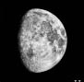
- What time is it when the moon phase shown at right first begins to rise above the horizon?
- in the late morning
- at noon
- in the afternoon
- at midnight
- in the early morning

- If Earth received the same amount of visible photons from the Sun as it currently does x-ray photons, which of the following would be true?
- The Earth’s surface temperature would be the same temperature as it is today.
- The Earth’s surface temperature would be cooler than it is today.
- The Earth’s surface temperature would be warmer than it is today.
d. There is not enough information to answer this question.

- Which of Galileo’s discoveries provided the greatest evidence that the Sun must be at the center of the solar system?
  - that Mars moves with retrograde motion
  - that Jupiter has several moons orbiting it
  - that Venus goes through phases
  - that the Sun rotates on its axis
  - that Saturn has rings

- Which one of the planets listed initially formed at the outermost location where the temperature was high enough for water to boil?
  - Venus
  - Earth
  - Mars
  - Jupiter
  - Saturn

-------------------------------------------------------------------------------------------------------------------------------
Imagine that the three stars listed below all formed at exactly the same time, but in different locations of the universe.

Cosmo Star is an O spectral class star with a MS lifetime of 3 million years. Its life will eventually end as a SN type II and become a black hole. Cosmo Star is located in a galaxy 10 billion light years (ly) from Earth.

Ollie Star is a K spectral class star with a MS lifetime of 12 billion years. Its life will eventually end as a slowly cooling white dwarf. Ollie Star is located in the MW at a distance of 10,000 ly from Earth.

Sullivan Star is an F spectral class star with a MS lifetime of 5 billion years. Its life will eventually end in a SN type I that will completely destroy Sullivan Star. Sullivan Star is located in a galaxy 6 billion ly from Earth.

- COPIED Which of these stars final end states will first be viewed on Earth?
              - Cosmo Star
              - Ollie Star
              - Sullivan Star
              - They will all be seen at the same time.

-------------------------------------------------------------------------------------------------------------------------------

- Which of the following would cause the force on the Moon by the Earth to increase by the largest amount?
- double the mass of the Moon.
- double the mass of Earth.
- move the moon two times closer to Earth.
- Due to Newton’s third law, the Moon’s force on Earth will always be the same size as the Earth’s force on the Moon so none of the changes listed in choices a-c could cause the force to increase.

- Which one property of a star will determine the rest of the characteristics of that star’s life?
  - luminosity
  - temperature
  - color
  - mass
  - spectral type
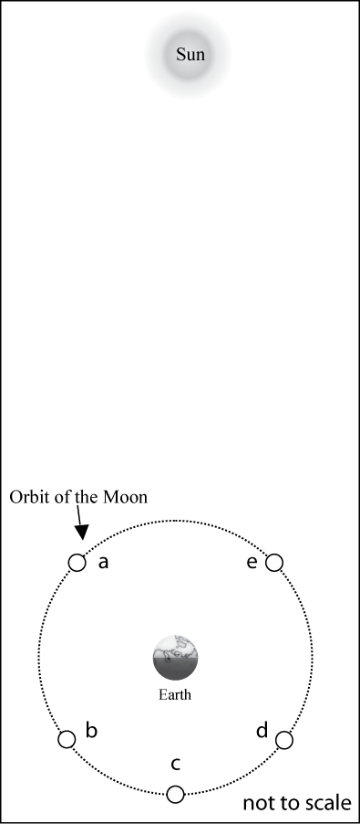

- Which Moon position (a-e), shown in the diagram at right, best corresponds with the moon phase shown below?

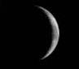

- Approximately how many Moons would fit between the Earth and the Moon?
- 30
- 50
- 120
- 150
- 220

- A galaxy that appears to be populated by mostly red stars, likely:
- never had blue stars in the galaxy
- had blue stars that are not present anymore but were at one time long ago
- has been around long enough for blue stars to all evolve into the red main sequence stars we see
- never contained enough gas to have blue stars develop
- has blue stars that are being blocked by dust

- Which of the following would be true about comparing gamma rays and radio waves?
- The radio waves would have a lower energy and would travel slower than gamma rays.
- The gamma rays would have a shorter wavelength and a lower energy than radio waves.
- The radio waves would have a longer wavelength and travel the same speed as gamma rays.
- The gamma rays would have a lower frequency and travel the same speed as radio waves.
- The radio waves would have a shorter wavelength and higher energy than gamma rays.

- How many planets (not including Pluto) formed at locations in the early solar nebula at temperatures cooler than your body temperature?
- Only one
- Two planets
- Three planets
- Four planets
- More than four planets

------------------------------------------------------------------------------------------------------------

The planet in the orbit shown in the drawing at right obeys Kepler’s Laws. Use this drawing to answer the next three questions.
D
A
B
C
7
5
3
1
2
6
8
4

- According to Kepler’s Second Law, during which portion of the planets orbit “B”, “C”, or “D”, would the planet take the same amount of time as it took for the portion of the orbit identified with letter “A”?

- During which part of the planet’s orbit (A, B, C, or D) would the planet move with the greatest speed?

- During how many portions of the planet’s orbit (A, B, C and D) would the planet be speeding up the entire time?

- Only during one of the portions shown.
- During two of the portions shown.
- During three of the portions shown.
- During four of the portions shown.
- None of the above.

------------------------------------------------------------------------------------------------------------------
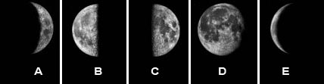

- If the moon is in the new phase today, how many of the moon phases shown above (A-E) would the moon go through during the next 12 days.
              - only one
              - two
              - three
              - more than three
              - none
------------------------------------------------------------------------------------------------------------

---------------------------------------------------------------------------------------------------------------------------

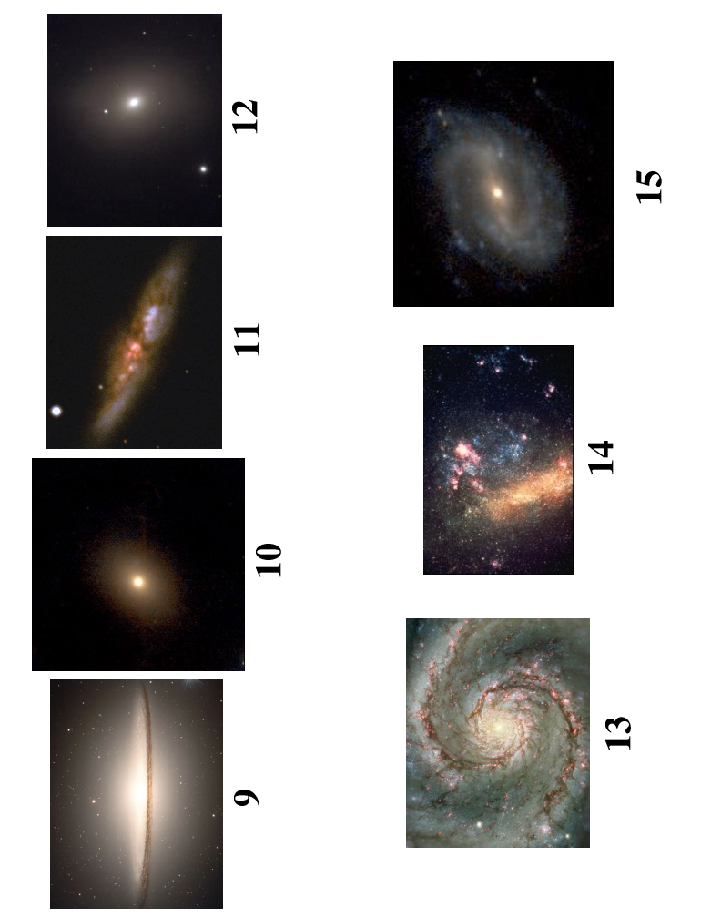
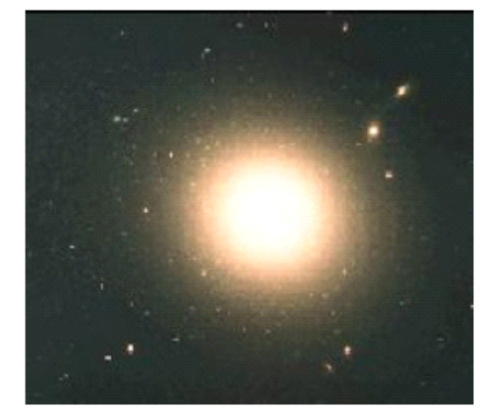

Galaxy A
Galaxy B

- In which of the galaxies above would you expect to see bright blue stars?
- Only galaxy A
- Only galaxy B
- Both galaxies A and B
- Neither galaxy A or B
---------------------------------------------------------------------------------------------------------------------------

Use the picture below to answer the next two questions. In this picture the Earth-Moon system is shown (not to scale) along with three possible positions (A-C) for a spacecraft traveling from Earth to the Moon. Note that position B is exactly halfway between Earth and the Moon.
Earth
A 
B 
Moon
C

- In what direction would the net (total) force point if the space ship were moving very quickly toward the Moon when at position “B”?
- toward Earth
- toward the Moon
- since the force on the spacecraft by Earth is equal to the force on the spacecraft by the Moon the net (total) force would be zero and not point in either direction.

- At which position (A, B or C) would the spacecraft feel the greatest acceleration?
- at position A
- at position B
- at position C
- The acceleration would be the same at all the positions.
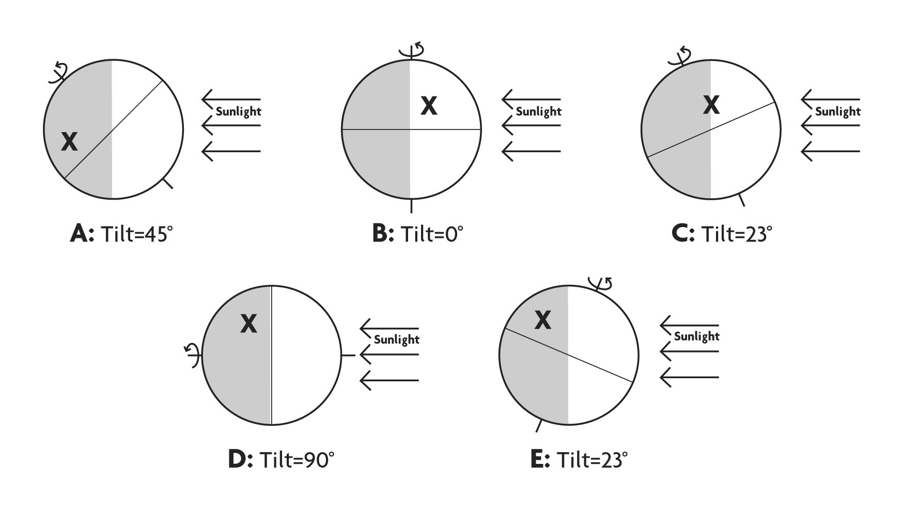

- Imagine that you placed identical glasses of water at each location indicated by an “X” for globes A – E above. Which of the following is the best ranking for the highest temperature (from coolest to hottest) that a glass of water would reach during a 24 hour period at each location. Note that the location marked with the “X” is at the same latitude in each case.

- B, E, C, A, D
- E, B, C, A, D
- A, C, B, E, D
- D, A, C, B, E
- A=B=C=D=E
-----------------------------------------------------------------------------------------------------------------------

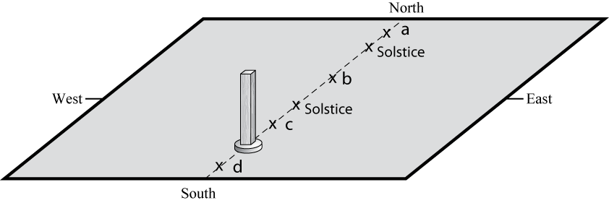
- For an observer in the continental U.S., which of the x’s (a – d) in the figure at right correctly shows the position of the top of the stick’s shadow at noon for different times of the year? Note that the positions of the Sun’s shadow at noon on the solstices are shown.
  - only position a
  - only position b
  - only position c
  - only position d
  - more than one of the positions (a, b, c, or d) is possible

-----------------------------------------------------------------------------------------------------------------------
Use the energy output versus wavelength graphs, for objects A-D, shown below to answer the next two questions.
Object A
Wavelength
visible range
Energy Output per second

Object D
Wavelength
V I B G Y O R
visible range
Energy Output per second

Object C
Wavelength
V I B G Y O R
visible range
Energy Output per second

Object B
Wavelength
V I B G Y O R
visible range
Energy Output per second

V I B G Y O R
- Which, if any, of the other objects has the same temperature as object B?
  - Object A
  - They are all the same temperature.
  - Object C
  - Object D
  - There is insufficient information to answer this question

- Which of these objects is the smallest?
  - Object A
  - Object B
  - Object C
  - Object D
  - There is insufficient information to answer this question.
-----------------------------------------------------------------------------------------------------------------------

- Which of the following is true of a binary star system consisting of a Red Giant and a White Dwarf?
- You will receive more energy when the dwarf is behind the giant than when the giant is behind the dwarf.
- The time it takes for the dwarf to pass behind the giant is shorter than the time for the giant to pass behind the dwarf.
- The force of gravity exerted on the dwarf by the giant is stronger than the force of gravity exerted on the giant by the dwarf.
- The orbital period of the dwarf is shorter than the orbital period of the giant.
- None of the above.
-------------------------------------------------------------------------------------------------------------------------------

Use the drawings below to answer the next two questions.
e-
B
e-
C
e-
D
e-
A

- Which atom would be absorbing light with the greatest energy?

- Which atom would emit light with the shortest wavelength?
-------------------------------------------------------------------------------------------------------------------------------

- Consider the information given below about three main sequence stars A, B, and C.
- Star A will be a main sequence star for 4.5 billion years.
- Star B has the same luminosity as the Sun.
- Star C has a spectral type of M5.

Which of the following is a true statement about these stars?
  - Star A has the greatest mass.
  - Star B has the greatest mass.
  - Star C has the greatest mass.
  - Stars A, B and C all have approximately the same mass.
  - There is insufficient information to determine this.

- Which of the following is most likely the light curve for the person sitting next to you taking this test?
C
X-ray UV VIS IR Radio
wavelength
long
short
Energy
X-ray UV VIS IR Radio
wavelength
short
Energy
B
X-ray UV VIS IR Radio
wavelength
short
Energy
A

In each figure below two rocky asteroids are shown with masses (m), expressed in arbitrary units, separated by a distance (d), also expressed in arbitrary units. Three of the asteroids are identified with the letters A, B, and C. Use these figures to answer the next two questions.

d = 1
d = 1
d = 1
m = 5
m = 3
m = 5
m = 5
B
C
A
m = 3
m = 5
- Which of the following correctly describes how the gravitational force exerted BY asteroid A on its “partner” asteroid compares to the gravitational force exerted BY asteroid B on its “partner” asteroid.
- The force of A on its partner is greater than the force of B on its partner.
- The force of B on its partner is greater than the force of A on its partner.
- The force of A on its partner is equal to the force of B on its partner.

- Which of the following is the correct ranking for the acceleration that asteroids A and C would experience as a result of the gravitational force exerted on them?
- A equal to C
- A greater than C
- C greater than A

- Which of the following is not a form of light?
a. radio waves
b. gamma rays
c. x-rays
d. All of the above are a form of light.
e. None of the above is a form of light

- Consider the dark line absorption spectra shown below for Star Q and Star T. What can you determine about the color of the two stars? [Assume that the left end of each spectrum corresponds to shorter wavelengths and that the right end of each spectrum corresponds with longer wavelengths.]

Star Q Star T

- Star Q would appear red and Star T would appear blue.
- Star Q would appear blue and Star T would appear red.
- Both stars would appear the same color.
- The color of the stars cannot be determined from this information.

Temperature (K)
Luminosity (solar units)
20,00010,0005,000
A
D
10,000
100
10
1
.1
.01
.001
.0001
1,000
C
B
E
Use the graph at right, showing the Luminosity versus Temperature of objects A - E, to answer the next question.

- Which of the following is the correct ranking for the size of the objects A-E, from largest to smallest.
- E=A>C=B>D
- D=B>C>A=E
- D>B=C>A>E
- E>A>C=B>D
- None of the above

- Which of the following lists, in the correct order, a possible evolutionary path for a star?
- Red Giant, Type II Supernova, Planetary Nebula, Neutron Star
- Red Giant, Neutron Star, White Dwarf, Nothing
- Red Giant, Type I Supernova, Black Hole
- Red Giant, Planetary Nebula, Black Hole
- Red Giant, Planetary Nebula, White Dwarf

