The figures below show three different Cases (1-3) in which light travels from Star S to Earth. The arrows represent light from Star S. The black box is covering up a region of spacetime through which light from Star S passes.



1. Rank the amount of light received by Earth from Star S, from greatest to least, for Cases 1-3.
2. For Cases 1-3, rank the amount that spacetime is being warped by the lensing objects, from greatest to least. Explain your reasoning.
3. For Cases 1-3, rank the mass of the lensing object present, from greatest to least. Explain your reasoning.

In Cases 4-6 below, the black box has been removed and the region of spacetime that was covered is now shown.

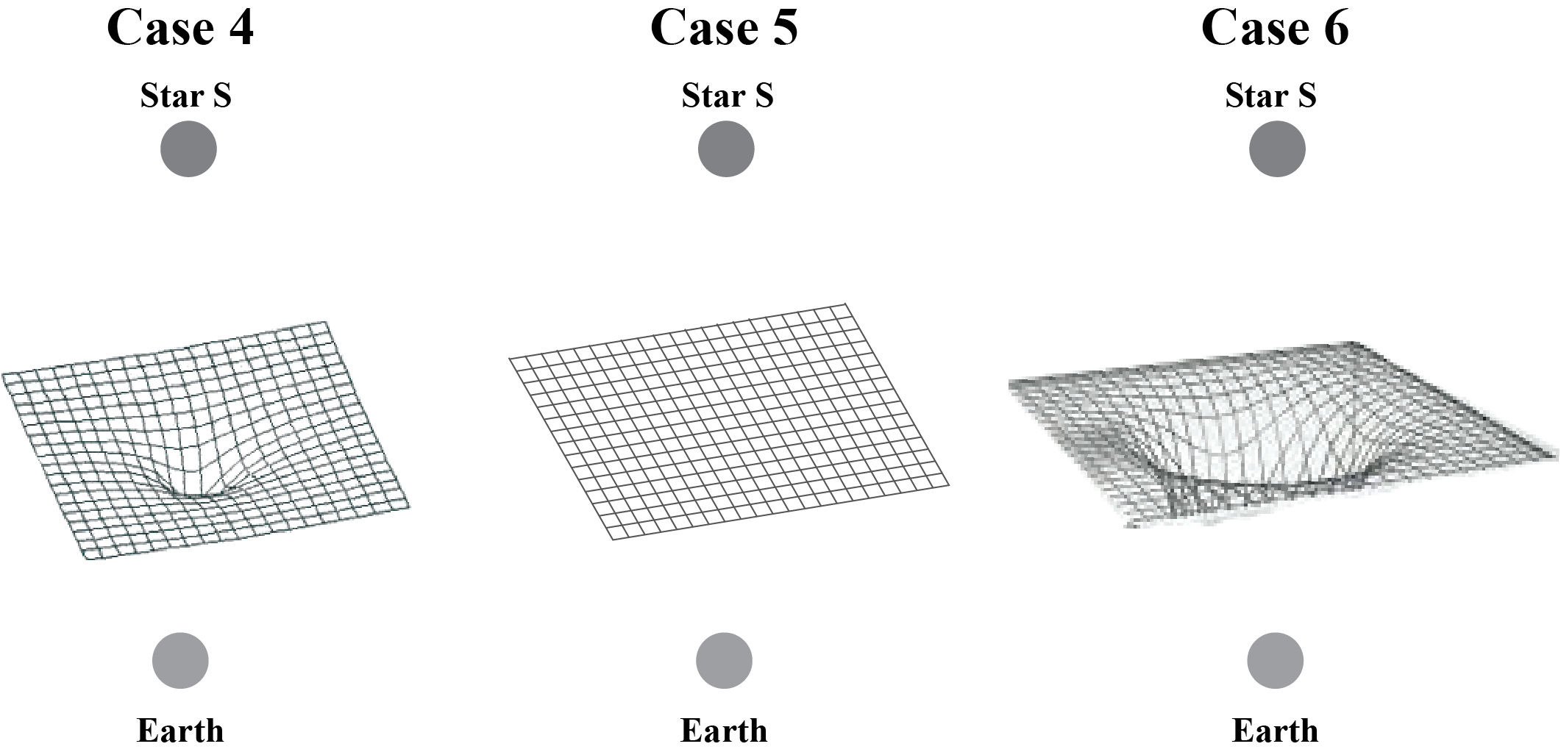

1. Match each of the Cases 4-6 with its corresponding situation in Cases 1-3. Explain your reasoning.
2. If the lensing objects for Cases 4 and 6 were moving at the same speed and entered your

field of view from the left, passed in front of your field of view, and then exited your field of

view to the right, which object will warp the spacetime between Earth and Star S for the

greatest amount of time? Explain your reasoning.

1. Graphs A and B below show possible brightness vs. time graphs for Star S as observed from Earth.

Match each graph with its corresponding situation, Case 4 or Case 6. Explain your reasoning.

1. Using Case 4 and Case 6 and Graphs A and B, complete the blanks in the sentences below by circling the correct words or phrases.

*The lensing object in Case 4 warps spacetime ________ (more/less/equally) compared to the lensing object in Case 6 because the mass of the lensing object in Case 4 is _______ (greater/less/the same). So, the lensing object in Case 4 bends the light from the distant star _______ (more/less/the same) compared to the lensing object in Case 6. This means it takes a ________ (longer/shorter/equal) amount of time for the warped region of spacetime for Case 4 to move between Earth and the distant star. This will make the light curve for Case 4 _________ (wider/narrower/the same) compared to the light curve for Case 6. Therefore, Case 4 corresponds to_______ (Graph A/Graph B) because the brightness peak is_______ (wider/narrower/the same) compared to the brightness peak in_______ (Graph A/Graph B).*

In Figure 1 below, Planet P is orbiting Star Z. The figure shows Star Z and Planet P at five consecutive times as they move from left to right through the region of spacetime between a distant star and Earth.

Distant star

Star Z

Planet P

Star Z

Planet P

Star Z

Planet P

Star Z

Planet P

Star Z

Planet P

Earth

Figure 1

1. Which object causes a greater warping of the region of spacetime around itself: Star Z or Planet P? Explain your reasoning.
2. Which object moves between Earth and the distant star first: Star Z or Planet P?
3. Which of these two graphs best corresponds to the observed brightness of the distant star depicted in Figure 1? Explain your reasoning.
4. Two students are discussing their answers to Question 9:

**Student 1:** *I think the correct graph is Graph C. We would see Planet P to the right of Star Z. So, the brightness bump from the planet needs to be on the right side of the brightness peak caused by Star Z. That is what Graph C shows.*

**Student 2:** *I disagree. I think the correct graph is Graph D. I agree that Planet P is to the right of Star Z, but I think you’re confusing the positions of the star and planet with the corresponding times when each object causes a bump on the graph. Since the planet enters the region between Earth and the distant star first, we should see the bump due to Planet P on the part of the graph that’s earlier in time. That matches Graph D.*

Do you agree or disagree with either or both of the students? Explain your reasoning.

1. Graphs E-H, below, show how the brightness of a distant star changes over time in different situations. In each situation, there is a star moving from left to right through the region of spacetime between Earth and the distant star. Each star that moves between the distant star and Earth is orbited by an exoplanet.
   1. Which graph (E-H) corresponds to the situation in which a star with a lower mass exoplanet located to the right of the star (as seen from Earth) moves through the region of spacetime between Earth and the distant star? Explain your reasoning.
   2. Which graph (E-H) corresponds to the situation in which a star with a higher mass exoplanet located to the left of the star (as seen from Earth) moves through the region of spacetime between Earth and the distant star? Explain your reasoning.
2. Graphs I and J, below, show how the brightness of a distant star changes over time in different situations. In each situation, there is a nearby star orbited by an exoplanet moving through the region of spacetime between Earth and the distant star. In which situation are the nearby star and its exoplanet further apart as seen from Earth? Explain your reasoning.
3. Graphs K and L below show how the brightness of a distant star changes over time in different situations. In each situation, there is a nearby star orbited by two exoplanets moving through the region of spacetime between Earth and the distant star. Each nearby star moves from left to right as seen from Earth, passing between Earth and the distant star.

Make a sketch of each extrasolar planet system moving between Earth and the distant star (one sketch for Graph K and one sketch for Graph L). Make sure to account for the sizes of the stars, the sizes of the planets, and the distances the planets are from their parent star. Also, be sure to correctly show whether the planets are located to the left or right of their parent star.