Name__________________________
SID#__________________________

NATS 102 – sections 09, 010H and 011

February 14, 2008

Exam #1
Test Form A

Answer all of the following questions on the bubble sheet provided using a #2 pencil. Make sure that your Name, Student ID Number and test form letter are on the answer sheet and that all answers are recorded in the correct position. Always select the BEST answer. Each question is worth 1 point. This is a closed-book, closed-note exam and you have approximately one hour to complete it. If you have questions, please raise your hand. You are not to talk to or attempt to obtain answers from other students for any reason.

Be sure to write and bubble in your ID number and test form letter.
If your student ID begins with an “S,” write it in and bubble a “0.”

DO NOT START THE EXAM UNTIL YOU ARE TOLD TO DO SO!
NATS 102 sections 09, 010H and 011 Exam #1 Form A – February 14, 2008

Answer all of the following questions on the bubble sheet provided using a #2 pencil. Make sure that your Name, Student ID Number and test form letter are on the answer sheet and that all answers are recorded in the correct position. If your student ID begins with an “S,” write it in and bubble a “0.” Always select the BEST answer. Each question is worth 1 point. This is a closed-book, closed-note exam and you have approximately one hour to complete it. If you have questions, please raise your hand.

- Which of the following statements is true about the location of the Sun at sunrise during the middle of summer?
- The Sun will rise north of West
- The Sun will rise north of East.
- The Sun will rise south of West.
- The Sun will rise south of East.
- None of the above.

- Which of the following groups of moon phases is above the horizon at 9:00 am?
- Third Quarter, Waning Crescent, and Waxing Gibbous
- New Moon, Third Quarter, and Waning Gibbous
- Waxing Gibbous, Full Moon, Waning Gibbous
- Waxing Crescent, First Quarter, Waxing Gibbous
- None. The moon can only been seen above the horizon during the night time.

- If the Moon is in the waning crescent phase tonight, approximately how long will it be until the Moon is in the waning gibbous phase?
- a month
- one week
- one day
- three weeks
- two weeks

- Stars located near _____ appear to move in circles when viewed from Earth.
- the Sun
- Polaris
- Orion
- the Moon

- What do we call the day(s) of the year when the Sun rises directly in the East and sets directly in the West?
- Solstices
- Circumpolar
- Equinoxes
- Celestial
------------------------------------------------------------------------------------------------------------------------------
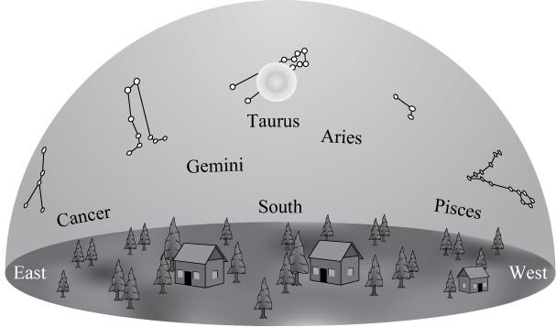
Use the drawing below to answer the next two questions.

- If you could see stars during the day, the drawing above shows what the sky would look like at noon on a given day. The Sun is near the stars of the constellation Taurus. Near which constellation would you expect the Sun to be located at sunset on this day?
a. Pisces
- Taurus
- Aries
- Cancer
- Gemini

- Which constellation will be highest in the sky 6 hours after the time shown in the drawing above?
  - Pisces
  - Cancer
  - Gemini
  - Taurus
  - Aries
-------------------------------------------------------------------------------------------------------------------------------

- Which phase of the Moon rises in the east as the Sun sets in the west?
- waxing crescent
- waning gibbous
- new
- third quarter
- full

- Which of the following rankings is correct for the size (width) of the following objects from smallest to largest?

- star, planet, solar system, galaxy, universe
- planet, star, galaxy, solar system, universe
- solar system, Planet, star galaxy universe
- planet, star, solar system, galaxy, universe
- star, solar system, planet, galaxy, universe

- What time is it when the new moon is highest in the sky?
- early morning
- noon
- early afternoon
- evening
- midnight

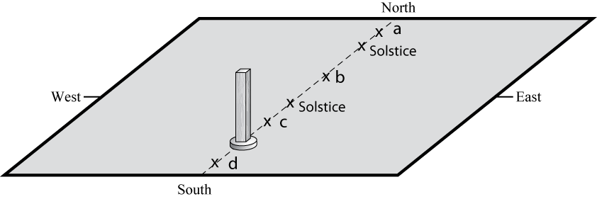
- For an observer in the continental U.S., which of the x’s (a, b, c or d) in the figure at right correctly show where the end of the stick’s shadow would be located at noon for different times throughout the year? Note that the positions of the Sun’s shadow at noon on the solstices are labeled for you.
  - only position a
  - only position b
  - only position c
  - only position d
  - more than one of the positions (a, b, c, or d) is possible

- Which of the following describes one reason that the northern and the southern hemispheres have different seasons at the same time?
- The Earth is closer to the Sun during summer in the southern hemisphere and is farther from the sun during winter in the northern hemisphere.
- During a day of the year when the Sun is high in the sky in the northern hemisphere it will be low in the sky in the southern hemisphere.
- The Earth is tilted, so the Sun is closer to one hemisphere than the other, which causes one hemisphere to be in winter and the other in summer.
- The energy received at Earth from the Sun changes throughout the year providing more energy to one hemisphere than the other.
- None of the above.

- Which of the following sequences of moon phases will occur one after the other within one cycle of phases:
- third quarter, waxing gibbous, full, waning crescent
- waxing gibbous, waxing crescent, new, waning crescent
- waning crescent, first quarter, full, waxing crescent
- full, waning gibbous, first quarter, new
- new, waxing crescent, first quarter, waxing gibbous

- During the new moon phase, how much of the Moon’s total surface is being illuminated by sunlight?
- none
- less than half
- half
- more than half

- In what phase and location described below will the Moon be when a solar eclipse occurs?
  - New phase and above the plane of Earth’s orbit
  - Full phase and above the plane of Earth’s orbit
  - New phase and crossing Earth’s orbital plane.
  - Full phase and crossing Earth’s orbital plane.
  - None of the above

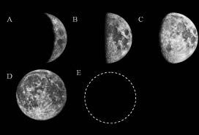
- You look to the eastern horizon as the Moon first rises and discover that it is in the new moon phase. Later that same day when the moon reaches its highest position in the sky, which of the moon phases shown at right will the Moon look like?

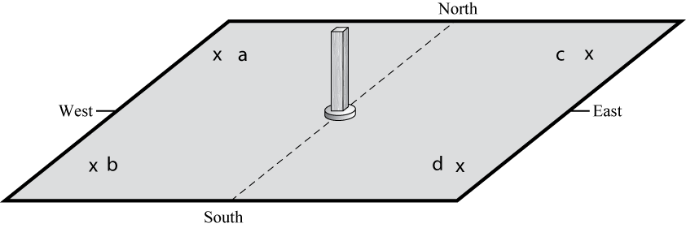
- Which “X” could represent the position of the end of the stick’s shadow made shortly after sunrise during the Winter?
  - a
  - b
  - c
  - d
  - None of the above

For the next four questions, use the two figures provided below, which show the motion of Stars A and B in the sky. Note that Star A reaches its maximum height above the horizon at 3:00 pm.

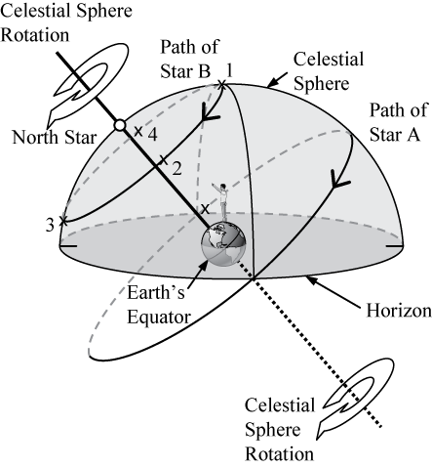

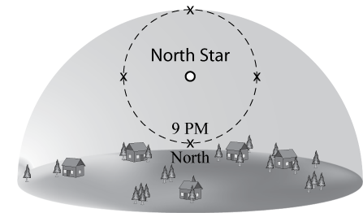

- At what time will Star B be located high in the Northeastern sky?
- 11:00 pm
- 9:00 am
- 11:00 am
- 6:00 am
- 6:00 pm

- In what direction is Star B moving at 3:00 am?
- west (to the left)
- east (to the right)
- south(out of the page)
- away from the horizon (up)
- toward the horizon (down)

- At what time would you see Star A high in the southern part of the sky?
  - 3:00 am
  - 9:00 am
  - 3:00 pm
  - 9:00 pm

- At what time would you see Star A in the west?
  - 3:00 am
  - 9:00 am
  - 3:00 pm
  - 9:00 pm

- If Earth were upright with no tilt, would the temperature at your location in July be colder, warmer or the same as it is currently during the month of July?
a. cooler
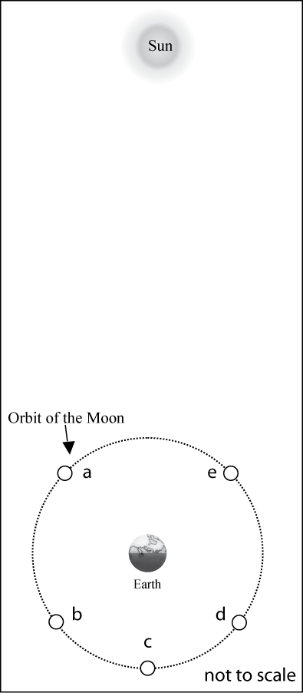
b. warmer
c. the same

- Which Moon position (a-e), shown in the diagram at right, best corresponds with the moon phase shown below?

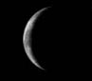

- At Noon on the day of the Summer Solstice, how will your shadow appear:
  - short and pointing to the south.
  - short and pointing to the north.
  - long and pointing to the north.
  - long and pointing to the south.
  - at noon on this day you will not cast a shadow.

- If you are located in the continental U.S. on the first day of October, how will the position of the Sun at noon be different two weeks later?
- It will have moved toward the North.
- It will have moved to a position higher in the sky.
- It will stay in the same position.
- It will have moved to a position closer to the horizon.
- It will have moved toward the west.

- Imagine that Earth’s orbit were changed to be a perfect circle about the Sun so that the distance to the Sun never changed. How would this affect the seasons?
- We would no longer experience a difference between the seasons.
- We would continue to experience seasons in essentially the same way we do now.
- We would still experience seasons, but the difference would be much more noticeable.
- We would still experience seasons, but the difference would be much less noticeable.

- Which of the following locations experiences the smallest amount of change in sunlight over the course of a year?
- north pole
- south pole
- equator
- They all experience the same amount of change in sunlight over a year.

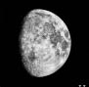
- What time is it when the moon phase shown at right first begins to set below the horizon?
- in the late morning
- at noon
- in the mid-afternoon
- at midnight
- in the early morning

- During the full moon phase, how much of the total Moon’s surface is being illuminated by sunlight?
- none
- all
- less than half
- more than half
- half

- In what phase and location described below will the Moon be, when a lunar eclipse occurs?
  - Full phase and below the plane of Earth’s orbit.
  - Full phase and crossing Earth’s orbital plane.
  - New phase and below the plane of Earth’s orbit.
  - New phase and crossing Earth’s orbital plane.
  - None of the above.

- Which of the following best describes why the Moon goes through phases?
- Earth's shadow falls on different parts of the Moon at different times.
- The Moon is somewhat flattened and disk-like, and appears more or less round depending on the precise angle from which we see it.
- Earth’s clouds cover potions of the Moon at various times resulting in the changing phases that we see.
- The sunlight reflected from Earth lights up the Moon but is less effective when the Moon is lower in the sky than when it is higher in the sky.
- We see only part of the lit-up face of the Moon depending on its position relative to Earth and the Sun.

- If Earth were tilted more (60º rather than 23.5º), then during winter at your location you would:
a. experience cooler temperatures.
b. experience warmer temperatures.
c. not experience any significant change in temperature.

(A)
star name
(B)
star name
(C)
star name
(D)
constellation
(E)
star name
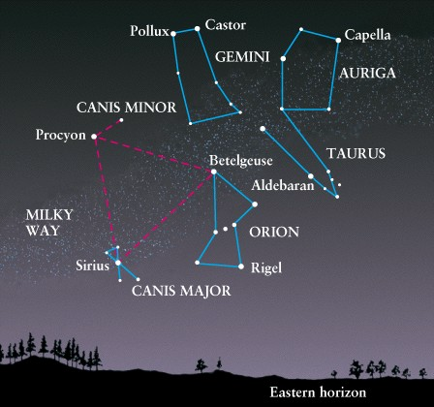
Which letter on the map at right shows:

- Betelgeuse?

- Sirius?

- a blue giant star in Orion?

- Gemini?

- Imagine you see Mars rising in the east at 6:30 pm. Six hours later what direction would you face (look) to see Mars when it is highest in the sky?
- toward the north
- toward the south
- toward the east
- toward the west
- directly overhead

- Which shadow plot (A or B) most closely corresponds to the Sun’s path through the sky during the summer?
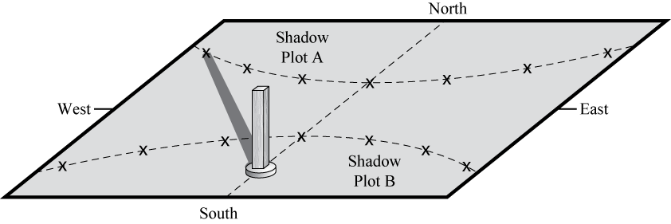
- Shadow Plot A
- Shadow Plot B

Use the figure below to answer the next three questions. In this Earth-Sun system drawing we have indicated the direction of both the daily rotation of Earth about its own axis and its annual orbit about the Sun. Imagine you are the observer shown on Earth in the northern hemisphere.

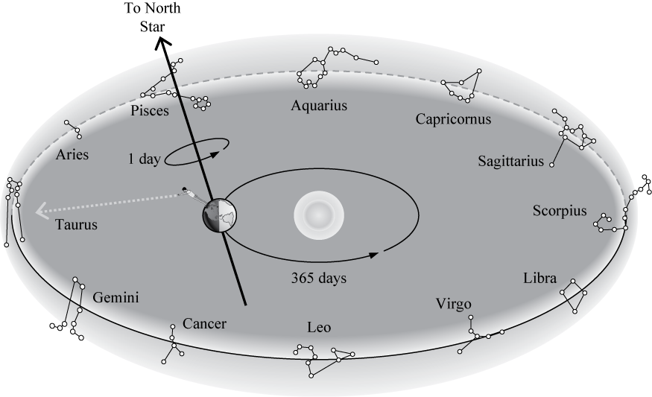

- For the time shown, which constellation will be highest in the sky at noon?
- Aquarius
- Pisces
- Leo
- Taurus
- Scorpius

- What will be an individual’s birth sign, 5 months after the time shown?
  - Libra
  - Aries
  - Sagittarius
  - Gemini
  - Scorpius

- Which constellation will be high in the sky at midnight in 9 months?
- Aquarius
- Pisces
- Leo
- Cancer
- Capricornus
- Based on the locations of the constellations described below, what would be the horoscope sign of a person born on this day?
- Taurus is high in the southern sky at sunset.
- Aquarius is on the eastern horizon at sunrise.
- Scorpius is on the western horizon at noon.
- Leo is high in the southern sky at midnight.
- Taurus
- Aquarius
- Scorpius
- Leo

- The Sun appears to rise and set in our sky because _______________, and you are one year older each time _____________.
- Earth rotates on its axis; Earth completes one orbit of the Sun
- the Sun moves across the orbit of Earth; the Sun completes one rotation on its axis
- Earth’s rotational axis is tilted, Earth completes one rotation on its axis
- the Sun rotates on its axis; Earth completes one orbit of the Sun
- Earth rotates on its axis; the Sun completes one rotation on its axis

- Which lettered position (a-e), in the image below, best represents the location on Earth that is experiencing winter in the Northern Hemisphere?

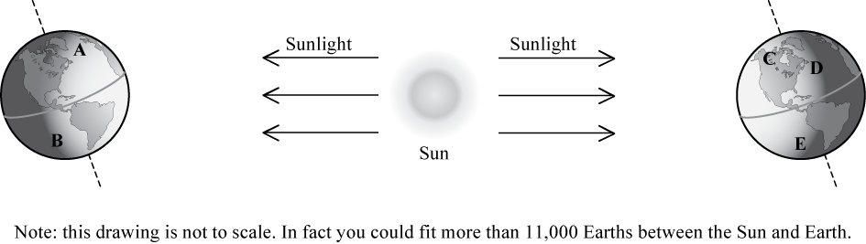

- Which of the following correctly ranks locations from closest to Earth to farthest from Earth?
  - the Sun, the edge of our solar system, the star Alpha Centauri, far edge of Milky Way galaxy, near side of Andromeda Galaxy
  - the star Alpha Centauri, the Sun, edge of our solar system, near side of Andromeda Galaxy, far edge of Milky Way galaxy
  - the edge of our solar system, the Sun, the star Alpha Centauri, far edge of Milky Way galaxy, near side of Andromeda Galaxy
  - the Sun, the star Alpha Centauri, edge of our solar system, near side of Andromeda Galaxy, far edge of Milky Way galaxy
  - the Sun, the edge of our solar system, the star Alpha Centauri, near side of Andromeda Galaxy, far edge of Milky Way galaxy

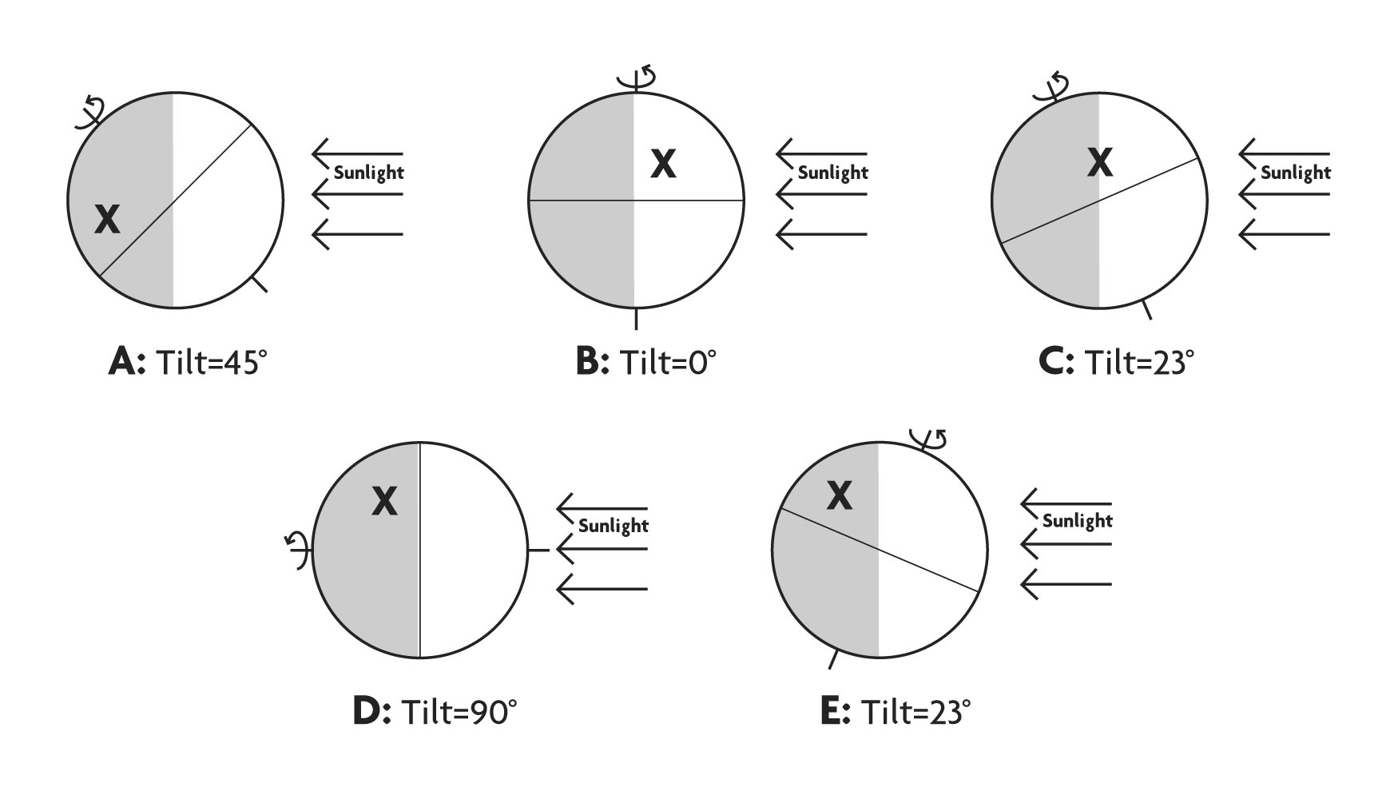

- Imagine that you placed identical glasses of water at each location indicated by an “X” for Globes A – E above. Which of the following is the best ranking for the highest temperature (from coolest to hottest) that a glass of water would reach during a 24 hour period at each location. Note that the location marked with the “X” is at the same latitude in each case.

- B, E, C, A, D
- E, B, C, A, D
- A, C, B, E, D
- D, A, C, B, E
- A=B=C=D=E
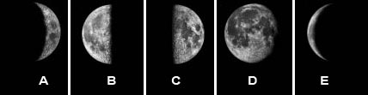
-------------------------------------------------------------------------------------------------------------------------------

- If the moon is in the new phase today, how many of the moon phases shown above (A-E) would the moon go through during the next 12 days.

              - only one
              - two
              - three
              - more than three
              - none
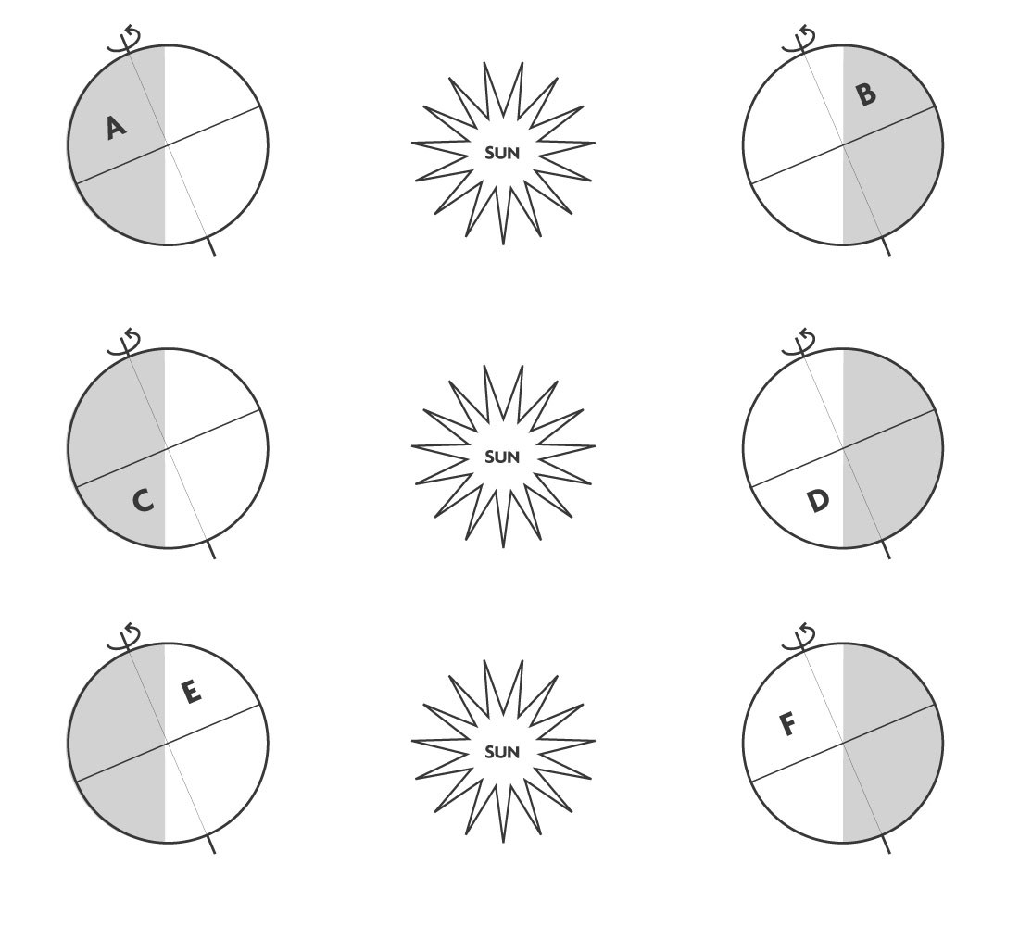

- How many of the Earth locations shown above (A-F) would be experiencing Summer?
- only one
- two
- three
- four
- more than four

-------------------------------------------------------------------------------------------------------------------------------
The figure below shows the evening sky as it would appear for an observer in the northern hemisphere. Notice that Polaris, the North Star, appears fairly high in the sky while other stars (labeled A - D) appear to slowly move around the North Star.
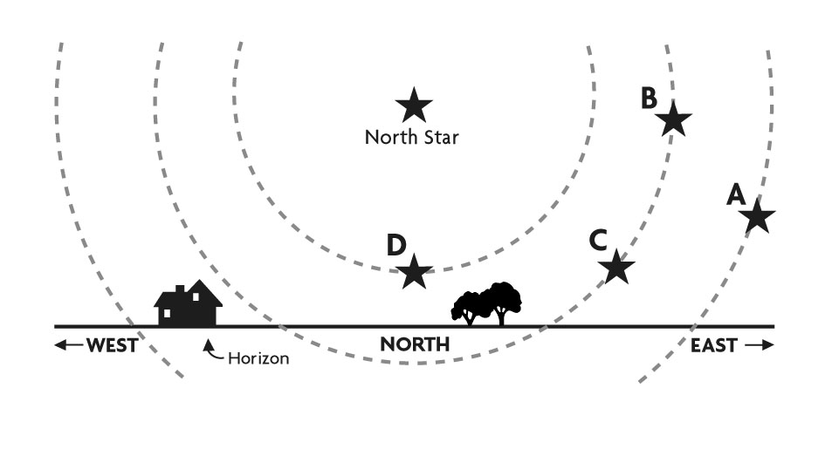
- Which of the following is the best ranking for the amount of time that each of the stars shown above (A - D), will be above the horizon during a 24 hour period, from greatest amount of time to least.
              - A>B>C>D
              - A>B=C>D
              - D>B>C>A
              - D>B=C>A
              - They would all spend the same amount of time above the horizon.

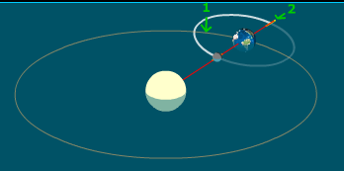
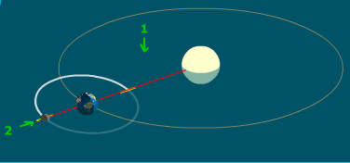
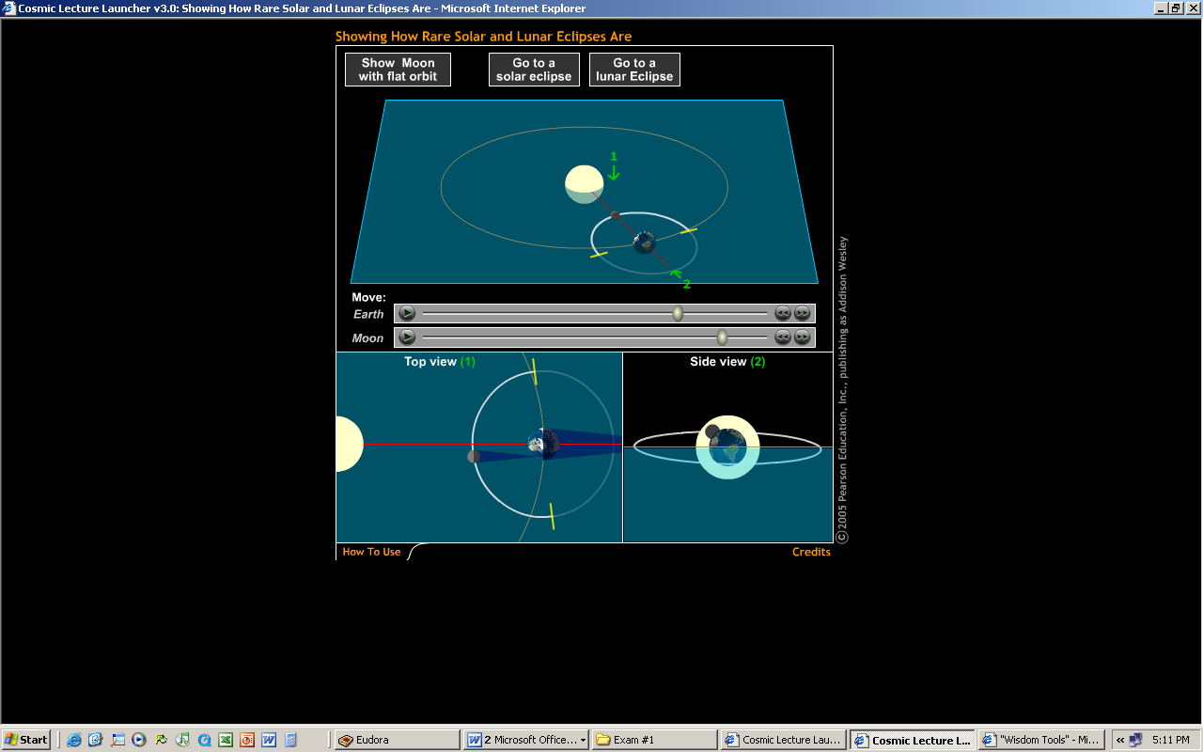
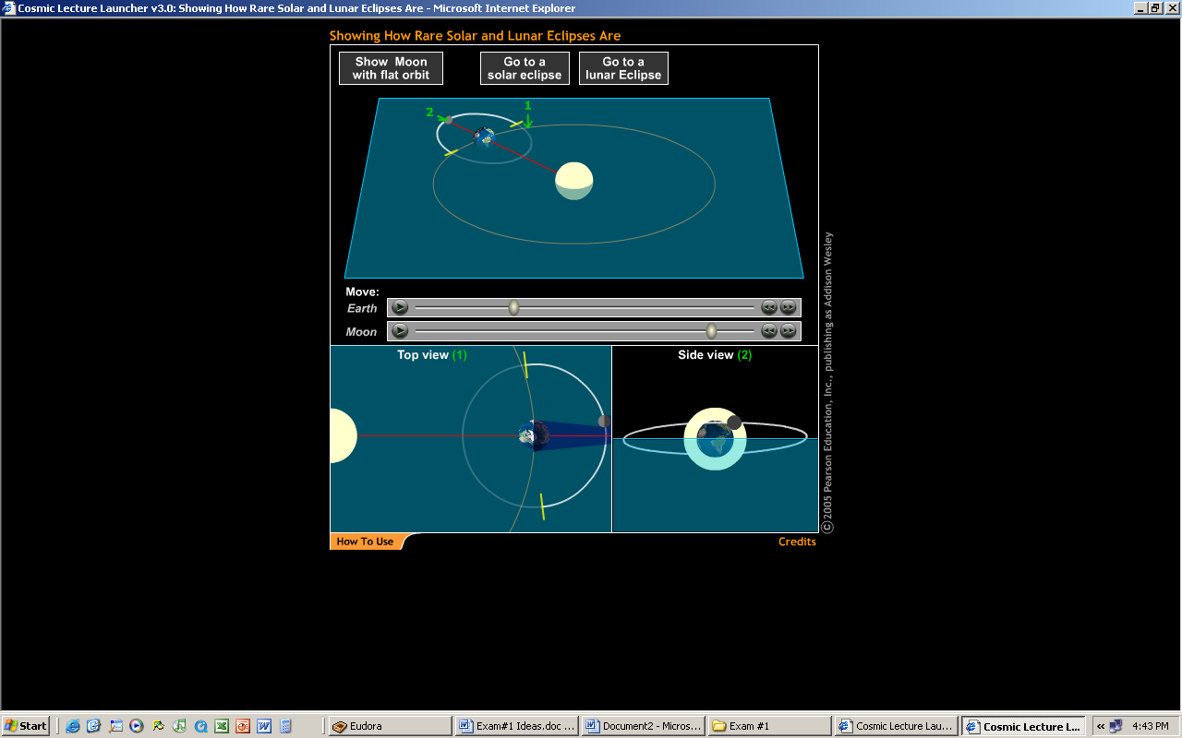
----------------------------------------------------------------------------------------------------------------------------
C
B
D
A

- Which of the four images shown above (A-D) from your homework on eclipses corresponds to a solar eclipse?

