Astronomy Assessment and TPS Questions:
Newton’s Laws and Gravity

- Imagine that you throw a ball directly upward. Which of the following statements best describes how Newton’s Second Law accounts for the motion of the ball when it reaches its maximum height?
  - The ball has a velocity that is zero and an acceleration that is zero.
  - The ball has a velocity that is upward and an acceleration that is downward.
  - The ball has a net force that is downward and an acceleration that is downward.
  - The ball has a net force that is downward and a velocity that is downward.
  - The ball has a net force that is downward and an acceleration of zero.

- Your weight on the Moon is about 1/6th of your weight on Earth. Which of the following reasons best explain this phenomenon?
  - There is no gravity on the Moon.
  - The mass of the Moon is smaller than the mass of Earth.
  - You are much farther from Earth when you are on the Moon.
  - There is no air on the Moon.
  - Your mass on the Moon is less than your mass on Earth

Use the picture below to answer the next six questions. In this picture the Earth-Moon system is shown (not to scale) along with three possible positions (A-C) for a spacecraft traveling from Earth to the Moon. Note that position B is exactly halfway between Earth and the Moon.
Earth
A
B
Moon
C

- At which position would the gravitational force exerted by the Moon on the spacecraft be the strongest?
  - Position A
  - Position B
  - Position C
  - The force would be the same at all three positions

- At which position would the spacecraft feel the strongest total gravitational force?
- Position A
- Position B
- Position C
- The force would be the same at all three positions.

- In what direction would the net (total) force point if the space ship were coasting very quickly toward the Moon when at position “B”?
  - toward Earth
  - toward the Moon
  - since the force on the spacecraft by Earth is equal to the force on the spacecraft by the Moon the net (total) force would be zero and not point in either direction.

- At which position (A, B or C) would the spacecraft feel the greatest acceleration?
  - at position A
  - at position B
  - at position C
  - The acceleration would be the same at all the positions.

- What would the spacecraft do as it coasted through position “C” on its way to the Moon?
- speed up
- slow down
- travel with a constant acceleration
- travel with a constant speed

- Using the diagram on the previous page, how does the presence of the spacecraft affect the gravitational force exerted on Earth by the Moon?
  - The Moon feels a greater force toward Earth than Earth does toward the Moon because the Moon revolves around Earth
  - The Moon and Earth feel an equal, but increased force toward each other because of the spacecraft between them
  - The Moon and Earth feel and equal force toward each other that is unaffected by the presence of the spacecraft
  - The Moon and Earth do not feel a gravitational force toward each other because of the presence of the spacecraft between them

In each figure below two rocky asteroids are shown with masses (m), expressed in arbitrary units, separated by a distance (d), also expressed in arbitrary units. Three of the asteroids are identified with the letters A, B, and C. Use these figures to answer the next five questions.
d = 1
d = 1
d = 1
m = 5
m = 3
m = 5
m = 5

B
C
A
m = 3
m = 5
- Which of the following correctly describes how the gravitational force exerted BY asteroid A on its “partner” asteroid compares to the gravitational force exerted BY asteroid B on its “partner” asteroid.
  - The force of A on its partner is greater than the force of B on its partner.
  - The force of B on its partner is greater than the force of A on its partner.
  - The force of A on its partner is equal to the force of B on its partner.

- Which of the following correctly describes how the gravitational force exerted BY asteroid A on its “partner” asteroid compares to the gravitational force exerted BY asteroid C on its “partner” asteroid.
  - The force of A on its partner is greater than the force of C on its partner.
  - The force of C on its partner is greater than the force of A on its partner.
  - The force of A on its partner is equal to the force of C on its partner.

- Which of the following correctly describes how the gravitational force exerted BY asteroid A on its “partner” asteroid compares to the gravitational force exerted BY asteroid C on its “partner” asteroid.
  - The force of A on its partner is greater than the force of C on its partner.
  - The force of C on its partner is greater than the force of A on its partner.
  - The force of A on its partner is equal to the force of C on its partner.

- Which of the following is the correct ranking for the acceleration that asteroids A and C would experience as a result of the gravitational force exerted on them?
  - A equal to C
  - A greater than C
  - C greater than A

- Which of the following is the correct ranking for the acceleration that asteroids A and B would experience as a result of the gravitational force exerted on them?
  - A=B
  - A>B
  - B>A

In each figure below two rocky asteroids are shown along with their masses (m), and the distance (d) they are separated by. Three of the asteroids are identified with the letters A, B, and C. Use these figures to answer the next two questions.
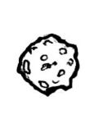
d = 1
d = 2
d = 2
m = 4
m = 2
m = 4
m = 4

B
C
A
m = 2
m = 4

- Which of the following is the correct ranking for the acceleration that asteroids A and C would experience as a result of the gravitational force exerted on them?
  - A equal to C
  - A greater than C
  - C greater than A

- Which of the following correctly describes how the gravitational force exerted BY asteroid A on its “partner” asteroid compares to the gravitational force exerted BY asteroid B on its “partner” asteroid?
  - The force of A on its partner is greater than the force of B on its partner.
  - The force of B on its partner is greater than the force of A on its partner.
  - The force of A on its partner is equal to the force of B on its partner.

- Which of the following would cause the force on the Moon by the Earth to increase by the largest amount?
  - double the mass of the Moon.
  - double the mass of Earth.
  - move the moon two times closer to Earth.
  - Due to Newton’s third law, the Moon’s force on Earth will always be the same size as the Earth’s force on the Moon so none of the changes listed in choices a-c could cause the force to increase.

- If the distance between two objects is tripled, the gravitational force exerted by one on the other will be:
  - the same
  - one-third as much
  - one-ninth as much
  - three times as much
  - nine times as much

- The gravitational attraction between an object and the Earth:
  - stops just above the atmosphere
  - extends to about half-way to the Moon
  - extends about five-sixth of the way to the Moon
  - extends to infinity

- In 1992 a fragile comet called Shoemaker-Levy 9 was broken into pieces by Jupiter’s gravity. This is best explained by:
  - The increasing strength of Jupiter’s gravity as the comet passed nearby crushed the comet into smaller pieces.
  - The gravity of the comet was smaller than Jupiter gravity.
  - Tidal forces caused a bulge in Jupiter that shattered the comet.
  - As the comet passed from Jupiter’s northern gravitation feld to the southern gravitational field, the change broke the comet apart.
  - As it passed close to Jupiter, the larger gravity on the Jupiter side of the comet versus the more distant side of the comet pulled the comet apart.

- The factors that most effect the gravitational force between two objects are
  - Density, weight, and distance
  - Mass and size
  - Density and distance
  - Weight and distance
  - Weight and size

The diagram below shows an apple in space at the midpoint between two astronauts. The astronauts are located at Location 1 and 2, but their sizes are not shown. The arrows indicate the direction of the gravitational force exerted on the apple by each astronaut. The length of the arrows indicates the strength of the gravitational force.
1
2

- The astronaut at Location 2 ______ the astronaut at Location 1.
- is more massive than
- is less massive than
- has the same mass as

- The gravitational force by the apple on the astronaut at Location 1 is ______ the gravitational force by the apple on the astronaut at Location 2.
  - greater than
  - less than
  - equal to

- If the apple were moving to the right while at the midpoint location shown, it would ______.
- move with a constant speed
- slow down
- speed up
- it cannot be moving to the right at this location.

- Which diagram below best describes the net (total) force of gravity on each of the three galaxies shown at right? Note that (i) Galaxy 3 has much more mass than Galaxies 1 and 2 (which have equal mass), and (ii) the arrows indicate the direction of the net (total) force of gravity exerted on each galaxy, but not the strength.
1
2
3
1
2
3
b)
1
2
3
e)
1
2
3
c)
1
2
3
a)
1
2
3
d)

- Which property(s) determine the gravitational force between two objects?
  - Mass of both objects
  - Distance between the objects
  - Diameter of both objects
  - Both a and b
  - Both a and c

- The _____ and _____ of an object are always pointing in the same direction
  - Net force and velocity
  - Acceleration and net force
  - Acceleration and velocity

- If the net force and acceleration of an object are both pointing in the same direction then the object is
  - Speeding up
  - Slowing down
  - Changing direction
  - It is impossible to determine based on this information

- Which of the following is not an example of acceleration?
  - Slowing down
  - Speeding up
  - Changing direction
  - Orbiting in a circle
  - All of the above are examples of acceleration

- Can an object that is not moving be accelerating?
  - No, to accelerate you have to be moving
  - Yes, but only if it has never moved before
  - Yes, objects are always accelerating
  - Yes, it could be changing direction

- An object’s net force and acceleration are pointing in the same direction, and the object is moving very fast in the opposite direction. This means the object is
  - Speeding up
  - Slowing down
  - Changing directions
  - It is impossible for an object’s velocity to be going in an opposite direction of its net force

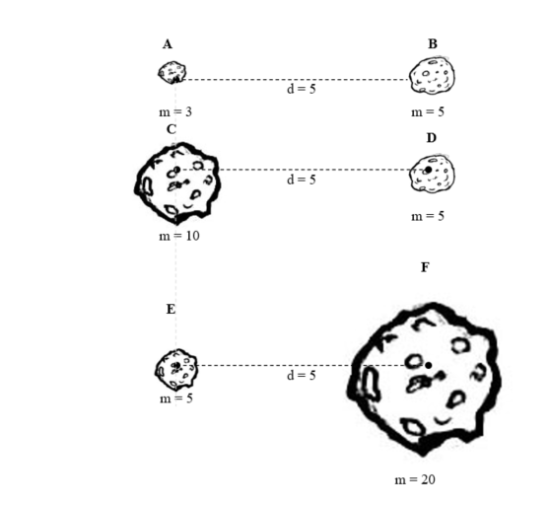

- Using the image above, which asteroid would experience the greatest amount of gravitational force being exerted on it?
  - A
  - F
  - D
  - C

- Using the image above, which of the following best describes the gravitational force experienced between asteroid “C” and asteroid “D”?
  - Asteroid “C” feels a greater gravitational pull on it than asteroid “D”
  - Asteroid “C” experiences the same gravitational pull on it as asteroid “D”
  - Asteroid “D” feels a greater gravitational pull on it than asteroid “C”

- Using the image on the previous page, which asteroid would experience the greatest amount of acceleration?
  - B
  - F
  - E
  - C

- Jupiter and one of its moons feel a gravitational force toward each other. How does the force felt by each of the two objects relate?
  - Jupiter feels a lesser force because it is more massive and pulling the moon toward it
  - Jupiter’s moon feels a lesser force because it is much less massive
  - Jupiter and its moon feel the same force but in opposite directions

- What change would result in the greatest increase in gravitational force felt by the Sun and Earth toward each other?
  - Increase the mass of Earth by 2
  - Increase the mass of the Sun by 2
  - Decrease the distance between the Sun and Earth by 2
  - Decrease the mass of the Sun and Earth by 2

- If the mass of Earth were increased by 2, how would this affect the gravitational force felt between it and the Sun?
  - Earth would feel a greater gravitational force toward the Sun, but the force felt by the Sun would be unaffected
  - Earth and the Sun would both feel an equal increase in gravitational force
  - Neither Earth nor the Sun would feel a difference in gravitational force because of the great distance between these two objects in space
  - The Sun would feel a greater gravitational force toward Earth, but the force felt by Earth would be unaffected

- A person is sitting motionless on a couch in Tucson. The net force felt by this person is:
  - Equal to the force being exerted by the Earth on the person
  - Equal to the force being exerted by the couch on the person
  - Equal to the force being exerted by the atmosphere on the person
  - Equal to zero

- Which of the following has to be true for an object that is speeding up?
- The net force and acceleration are in opposite directions
- The velocity and acceleration are in opposite directions
- The net force and velocity are in opposite directions
- The velocity and acceleration are in the same direction
- None of the above

- Which of the following has to be true for an object that has no net force?
- It will have no acceleration
- Its acceleration and velocity are the exact same just in opposite directions
- Its acceleration and velocity are the exact same and in the same direction
- None of the above
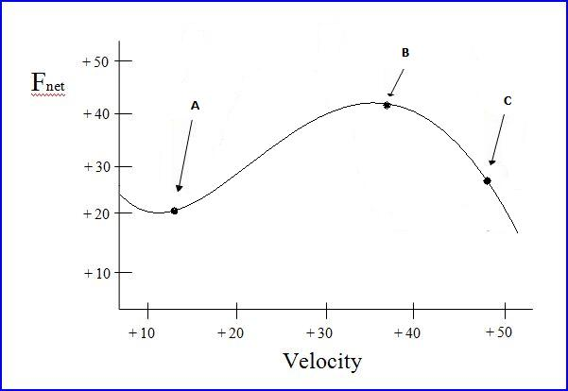

- Using the graph above, at which point is the object experiencing the greatest amount of acceleration?
  - A
  - B
  - C

- Using the graph above, at which point is the object speeding up by the least amount?
  - A
  - B
  - C

- Using the graph on the previous page, at which point is the object moving the fastest?
  - A
  - B
  - C

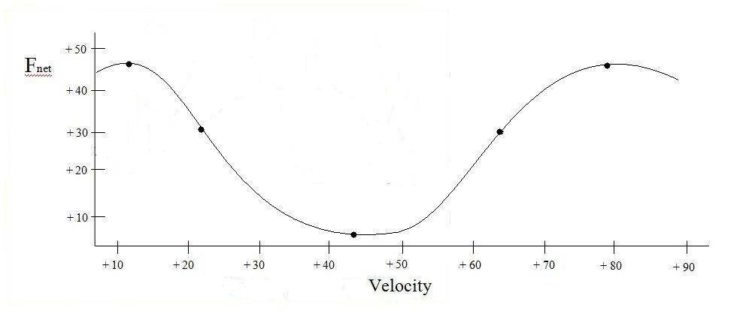
- Using the graph above, how many of the points on the graph above indicate a time when the object feels the greatest net force?
  - 1
  - 2
  - 3
  - 4
  - 5

- Using the graph above, how many of the points on the graph above indicate a time when the object is experiencing the greatest acceleration?
  - 1
  - 2
  - 3
  - 4
  - 5

- Using the graph above, how many points on the graph above indicate a time when the object is moving the fastest?
  - 1
  - 2
  - 3
  - 4
  - 5

