Astronomy Assessment and TPS Questions:
Star Charts

- How many constellations do astronomers officially recognize today?
- 50
- 88
- 134
- 180

- Well-known, “connect-the-dot” star patterns are called
- asterisms.
- constellations.
- star maps.
- the Milky Way.
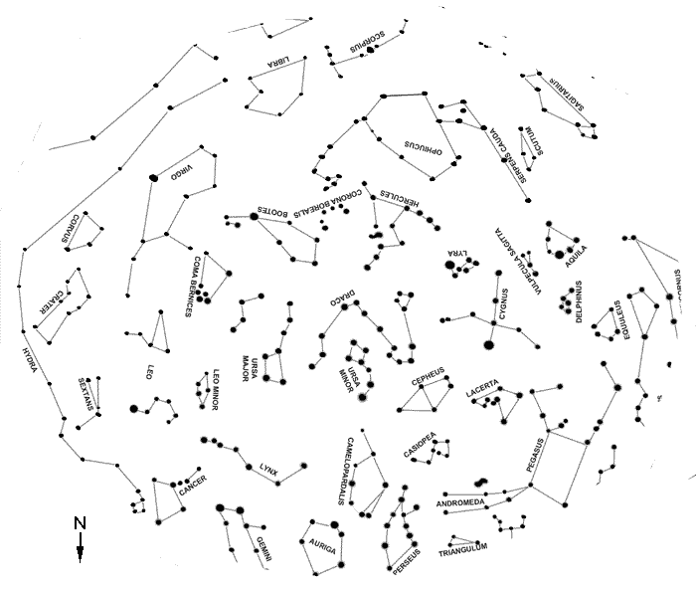
The star map provided below shows the sky at midnight on July 1 as seen from Tucson. Use this star map to answer the next two questions.

- What is the name of the star group that will appear high in the southern part of the sky at midnight?
- Auriga
- Ursa Major
- Draco
- Corona Borealis
- Scorpius

- What is the name of the star group that will appear near the horizon when looking to the east at midnight?
- Auriga
- Scorpius
- Draco
- Equuleus
- Crater
Which letter on the map at right shows:

- Betelgeuse?

- Canis Major?

- A blue supergiant star in Orion?

- Gemini?

Which letter on the map at right shows:
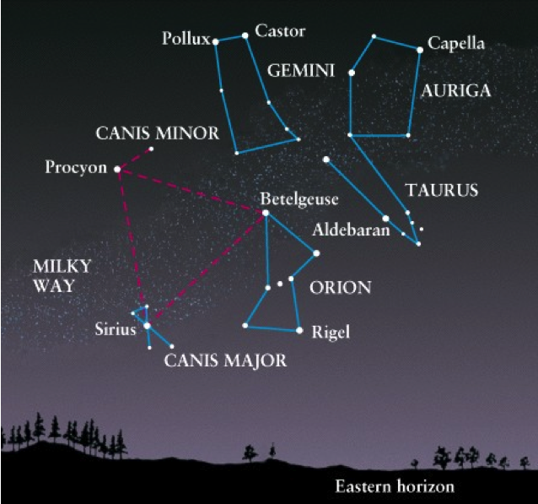
(A)
star name
(B)
star name
(C)
star name
(D)
constellation
(E)
star name
- Betelgeuse?

- Sirius?

- a blue supergiant star in Orion?

- Gemini?

Which letter on the map at right shows:
G) Constellation
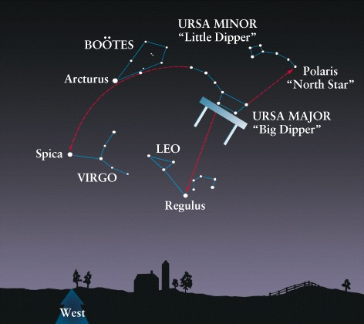
B
A
C
D
E
- Spica?

- Boötes?

- Leo?

- Arcturus?

