Astronomy Assessment and TPS Questions:
Making Sense of the Universe and Expansion

- Planet Rufus is 3 billion light years away from Earth. How big is Planet Rufus’s observable universe?
  - The same size as ours
  - Bigger than ours
  - Smaller than ours

- In the “balloon” analogy, what does the inside of the balloon represent?
  - Space and time
  - The center of the universe
  - Nothing, it doesn’t exist
  - Where the universe used to exist

- What is the shape of our current universe?
  - Sphere
  - Cube
  - Triangle
  - None of the above

- Which of the following things does the universe not have?
  - Dark matter
  - An accelerating rate of expansion
  - A dimension of time
  - A center

- In the balloon model of the expanding universe, which of the following parts represent aspects of the real universe?
  - The space inside the balloon
  - The surface of the balloon
  - The space outside of the balloon
  - More than one of the above

- Which of the following statements about the observable universe is correct?
  - It includes all the galaxies in the universe
  - It is the same size for all possible vantage points
  - It extends to the edge of the universe
  - It includes the same region of space for all possible vantage points

- In a balloon model of the universe, why would it be better to represent galaxies as pins stuck in the balloon instead of dots drawn with marker on the balloon?
  - Galaxies are all exactly the same size, just like the pins would be.
  - Marker dots would expand as the balloon did, and galaxies are not expanding.
  - The pins would stick through the surface of the balloon into the center, which is also part of the model.
  - The pins would keep the balloon from expanding too fast by causing air to leak out.

- The universe is 14 billion years old. If the universe is not expanding, how long will it be until a galaxy 17 billion light-years away is at the edge of our observable universe?
  - 17 billion years
  - 14 billion years
  - 3 billion years
  - The observable universe does not have an edge.

A | The real universe has no center
B | The real universe has no edge
C | The real universe expands
D | The real universe has no definite shape
E | The real universe is 4-dimensional

- Use the above chart to answer this question. How many of the above characteristics of the universe (A-E) are accurately represented by the surface of the balloon in the balloon analogy?
  - 1
  - 2
  - 3
  - 4
  - All 5

A | The balloon has a defined shape
B | The balloon expands
C | The balloon has an inside and an outside
D | The balloon expands into already existing space
E | The balloon’s surface has no edge

- Use the above chart to answer this question. How many of the above characteristics of balloon in the balloon analogy (A-E) are also true for the real universe?
  - 1
  - 2
  - 3
  - 4
  - All 5

- If the edge of the observable universe were 10 billion light years away, how many of the following would be true?
- The universe would be younger than it is now
- Someone in a galaxy at the edge of our observable universe would be able to see 10 billion light years in our direction, but would see only the dark edge of the universe in the opposite direction.
- We wouldn’t be able to see as many stars and galaxies as we can now.
- The center of the universe would be closer to us.

- Only 1
- 2
- 3
- 4
- None of the above

- The universe is X years old as of today. Light could not yet have reached us from how many light years away?
  - X light years away
  - X minus 1,000 light years away
  - X plus 1,000 light years away
  - .5X light years away

- Galaxy X and Galaxy Y are 8 billion light-years apart in an expanding universe. If light leaves Galaxy Y today, then how far apart will the two galaxies be by the time that light reaches Galaxy X?
  - They will be more than 8 billion light years apart.
  - They will be less than 8 billion light years apart.
  - They will be exactly 8 billion light years apart.

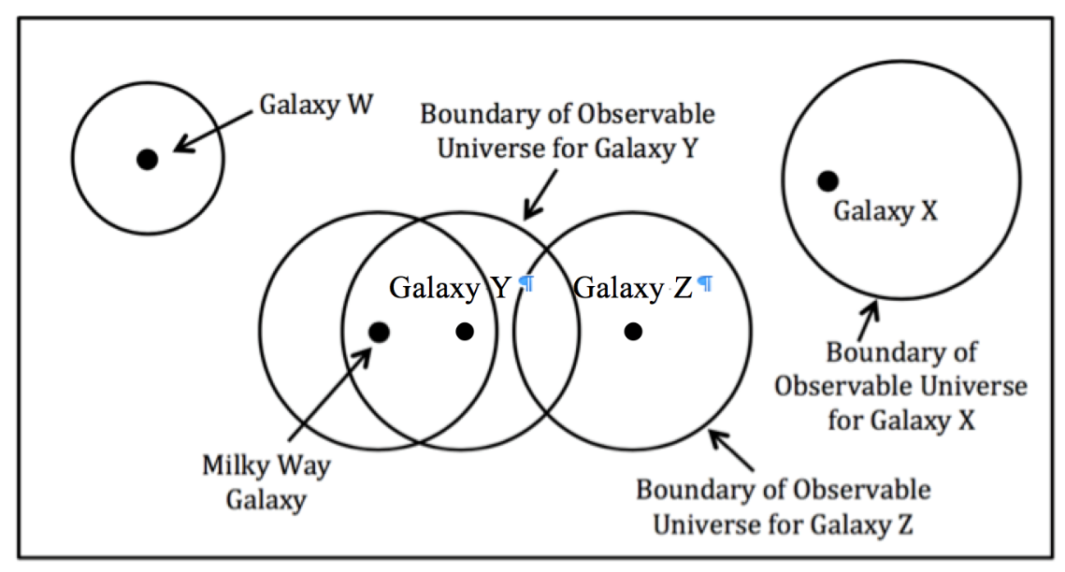

- If the Observable Universe shown above for the Milky Way Galaxy is correct in the above drawing, then how many of the observable galaxies drawn above for Galaxies W, X, Y and Z are also correct.
- Only one
- Two
- Three
- All four.

