Astronomy Assessment and TPS Questions:
Gravitational Microlensing

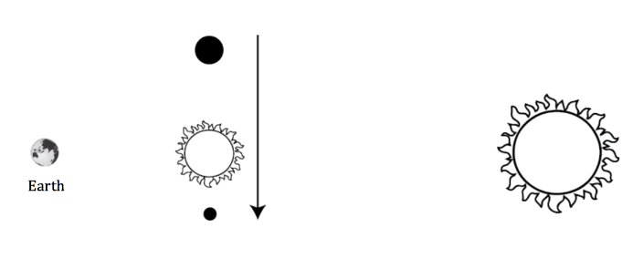
- Which of the below graphs correctly represents the observed brightness vs. time of the background star, as a result of the microlensing caused by the extrasolar planet system shown at right?

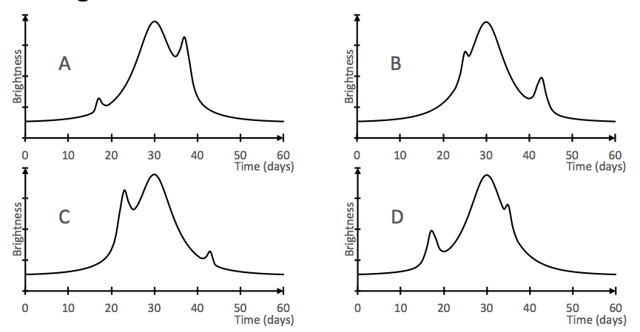

- Which of the four brightness vs. time graphs below best represents the microlensing caused by a low-mass planet orbiting a high-mass star?

