Astronomy Assessment and TPS Questions:
Solar vs. Sidereal Day-Ecliptic

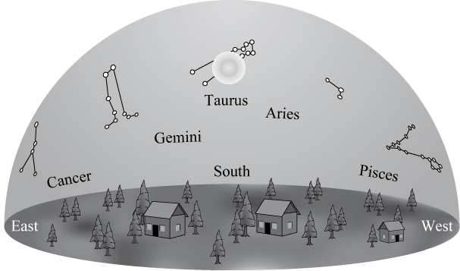
Use the drawing below to answer the next four questions.

- If you could see stars during the day, the drawing above shows what the sky would look like at noon on a given day. The Sun is near the stars of the constellation Taurus. Near which constellation would you expect the Sun to be located at sunset on this day?
a. Pisces
- Taurus
- Aries
- Cancer
- Gemini

- If you could see stars during the day, the drawing above shows what the sky would look like at noon on a given day. The Sun is near the stars of the constellation Taurus. Near which constellation would you expect the Sun to be located at 6am on this day?
  - Pisces
  - Aries
  - Cancer
  - Taurus
  - Gemini

- Which constellation will be highest in the sky 6 hours after the time shown in the drawing above?
  - Pisces
  - Cancer
  - Gemini
  - Taurus
  - Aries

- Which constellation in the drawing above will be highest in the sky at sunset?
  - Pisces
  - Gemini
  - Taurus
  - Aries
  - Cancer

- In general, individuals get their horoscope birth signs from
- the constellation that is overhead at midnight when they are born.
- the constellation that is hidden by the Sun when they are born.
- the constellation that is most like their personalities.
- tracking the changing positions of the planets.

- Which of the following descriptions of Zodiacal constellations best defines the birth sign of a person?
- Scorpius is in the east at sunset.
- Cancer is high in the southern sky at sunrise.
- Libra is on the eastern horizon at noon.
- Taurus is on the western horizon at sunset.
- Taurus
- Libra
- Cancer
- Scorpius

- Based on the locations of the constellations described below, what would be the sign of a person born on this day?
- Taurus is high in the southern sky at sunset
- Aquarius is on the eastern horizon at sunrise.
- Scorpius is on the western horizon at noon.
- Leo is high in the southern sky at midnight.
- Taurus
- Aquarius
- Scorpius
- Leo

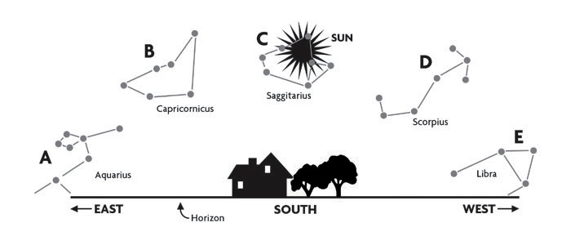
- Which of the following is the best ranking for the constellations shown above (A - E) in the order that they will appear from highest in the sky to farthest below the horizon, 3 hours before the time shown.
              - C, D=B, A=E
              - A, B, C, D, E
              - D, C=E, B, A
              - E, D, C, B, A
              - B, A=C, D, E

