**Astronomy Assessment and TPS Questions:**

**Galaxy Classification**

1. Why are the spiral arms of spiral galaxies typically blue in color?
   1. They are usually moving toward us and are Doppler shifted to blue wavelengths.
   2. The gas and dust in the arms filter out all but the blue light from stars in the arms.
   3. Stars are forming in the spiral arms so there are many more high mass, hot, blue stars.
   4. Almost all the stars of the disk are in the arms of the galaxy and their light makes it appear blue.

-----------------------------------------------------------------------------------------------------------------

Use the three images of galaxies shown at right (**A**, **B**, and **C**) to answer the following three questions

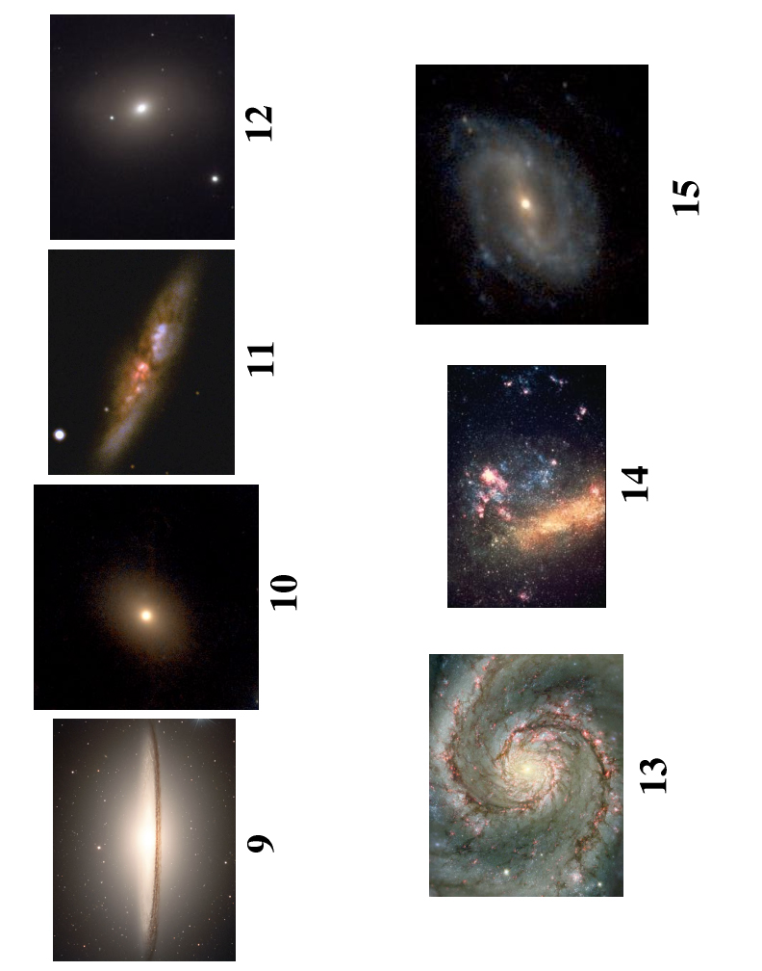

**A**

**B**

**C**

1. In which of the galaxies would you expect to see many bright blue stars (choose all that apply)?

1. In which of the galaxies would you expect to see mostly red stars (choose all that apply)?
2. In which of the galaxies would you expect to see regions of abundant gas and dust (choose all that apply)?

-----------------------------------------------------------------------------------------------------------------

1. In how many of the three galaxies shown below would you expect to see regions of abundant gas and dust?
   1. only one
   2. two
   3. all three
   4. none

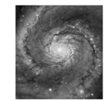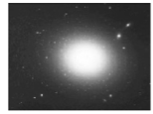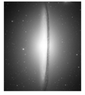

-----------------------------------------------------------------------------------------------------------------

Use the two images of galaxies shown below (**A** and **B**) to answer the following two questions.



Galaxy **B**

Galaxy **A**

1. In which of the galaxies would you expect to see many bright blue stars?
2. Only galaxy **A**
3. Only galaxy **B**
4. Both galaxies **A** and **B**
5. Neither galaxy **A** or **B**
6. In which one of the galaxies would you expect to see mostly red stars?
7. Only galaxy **A**
8. Only galaxy **B**
9. Both galaxies **A** and **B**
10. Neither galaxy **A** or **B**

-----------------------------------------------------------------------------------------------------------------

1. A galaxy that appears to have very few bright, blue stars, likely:
2. never had blue stars in the galaxy
3. had blue stars that are not present anymore but were at one time long ago
4. has been around long enough for the blue stars to have evolved into red main sequence stars
5. never contained enough gas to have blue stars develop
6. has blue stars that are being blocked by dust
7. The space between the spiral arms of the Milky Way contains
   1. density waves.
   2. little dust and few stars.
   3. about the same number of stars as in the arms.
   4. only reflection and emission nebulae.
8. How many of the four galaxies shown could be a Spiral Galaxy?

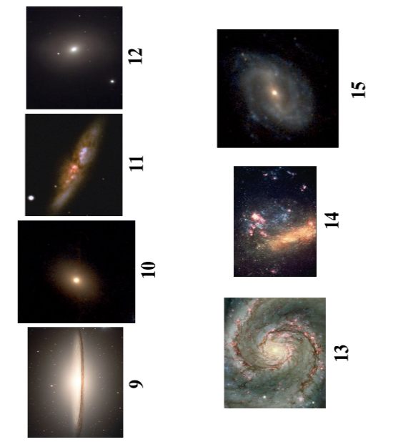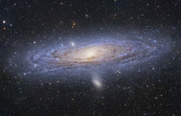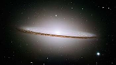

* 1. One
  2. Two
  3. Three
  4. Four
  5. There is insufficient information to determine this.

1. Why are the arms of spiral galaxies blue?
   1. The arms are usually moving toward us, so they are Doppler shifted to blue wavelengths.
   2. The gas and dust in the arms filter out all but the blue light from stars in the arms.
   3. Active star formation is occurring in the spiral arms.
   4. Most of the stars of the disk are in the arms of the galaxy and their light makes it appear blue.

-----------------------------------------------------------------------------------------------------------------

Assume the two galaxies shown have the same total number of stars. Answer the following three questions

1. Which of these two galaxies most likely has the fewest bright blue stars?



* 1. Galaxy **A**
  2. Galaxy **B**
  3. They have the same number of bright   
     blue stars.
  4. There is insufficient information to determine this.

**B**

**A**

1. Which type of galaxy has “arms”?
2. elliptical
3. spiral
4. both elliptical and spiral
5. none of the above
6. Which type of galaxy appears mostly red in color?
7. elliptical
8. spiral
9. both elliptical and spiral
10. neither appear mostly red

-----------------------------------------------------------------------------------------------------------------

1. Which of the types of light listed below do elliptical galaxies give off the greatest amount of?
   1. Blue light
   2. Red light
   3. X ray
   4. UV

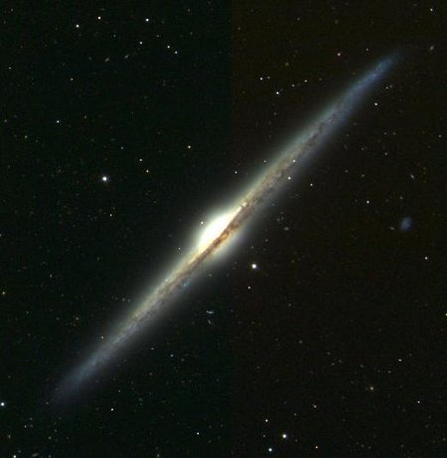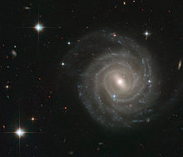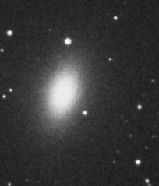

A B C

1. How many of the galaxies shown above are spiral galaxies?
   1. Only one
   2. Two
   3. All three
2. How many of the galaxies shown above are elliptical galaxies?
3. Only one
4. Two
5. All three

-----------------------------------------------------------------------------------------------------------------

1. Why do elliptical galaxies **not** produce new, young stars?
2. They are not massive enough.
3. They do not have enough gas and dust.
4. They do not experience enough internal pressure.
5. Elliptical galaxies actually do produce new, young stars.
6. Do spiral galaxies tend to produce many spectral types of stars, just a few, or only one?
7. Many
8. A few
9. Only one
10. During star formation, what kinds of new stars form in spiral galaxies?
11. Only blue stars, all the red stars are old
12. Only red stars, all the blue stars are old
13. All types of main sequence stars
14. Blue stars, red stars, white dwarfs and red giants
15. If you found many **B** spectral type stars in a galaxy, which kind of galaxy would you be observing?
16. elliptical
17. spiral
18. either an elliptical or a spiral
19. none of the above
20. Which of the following do elliptical galaxies contain?
21. **O**-type main sequence stars
22. **M**-type main sequence stars
23. **A**-type main sequence stars
24. Gas and dust
25. All of the above
26. Which of the following do spiral galaxies contain?
27. **O**-type main sequence stars
28. **M**-type main sequence stars
29. **A**-type main sequence stars
30. Gas and dust
31. All of the above
32. Which of the following exist in abundance only in spiral galaxies and not in elliptical galaxies?
33. Main sequence stars with long lifetimes
34. **M** type main sequence stars
35. Low mass main sequence stars
36. Very hot main sequence stars
37. Which type of galaxy contains star nurseries?
38. spiral
39. elliptical
40. both elliptical and spiral
41. none of the above
42. Which type of galaxy is more like a star nursing home?
43. spiral
44. elliptical
45. both elliptical and spiral
46. none of the above
47. Which pair of features of a spiral galaxy implicitly indicates star formation?
48. Halo & red light
49. Bright blue stars & dark areas of gas and dust
50. Old red stars & bright blue stars
51. Globular clusters & a bright halo
52. None of the above
53. Which type of stars are elliptical galaxies mostly composed of?
54. Main sequence stars with short lifetimes
55. Main sequence stars with large masses
56. Main sequence stars with cool temperatures
57. Main sequence stars with high luminosities
58. Red giants

-----------------------------------------------------------------------------------------------------------------

Use the images below to answer the following three questions



**A**

**B**

**C**

1. Using the images above, which of the galaxies has/have **only** old stars?
   1. **A**
   2. **B**
   3. **C**
   4. Only **B**&**C**
   5. All of the galaxies
2. Using the images above, which of the galaxies has/have lots of gas and dust?
3. **A**
4. **B**
5. **C**
6. Only **A**&**C**
7. All of the galaxies
8. In which type of galaxy would you find most of the stars to be red giants?
9. Elliptical galaxies
10. Spiral galaxies
11. Neither
12. Both

-----------------------------------------------------------------------------------------------------------------

Use the images below to answer the following three questions



A B C

1. How many of the galaxies shown above would you expect to have an abundant amount of gas and dust?
2. Only one
3. Two
4. All three
5. In how many of the galaxies shown above would you expect stars to be forming?
6. Only one
7. Two
8. All three
9. How many of the galaxies shown above would you expect to contain many O-type stars?
10. Only one
11. Two
12. All three

-----------------------------------------------------------------------------------------------------------------

1. You observe a galaxy that is producing almost no X-ray radiation. This galaxy is most likely a(n):
2. elliptical galaxy
3. spiral galaxy
4. It could be an elliptical or a spiral galaxy.
5. none of the above
6. When you view a spiral galaxy, why do you not see much red light?
7. Red stars are blocked by gas and dust.
8. All of the red stars have died out in spiral galaxies.
9. Blue stars in spiral galaxies are much brighter than red stars.
10. Spiral galaxies do not produce many red stars.
11. Which type of galaxy gives off red light?
12. elliptical
13. spiral
14. both elliptical and spiral
15. none of the above
16. Galaxies that appear blue _________.
17. Contain only blue stars
18. Contain mostly blue stars
19. Contain all types of stars
20. How would you expect the luminosity of a spiral galaxy to compare to the luminosity of an elliptical galaxy if they have the same number of stars?
21. The elliptical galaxy would be more luminous.
22. The spiral galaxy would be more luminous.
23. They would have the same luminosity.
24. What are the “dark” regions in the disks of spiral galaxies?
25. Places where there are no stars
26. Places where the stars do not give off visible light
27. Places where there is an abundance of black holes
28. Places where stars are currently forming



A B C

Energy

-----------------------------------------------------------------------------------------------------------------

Use the images above ??? and spectral curve below ????to answer the following two questions

X-ray UV VIS IR Radio

**wavelength**

long

short

1. Using the images and spectral curve above, how many of the galaxies could have this spectral curve as its/their overall light curve?
2. Only 1
3. 2
4. All 3
5. None

Wavelength

visible range

Energy Output per second

V I B G Y O R

1. Using the images and spectral curve above, how many of the galaxies could have this spectral curve as its/their overall light curve?
2. Only 1
3. 2
4. All 3
5. None

-----------------------------------------------------------------------------------------------------------------

1. Which of the following galaxy collisions could **not** produce a spiral galaxy?
2. an elliptical and a spiral colliding
3. two spirals colliding
4. two ellipticals colliding
5. 3 spirals colliding
6. All of the above could produce a spiral galaxy.
7. When the Milky Way eventually collides with another galaxy, which type(s) of galaxy could result from the collision?
8. spiral
9. elliptical
10. either an elliptical or a spiral galaxy could form
11. There is no way to tell.
12. If a combination of **any** two galaxies were to collide, which type(s) of galaxy could be produced from the collision?
13. elliptical
14. spiral
15. either an elliptical or a spiral galaxy could form
16. none of the above

-----------------------------------------------------------------------------------------------------------------



1. Use the picture above to answer this question. If in ten million years the galaxy shown above collides with a spiral galaxy, what could occur?
2. Only an elliptical galaxy could form
3. Only a spiral galaxy could form
4. Either an elliptical or a spiral galaxy could form
5. No new galaxy could form

-----------------------------------------------------------------------------------------------------------------

-----------------------------------------------------------------------------------------------------------------

Use the images below to answer the following three questions



**A**

**B**

**C**

1. Which of the galaxies shown above would be the result of an elliptical galaxy colliding with another elliptical galaxy?
2. **A**
3. **B**
4. **C**
5. **A** or **C**
6. All three
7. Use the three pictures above to answer. Which of the following is possible?
8. The collision of Galaxy **A** and Galaxy B can produce Galaxy **C**.
9. The collision of Galaxy **A** and Galaxy C can produce Galaxy **B**.
10. The collision of Galaxy **B** and Galaxy C can produce Galaxy **A**.
11. All of the above
12. None of the above



1. Use the image above to answer this question. Which of the following must be false about the galaxy shown?
2. It contains old stars.
3. It has active star formation.
4. It formed from the collision of two elliptical galaxies.
5. It contains red stars.
6. None of the above

-----------------------------------------------------------------------------------------------------------------

1. Which of the following is true of red giants?
2. They live much longer than main sequence stars.
3. They contribute the majority of red light responsible for giving elliptical galaxies a reddish color.
4. They are a relatively short phase within the life of a star.
5. They are too dim to contribute much to the reddish color of elliptical galaxies.
6. None of the above
7. How do you know the red light coming from elliptical galaxies cannot be mainly from red giants?
8. Red giants are not very luminous.
9. Red giants are too big to be the dominant star of the galaxy.
10. Because the red giant phase is very short, there are fewer red giants than other types of stars.
11. Most of the stars that exist over the lifetime of an elliptical galaxy never become red giants.
12. None of the above
13. How many of the following statements are true of a galaxy that contains active star formation?

* Has a very large central bulge and no arms
* Contains abundant gas and dust
* Emits most of its light as gamma rays
* Has many low-mass stars

1. Only 1
2. 2
3. 3
4. 4
5. The collision of a galaxy containing mostly **M**-type stars with a galaxy containing lots of gas and dust could create which kind of galaxy?
6. elliptical
7. spiral
8. either an elliptical or a spiral
9. none of the above
10. You are observing Galaxy **H**. A lot of the light you observe has very short wavelengths. Galaxy **H** most likely:
11. has almost no stars producing long wavelengths of light.
12. contains only low mass stars.
13. contains only very young stars.
14. has abundant gas and dust.
15. None of the above
16. Galaxy **A** has arms and many young stars. Galaxy **B** has a relatively low temperature and emits mostly low frequency light. They contain the exact same number of stars. Which galaxy is more massive?
17. Galaxy **A**
18. Galaxy **B**
19. They have the same mass.
20. Cannot tell based on information given