Astronomy Assessment and TPS Questions:
Motion of Extrasolar Planets

- Given the location marked with the dot on the star’s radial velocity curve, at what location (A-D) would you expect the planet to be located at this time?

Time
Radial Velocity
-10 m/s
- 20 m/s
A
C

D
B
Earth
Orbit of planet
Orbit of star
10 m/s
20 m/s

- Given the location marked with the dot on the star’s radial velocity curve, at what location (A-D) would you expect the planet to be located at this time?

A
C

B
D
Earth
Orbit of planet
Orbit of star
10 m/s
20 m/s
Radial Velocity
-10 m/s
- 20 m/s
Time

To answer the next two questions use the graphs shown below showing the radial velocity versus time for four stars (A-D) that have extra-solar planets orbiting them.
Time (years)
Velocity (m/s)
20
-20
1
3
Time (years)
Velocity (m/s)
20
-20
2
4
Time (years)
Velocity (m/s)
20
-20
3
6
Time (years)
Velocity (m/s)
20
-20
5
10
A
B
C
D
2
4
5
15
20
25
6
8
10
9
12
15

- From which star would we receive light red-shifted the least?

- Which star has an extra-solar planet with the shortest orbital period?

- Assume that the stars are identical and are orbited by identical planets. For which case would you expect the planet to be orbiting closest to the star?

- An exoplanet system containing two exoplanets is shown at right. You can see the transits of both planets from Earth. Graphs A and B below provide two possible graphs of the observed brightness of the star vs time.

Which graph best corresponds with the system?

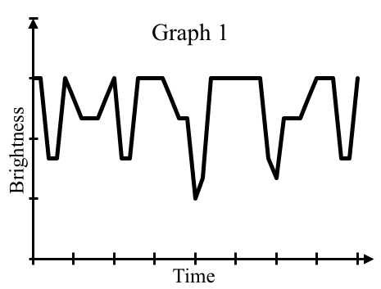
Graph A
Graph B

Below are two graphs (A and B) which each indicates the presence of one or more extrasolar planet orbiting a star. Use these graphs to answer the next four questions.

Graph A
Radial Velocity
Graph B
10 m/s
20 m/s
-10 m/s
- 20 m/s
Time (Years)
1
2

- Which graph(s) demonstrates that we can detect the presence of extrasolar planets by observing changes in the light we receive from a star.
- Only Graph A
- Only Graph B
- Both graphs
- Neither graph

- Which of the graphs indicates the presence of a planet with an orbital period equal to Earth’s orbital period about the Sun?
- Only Graph A
- Only Graph B
- Both graphs
- Neither graph

- Which of the following is the most correct regarding the situation illustrated in Graph A?
- There is only one extrasolar planet orbiting the star
- There is a small extrasolar planet that is close and a large extrasolar planet that is far from the star
- There is a large extrasolar planet that is close and a small extrasolar planet that is far from the star
- There is a small extrasolar planet and a large extrasolar planet which are the same distance away from the star
- There are three extrasolar planets orbiting the star

- Three different extrasolar planet systems (A, B, and C) are shown below. The masses of the planets and stars are provided along with the distance between them. Which star will give off light with the smallest Doppler shift?
B
3m_{planet}
3M_{Star}
1d
1d
C
3m_{planet}
1M_{Star}
A
3d
3M_{Star}
1m_{planet}

- Consider the graph shown below that depicts the light from a star with two exoplanets orbiting it. Which of the locations identified on the graph below (1, 2 and 3) correspond with the time when one planet is completely in front of the star while the second planet is only partially in front of the star?
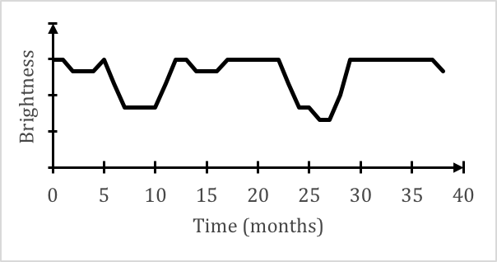
1
2
3

  - location 1
  - location 2
  - location 3
  - none of the locations

- The two graphs at right each show the change in light from a star that is orbited by an extrasolar planet. One graph corresponds with a large extrasolar planet that is close to its star, and the other graph corresponds with a small extrasolar planet that is far from its star. Which of the following statements best describes an error in how one or both of the graphs are drawn.
  - The dips for the large extrasolar planet are to shallow
  - The dips for the small extrasolar planet are too wide
  - The sides of the dips are too steep
  - The graphs are drawn correctly for the information given

- Given the location marked on the star's radial velocity curve, at which location in the planet's orbit would you expect the planet to be?

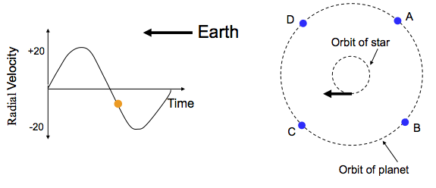

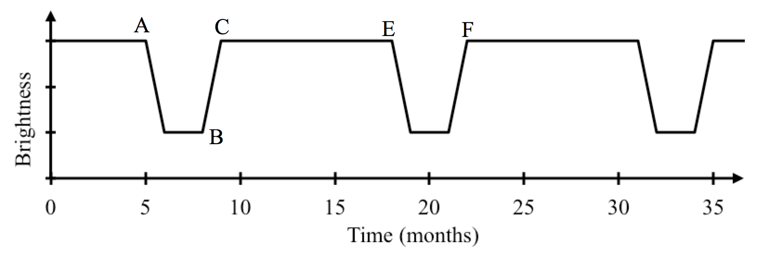
- From ____ to ____, the leading edge of the exoplanet first starts to cross nearest edge of its parent star to just starting to cross the far edge of its parent star.
- A to B
- B to C
- A to C
- C to E
- E to F

- From ____ to ____, the exoplanet does not block any light from its parent star.
- A to B
- B to C
- A to C
- C to E
- E to F

- From ____ to ____ , the exoplanet goes through one full orbit of its parent star.
- A to C
- A to B
- C to E
- A to E
- A to F

- How does the planet’s location in orbit relate to the star’s location in orbit?
  - The planet is always on the same side of the orbit as the star
  - The planet is always on the opposite side of the orbit as the star
  - The planet’s location always is independent of the star’s location in orbit

- How does the direction of the planet’s orbit relate to the direction of the star’s orbit?
  - If the planet orbits counterclockwise then the star orbits clockwise
  - If the planet orbits clockwise then the star orbits counterclockwise
  - If the planet orbits counterclockwise then the star also orbits counterclockwise

- In an extrasolar planet system, which takes longer to complete one orbit?
  - The star
  - The planet
  - They take the same amount of time.

- In an extrasolar planet system, what takes longer to complete one orbit?
  - The star, because it is moving slower
  - The planet, because it has a larger orbit
  - They both take the same amount of time to complete one orbit

- In an extrasolar planet system, what moves faster?
  - The star
  - The planet
  - They both move at the same speed

- Planet Uno is orbiting Star Q. Which of the following would take the greatest amount of time?
  - The orbital period for Planet Uno
  - The orbital period for Star Q
  - Their orbital periods take the same amount of time.

- The planet and star in an orbital system are always________.
  - located opposite each other
  - on the same side of the orbit
  - changing positions, so one year they could be opposite and the next they’re not
  - orbiting in opposite directions
  - More than one of the above is correct

- How will a star and its orbiting planet move relative to each other?
  - They will always move in the same direction.
  - They will always move closer to each other.
  - They will always move in opposite directions.
  - None of the above

- A planet in a solar system will orbit around _______.
  - the center of the star
  - the center of mass
  - the midpoint between the star and the planet

- What would best describe the orbit of an extra-solar planetary system?
  - The planet orbits around the star
  - The star orbits around the planet
  - They both orbit a common center of mass
  - None of the above

- Where would the center of mass be for an orbiting system consisting of the Sun and your backpack?
  - Halfway between the 2 objects
  - Inside of the Sun
  - Inside of the backpack
  - None of the above

- In an extra-solar planetary system, which of the following is always the same for the planet and the star?
  - Orbital period
  - Direction of motion
  - Location in orbit
  - Speed
  - Mass

- If a star’s light is neither redshifted nor blueshifted, the planet is moving
  - toward Earth.
  - away from Earth.
  - perpendicular to your line of sight from Earth.
  - independent of the motion of the star.

- How must the plane of the orbits in an extra-solar planetary system be oriented if we are never able to detect a Doppler shift in the star’s light?
  - It must be very far from Earth
  - It must be parallel to the line of sight from Earth
  - It must be perpendicular to the line of sight from Earth
  - It must be small in diameter compared to its distance from Earth

- While watching a planet orbiting a star, you notice that the Doppler shift in the light of the star is becoming increasingly blueshifted. What must be happening to cause this?
  - The star’s speed is increasing toward you
  - The star’s speed is increasing away from you
  - The star’s speed is decreasing toward you
  - The star’s speed is decreasing away from you

Use the graphs below to answer the following three questions.
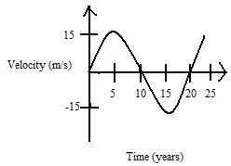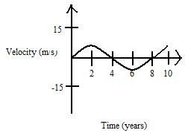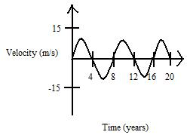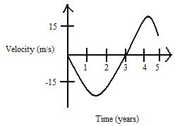
C
D
B
A

- Use the radial velocity curves above to answer this question. Which star appears to have the largest Doppler shift?

- Use the radial velocity curves above to answer this question. Which star has the shortest orbital period?
  - A
  - B
  - C
  - D
  - More than one of the above

- Use the radial velocity curves above to answer this question. Rank the stars’ orbital periods from largest to smallest.
  - D>A>B>C
  - A>B=C>D
  - D>A=B>C
  - A>B>C>D

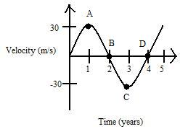

- Use the above graph to answer the question. How long is this star’s orbit?
  - 1 year
  - 2 years
  - 3 years
  - 4 years
  - 5 years

- Use the above graph to answer the question. At what point (A-D) is the star’s light blueshifted the most?

Orbit of star
Orbit of planet
Towards
Earth
B
A
D
C
2
3
4
1

- In the diagram above, when the planet is in position D where is the star?
  - Position 1
  - Position 2
  - Position 3
  - Position 4

- In the diagram above, an observer on Earth would notice the greatest redshift in the star’s light while the planet is at which position in orbit?
  - A
  - B
  - C
  - D

Time (years)Time (years)
Velocity (m/s)
2020
-20-20
11
3
Time (years)
Velocity (m/s)
20
-20
2
4
Time (years)
Velocity (m/s)
20
-20
3
6
Time (years)
Velocity (m/s)
20
-20
3
6
A A
B
C
D
2
4
5
9
12
15
5
8
10
9
12
15

- Using the radial velocity graphs for Stars A-D (which all have one planet orbiting them), which of the stars would you expect to be located on the opposite side of its orbit compared to its companion planet?
  - Star A
  - Star B
  - Star C
  - Star D
  - All of the above

- Using the radial velocity graphs for Stars A-D (which all have one planet orbiting them), from which star would you observe the smallest blueshift?
  - Star A
  - Star B
  - Star C
  - Star D
  - Cannot be determined from information provided

- Using the radial velocity graphs for Stars A-D (which all have one planet orbiting them), which star has the shortest orbital period?
  - Star A
  - Star B
  - Star C
  - Star D
  - Cannot be determined from information provided

- Using the radial velocity graphs for Stars A-D (which all have one planet orbiting them), which star has the planet with the longest orbital period?
  - Star A
  - Star B
  - Star C
  - Star D
  - Cannot be determined from information provided

- In an extrasolar planet system, a star with a negative radial velocity will be_______ while its planet is moving_______.
  - blueshifted, away from Earth
  - blueshifted, toward Earth
  - redshifted, away from Earth
  - redshifted, toward Earth

- Which of the following results in the largest Doppler shift?
  - A very high mass planet, a high mass star, and a large distance between the two
  - A very high mass planet, a low mass star, and a large distance between the two
  - A very high mass planet, a low mass star, and a small distance between the two
  - A low mass planet, a low mass star, and a large distance between the two
  - A high mass planet, a high mass star, and a small distance between the two

- Which combinations of characteristics for an extrasolar planet system would cause a star to experience a large Doppler shift?
  - It is a low mass star with a small mass planet orbiting close to the star
  - It is a high mass star with a small mass planet orbiting far away from the star
  - It is a low mass star with a large mass planet orbiting close to the star
  - It is a high mass star with a large mass planet orbiting far away from the star

- While watching a planet orbiting a star, you notice that the Doppler shift in the light of the star is becoming increasingly blueshifted. If you come back to observe this system again ½ of a period later, what will be happening?
  - The planet’s speed will be increasing toward you
  - The planet’s speed will be increasing away from you
  - The planet’s speed will be decreasing toward you
  - The planet’s speed will be decreasing away from you

- You are observing an extrosolar planet system where there is a large-mass planet that is in a close orbit around a low-mass star. If the planet is moving away from you, which of the following will be correct?
  - The star’s light will be slightly redshifted
  - The star’s light will be slightly blueshifted
  - The star’s light will be blueshifted by a large amount
  - The star’s light will be redshifted by a large amount

- While watching a planet orbiting a star, you notice that the Doppler shift in the light of the star is becoming increasingly blueshifted. What must be happening?
  - The planet’s speed is increasing toward you
  - The planet’s speed is increasing away from you
  - The planet’s speed is decreasing toward you
  - The planet’s speed is decreasing away from you

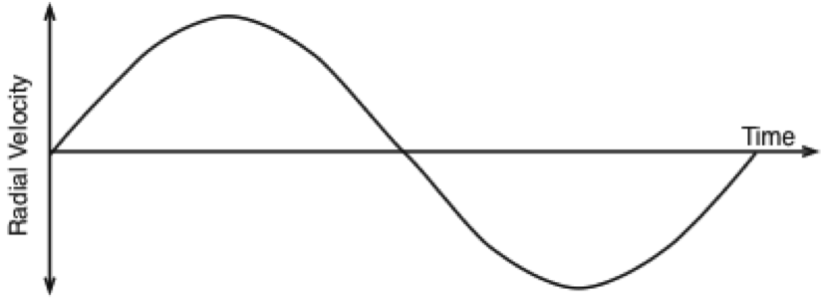
2
3
1

4
+20
-20

- Use the diagram above to answer the question. At which point on the curve is the light of the star the most redshifted?
  - 1
  - 2
  - 3
  - 4
  - More than one of the above

- Use the diagram above to answer the question. At which point on the curve is the light of the star neither redshifted nor blueshifted?
  - 1
  - 2
  - 3
  - 4
  - More than one of the above

- Use the diagram above to answer the question. At which point is the light of the star the most blueshfited?
  - 1
  - 2
  - 3
  - 4
  - More than one of the above
Time (years)
-20
20
1
A
Velocity (m/s)
3
2
4
5

Use the figure above to answer the following 2 questions.

- Using the radial velocity graph for Star A (which has one planet orbiting it), at the time indicated by the arrow, where is Star A?
  - At the point in its orbit that is farthest from Earth
  - At the point in its orbit that is closest to Earth
  - Halfway between its closest and farthest points from Earth
  - Cannot be determined from the information provided

- Use the radial velocity graph for Star A (which has one planet orbiting it). Star A is at the time indicated by the arrow. How long will it be until its planet reaches the same point in its orbit?
  - About 3 years
  - About 1.5 years
  - About 6 years
  - The planet is already at the same point in its orbit
  - Cannot tell from information provided

Use the graphs below to answer the following question.
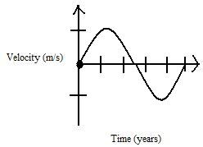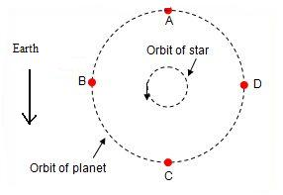

- For the location marked on the radial velocity graph, at what position (A-D) would you find the planet?

A
C

B
D
Earth
Orbit of planet
Orbit of star
10 m/s
20 m/s
Radial Velocity
-10 m/s
- 20 m/s
Time
1

3
4
2

- Use the diagrams above to answer the question. The point marked by 4 on the star’s radial velocity curve corresponds with which location of the planet in the orbit?
  - A
  - B
  - C
  - D

- Use the diagrams above to answer the question. The location marked by D on the planet’s orbit corresponds with which point on the star’s radial velocity curve?
  - 1
  - 2
  - 3
  - 4

- Use the diagrams above to answer the question. The planet is moving away from Earth at which interval in time shown on the star’s radial velocity graph?
  - Between 1&2
  - Between 2&3
  - Between 3&4

Time (years)
Velocity (m/s)
20
-20
1
3
Time (years)
Velocity (m/s)
20
-20
2
4
Time (years)
Velocity (m/s)
20
-20
3
6
Time (years)
Velocity (m/s)
20
-20
5
10
A
B
C
D
2
4
5
15
20
25
6
8
10
9
12
15

To answer the next two questions use the graphs shown above showing the radial velocity versus time for four stars (A-D) that have extra-solar planets orbiting them.

- Use the graphs above to answer this question. Assume that the stars are identical and the planets are equally distant from their respective stars. For which case would you expect the planet to be the most massive?
  - A
  - B
  - C
  - D
  - Insufficient information to answer

- Imagine you are observing an extrasolar planet system including Star Alpha and Planet Lambda. One year on Planet Lambda is 6 Earth months. From the redshift in the light from Star Alpha, you determine that the star has a radial velocity of 100 m/s. Which of the following could be the radial velocity of Planet Lambda 3 Earth-months later?
  - 100 m/s
  - -100 m/s
  - 200 m/s
  - -200 m/s
  - None of the above

