Astronomy Assessment and TPS Questions:
Binary Stars

- From which binary star system (made up of two main sequence stars) described below would an Earth observer detect the least amount of total light?
  - When a star with an absolute magnitude of 8.0 is in front of a star with an absolute magnitude of -2.0.
  - When a star with an absolute magnitude of 2.0 is behind a star with an absolute magnitude of -2.0.
  - When a star with an absolute magnitude of 8.0 is behind a star with an absolute magnitude of 2.0.
  - When a star with an absolute magnitude of 8.0 is in front of a star with an absolute magnitude of 2.0.
  - When a star with an absolute magnitude of 8.0 is behind a star with an absolute magnitude of -2.0.

- Consider the two following binary star systems (both systems are 10 parsecs away)

- Binary Star System A: an O-type Main Sequence Star in front of a G-type Main Sequence Star
- Binary Star System B: an O-type Main Sequence Star in front of a M-type White Dwarf

From which Binary Star System will you receive the most light?
  - Binary Star System A
  - Binary Star System B
  - You would receive the same amount of light from both binary star systems
  - It is impossible to tell from the given information

- Consider the two following binary star systems (both systems are 10 parsecs away)

- Binary Star System A: an M-type Red Giant in front of a A-type Main Sequence Star
- Binary Star System B: an M-type Red Giant in front of a B-type White Dwarf

From which Binary Star System will you receive the most light?
  - Binary Star System A
  - Binary Star System B
  - You would receive the same amount of light from both binary star systems
  - It is impossible to tell from the given information

- For a white dwarf to become a nova, it is necessary for it to
- have a companion
- become a black hole.
- have begun life as a high-mass star.
- expand into a giant.

- Which of the graphs would correspond with an F spectral type main sequence star orbiting a K spectral type Red Giant star in a binary star system? If none of the graphs is correct, bubble in an “e”.
A
Brightness
Brightness
Brightness
Brightness
B
C
D
- Which of the graphs (A-D) would correspond with a B spectral type main sequence star orbiting a K spectral type Red Giant star in a binary star system? If none of the graphs is correct, bubble in an “e”.
A
Brightness
Brightness
Brightness
Brightness
B
C
D
-----------------------------------------------------------------------------------------------------------------

Use the graph below to answer the following two questions
A.
B.
C.
The sketches below illustrates how two main sequence stars might look at three different times. Use this set of sketches to answer the next two questions. Note: The sketch with the small circle shown with dashed lines illustrates the time when the smaller star was located behind the larger star.

- In which case shown would the amount of light we would observe from Earth be the least.
- at time A
- at time B
- at time C
- At more than one of the times.
- There is not enough information to determine this.

- In which case shown would the amount of light we would observe from Earth be the greatest.
- at time A
- at time B
- at time C
- At more than one of the times.
- There is not enough information to determine this.
-----------------------------------------------------------------------------------------------------------------

- When would you receive the least amount of light from a binary star system consisting of a M5 Red Giant and an M5 main sequence star?
  - When the Red Giant is in front of the main sequence star.
  - When the main sequence star is in front of the Red Giant.
  - You would receive the same amount of light for both situations described in choices “a” and “b”.

- Which of the following is true of a binary star system consisting of a Red Giant and a White Dwarf?
- You will receive more energy when the dwarf is behind the giant than when the giant is behind the dwarf.
- The time it takes for the dwarf to pass behind the giant is shorter than the time for the giant to pass behind the dwarf.
- The force of gravity exerted on the dwarf by giant is stronger than the force of gravity exerted of the giant on the dwarf.
- The orbital period of the dwarf is shorter than the orbital period of the giant.
- None of the above.
-----------------------------------------------------------------------------------------------------------------

Use the graph below to answer the following three questions
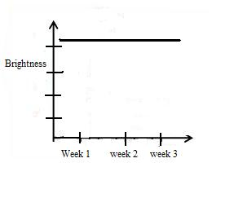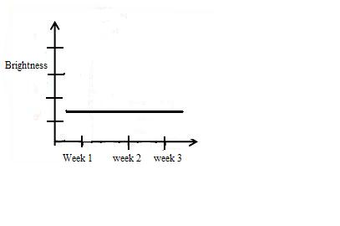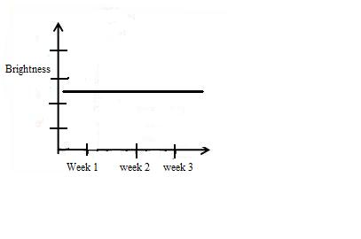
A B C
The graphs above represent the light from 2 different main sequence stars as well as the light from both of them combined.

- Using the graphs above, which graph represents the coldest star?
  - Graph A
  - Graph B
  - Graph C

- Using the graphs above, which Graph represents the hottest star?
  - Graph A
  - Graph B
  - Graph C

- Using the graphs above, which Graph represents both of the stars’ light?
  - Graph A
  - Graph B
  - Graph C

-----------------------------------------------------------------------------------------------------------------

Use the graph below to answer the following three questions

Brightness

Time

1 2 3 4 5 6 7 8 9 10 11 12

- Using the graph above, how many stars are involved in the process shown by the graph?
  - 1
  - 2
  - more than 2
  - cannot tell based on information provided

- Using the graph above, which dip in the graph takes up a greater amount of time?
  - the shallow dip
  - the deeper dip
  - Both dips take the same amount of time.

- Using the graph above, during which time interval(s) is the least amount of light being observed?
  - 0-3 and 7-9
  - 4-6
  - 10-12
  - None of the above
-----------------------------------------------------------------------------------------------------------------

- If you are observing two nearby stars of different brightness, when will you observe the most light?
  - When they are side by side
  - When the brighter star is in front of the dimmer star
  - When the dimmer star is in front of the brighter star
  - The amount of light you see has nothing to do with the position of the stars.

- In a binary star system consisting of a red giant and a white dwarf, what would take the most time?
  - For the red giant to pass behind the white dwarf
  - For the white dwarf to pass behind the red giant
  - For the white dwarf to make a complete revolution around the red giant
  - All of the above take the same amount of time
- In a binary with two stars of different size, when is a larger total area blocked?
  - When the big star is in front of the small star
  - When the small star is in front of the big star
  - You lose the same amount of area no matter which star is in front.

- If you have two stars orbiting each other, what would produce the largest dip in the overall brightness of the two stars?
  - The colder star goes in front of a hotter star
  - The hotter star goes in front of a colder star
  - The stars are both fully visible
-----------------------------------------------------------------------------------------------------------------

Use the graph below to answer the following three questions
Brightness
Time
1
2
3
5
4
7
6
8
9
10
11
12

- Using the graph above, which of the following statements about the stars shown in the graph are true?
  - One star is bigger because one dip is lower than the other.
  - One star is brighter because one dip is lower than the other.
  - The stars are the same brightness because the dips are the same length.
  - The stars are the same size because the dips are the same length.

- Using the graph above, what is happening during time interval 3-4?
  - The brighter star is passing in front of the dimmer star.
  - The dimmer star is passing in front of the brighter star.
  - The brighter star is fully behind the dimmer star.
  - The dimmer star is fully behind the brighter star.
  - None of the above

- Using the graph above, what is happening during the time interval 9-10?
  - The brighter star is passing in front of the dimmer star.
  - The dimmer star is passing in front of the brighter star.
  - The brighter star is fully behind the dimmer star.
  - The dimmer star is fully behind the brighter star.
  - None of the above
-----------------------------------------------------------------------------------------------------------------
- The two stars that created the light curve above are Main Sequence stars. One is an A spectral type and the other is an F spectral type. During time interval 10-12, what is happening?
  - The stars are side by side.
  - The A star is in front of the F star.
  - The F star is in front of the A star.
  - The stars are blueshifted.
  - None of the above

- When two different sized stars orbit each other, the bottom of the dip in the graph of overall brightness has to be flat. Why?
  - The light that is blocked takes a while to reach us causing a “lag” in time which appears as a flat dip in the bottom of the graph
  - Since the brighter star is bigger, it represents the true luminosity of the brighter star
  - It takes a long time for a star to pass in front of another

- A binary star system consists of a main sequence O type star and a red giant. When would more light be lost?
  - When the O type star passes in front of the red giant
  - When the red giant passes in front of the O type star
  - An equal amount of light is lost both times

- Consider the following binary star systems:
- System A: A type O white dwarf in front of a type M main sequence star
- System B: A type O main sequence star in front of a type M red giant
From which binary star system would you receive the most light?
- Binary Star System A
- Binary Star System B
- You would receive the same amount of light from both binary star systems
- It is impossible to tell from the given information

- Stars A and C are main sequence stars in a binary star. When Star C passes in front of Star A, more light is visible from Earth than when Star A passes in front of Star C. What can you determine about Stars A and C?
  - Star A must be smaller than Star C
  - Star A must have shorter peak wavelength than Star C
  - Star A must be more massive than Star C
  - Star C must be cooler than Star A

-----------------------------------------------------------------------------------------------------------------

Use the graphs below to answer the following two questions

- In the graph of a binary star system, how could the dips in overall brightness be the same size?
  - A spectral type A main sequence star is orbiting a spectral type O main sequence star
  - One star is not on the main sequence
  - A spectral type M main sequence star is orbiting a spectral type K main sequence star
  - More than one of the above are correct
  - You can never have two dips the same size

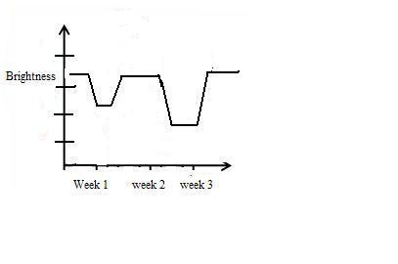

- How many of the graphs above are possible for a binary star system?
  - Only 1
  - 2
  - 3
  - 4
  - All 5
-----------------------------------------------------------------------------------------------------------------

-----------------------------------------------------------------------------------------------------------------

Use the graph below to answer the following three questions

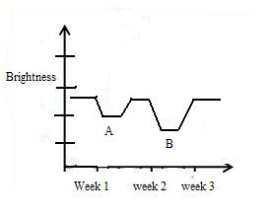
- Using the graph above, which location corresponds to the time in which the larger star passes in front of the smaller star?
  - Location A
  - Location B
  - You cannot tell from this information

- Using the graph above, which location corresponds to the time when the more luminous star passes in front of the dimmer star?
  - Location A
  - Location B
  - You cannot tell from this information

- Using the graph above, which location corresponds to the time when a Red Giant passes in front of an O type star?
  - Location A
  - Location B
  - You cannot tell from this information

-----------------------------------------------------------------------------------------------------------------

Use the graphs below to answer the following four questions
A
Brightness
Time
1
2
3
5
4
7
6
8
9
10
11
12

B
Brightness
Time
11
22
33
55
44
77
66
88
99
10
1111
12112

C
Brightness
Time
1
2
3
5
4
7
6
8
9
10
11
12

- Using the graphs above, how many of the light curves are possible for a binary with 2 main sequence stars?
  - 1
  - 2
  - 3
  - None

- Using the graphs above, which of the following binary pairs could produce light curve A?
  - A red giant and an M-type main sequence star.
  - A G-type main sequence star and an F-type main sequence star
  - A red giant and an O-type main sequence star of the same size
  - Two F-type main sequence stars of exactly the same size
  - None of the above

- Using the graphs above, which of the following binary pairs could produce light curve B?
  - A red giant and an M-type main sequence star.
  - An O-type main sequence star and an A-type main sequence star
  - A red giant and an O-type main sequence star of the same size
  - Two K-type main sequence stars of exactly the same size
  - None of the above

- Using the graphs on the previous page, which of the following binary pairs could produce light curve C?
  - A red giant and an M-type main sequence star.
  - A B-type main sequence star and a G-type main sequence star
  - A red giant and an O-type main sequence star of the same size
  - Two G-type main sequence stars of exactly the same size
  - None of the above

