Astronomy Assessment and TPS Questions:
Seasons
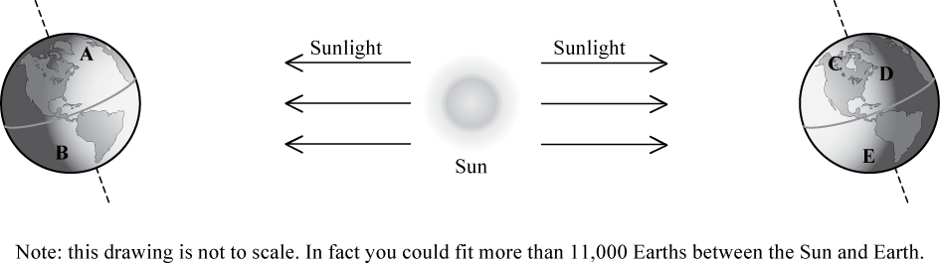

Use the image above to answer the next three (3) questions.

- Which lettered position (a-e), in the image below, best represents the location on Earth that is experiencing winter in the Northern Hemisphere?

- Which lettered position (a-e), in the image below, best represents the location on Earth that is experiencing winter in the Southern Hemisphere?

- Which one lettered position (A-E), in the image below, best represents the location on Earth that is experiencing summer in the Southern Hemisphere?

- What do we call the day(s) of the year when the Sun rises directly in the East and sets directly in the West?
- Solstices
- Circumpolar
- Equinoxes
- Celestial

- If the seasons on Earth were the same in both the northern and southern hemispheres at the same time, what would have to change about the current state of the Earth-Moon-Sun system?
  - The Sun would need to give off the same amount of energy all the time.
  - The Earth would have to stay the same distance from the Sun all the time.
  - The amount of direct sunlight and hours of daylight would have to stay the same all year long.
  - The Earth would have to orbit the Sun at the same speed all the time.
  - All of the above.

- Imagine that Earth’s orbit were changed to be a perfect circle about the Sun so that the distance to the Sun never changed. How would this affect the seasons?
- We would no longer experience a difference between the seasons.
- We would still experience seasons, but the difference would be much less noticeable.
- We would still experience seasons, but the difference would be much more noticeable.
- We would continue to experience seasons in the same way we do now.

- Imagine that Earth moved 1 million miles closer to the Sun during its orbit than it currently does, and 6 months later it moved 1 million miles further away than it currently does. How would this affect the seasons?
- We would no longer experience a difference between the seasons.
- We would continue to experience seasons in essentially the same way we do now.
- We would still experience seasons, but the difference would be much more noticeable.
- We would still experience seasons, but the difference would be much less noticeable.

- Which of the following best describes the cause for the seasons here on Earth?
- The distance between Earth and the Sun changes during the year.
- More sunlight reaches Earth during some times of the year than others.
- Earth’s rotational axis is tilted with respect to the plane of Earth’s orbit around the Sun.
- The Sun gives off different amounts of sunlight during different times of the year.
- Some times of the year Earth orbits the Sun more slowly than other times of the year.

- Which of the following describes one reason that the northern and the southern hemispheres have different seasons at the same time?
  - The Earth is closer to the Sun during summer in the southern hemisphere and is farther from the sun during winter in the northern hemisphere.
  - During the time of the year when the Sun is high in the sky in the northern hemisphere it will be low in the sky in the southern hemisphere.
  - The Earth is tilted, so the Sun is closer to one hemisphere than the other, which causes one hemisphere to be in winter and the other in summer.
  - The amount of energy given off by the Sun changes throughout the year and provides more energy to one hemisphere than the other.
  - The amount the Earth is tilted changes over the course of the year and causes the amount of sunlight that reaches each hemisphere to be different which causes the seasons to be opposites.

- If Earth were upright with no tilt, would the temperature at your location in July be colder, warmer or the same as it is currently during the month of July?
a. cooler.
b. warmer.
c. the same.

- If Earth were tilted more (60º rather than 23.5º), then during winter at your location you would:
a. experience cooler temperatures.
b. experience warmer temperatures.
c. not experience any change in temperature.

- If Earth were tilted less (10º rather than 23.5º), then during winter at your location you would:
a. experience cooler temperatures.
b. experience warmer temperatures.
c. not experience a change in temperature.

Imagine that you placed identical glasses of water at each location indicated by an “X” for globes A – E below
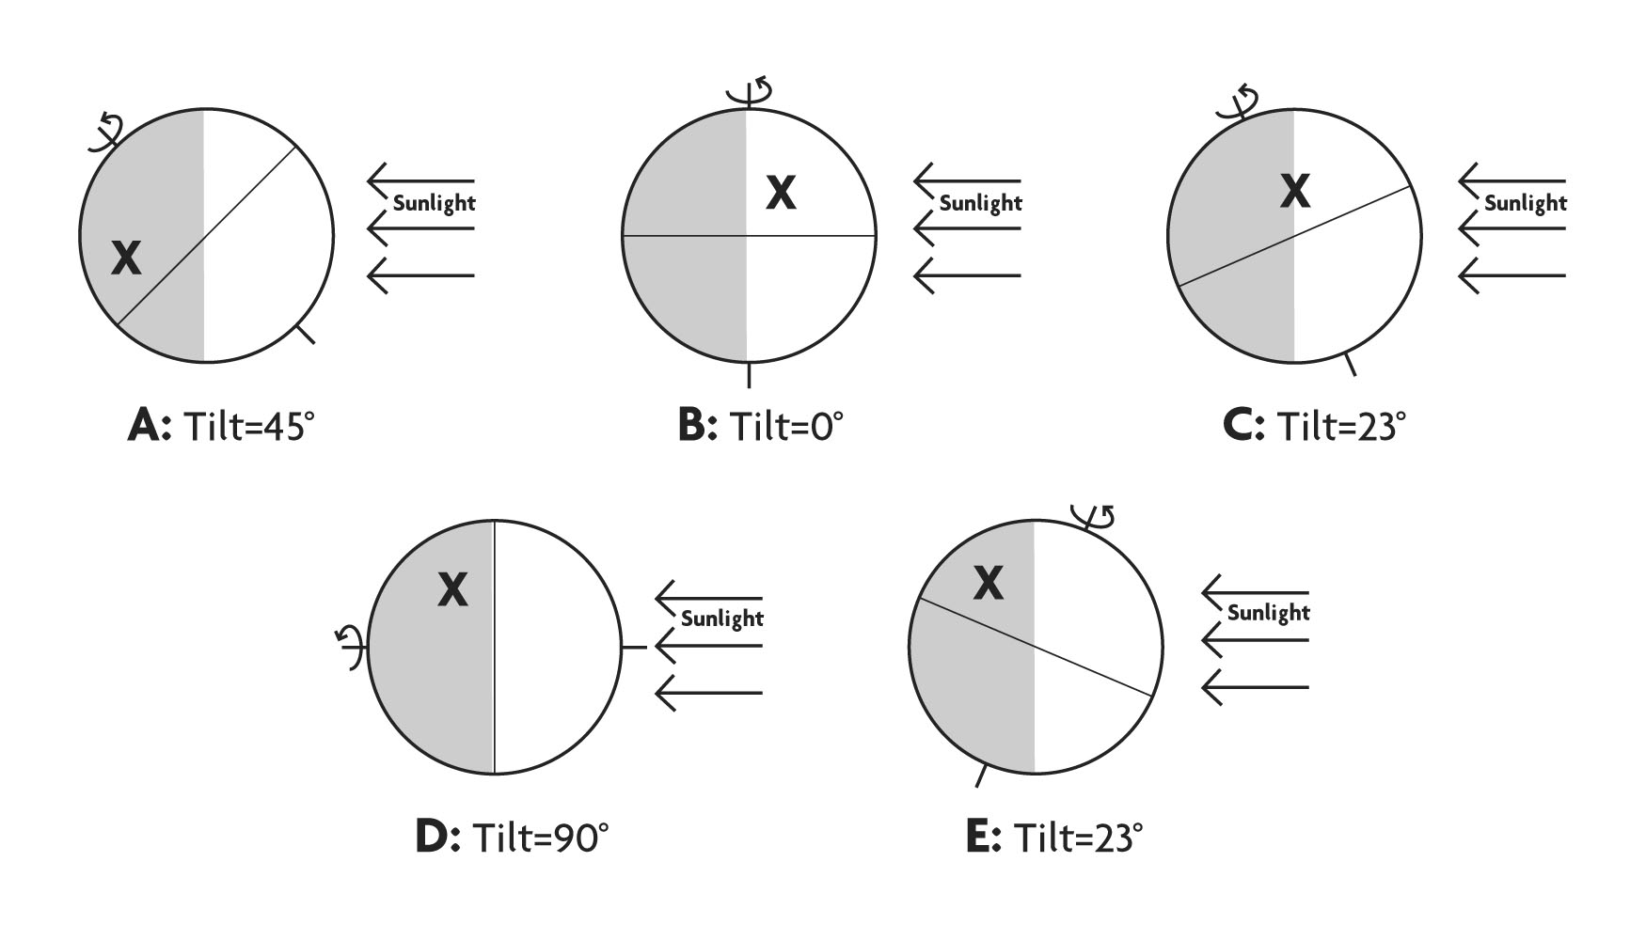
- Rank the highest temperature (from coolest to hottest) a glass of water would reach during a 24 hour period at each location. Note that the location marked with the “X” is at the same latitude in each case.
- B, E, C, A, D
- E, B, C, A, D
- A, C, B, E, D
- D, A, C, B, E
- A=B=C=D=E

- How many of the Earth locations shown above (A-E) would be experiencing Summer?
- only one
- two
- three
- four
- more than four

- How many of the Earth locations shown above (A-E) would be experiencing Summer?
- only one
- two
- three
- four
- all the positions are experiencing Summer.

For the next two questions, consider the five situations shown below (A – E) in which Earth is drawn along with the light coming from the Sun.
A.
B.
C.
D.
E.
- How many of the situations shown above are physically possible in terms of how the Earth’s tilt is represented relative to daytime, nighttime, and the direction of sunlight.
  - only one
  - two
  - three
  - four
  - all of the above are possible.

- For the situation(s) that you identified in the previous question as being physically possible, how many of the locations marked with an “X” would be experiencing Summer?
  - only one
  - two
  - three
  - four or more
  - none

- If the earth rotated east-to-west instead of west-to-east,
  - our seasons would occur in reverse order.
  - we would not have seasons.
  - daylight periods would be longer in winter and shorter in summer.
  - winter in the Northern Hemisphere would occur in July.
  - None of the above

- In the figure of the earth below, the location (A through D) that receives the largest number of daylight hours per day is…
  - Location A
  - Location B
  - Location C
  - Location D
  - Location E

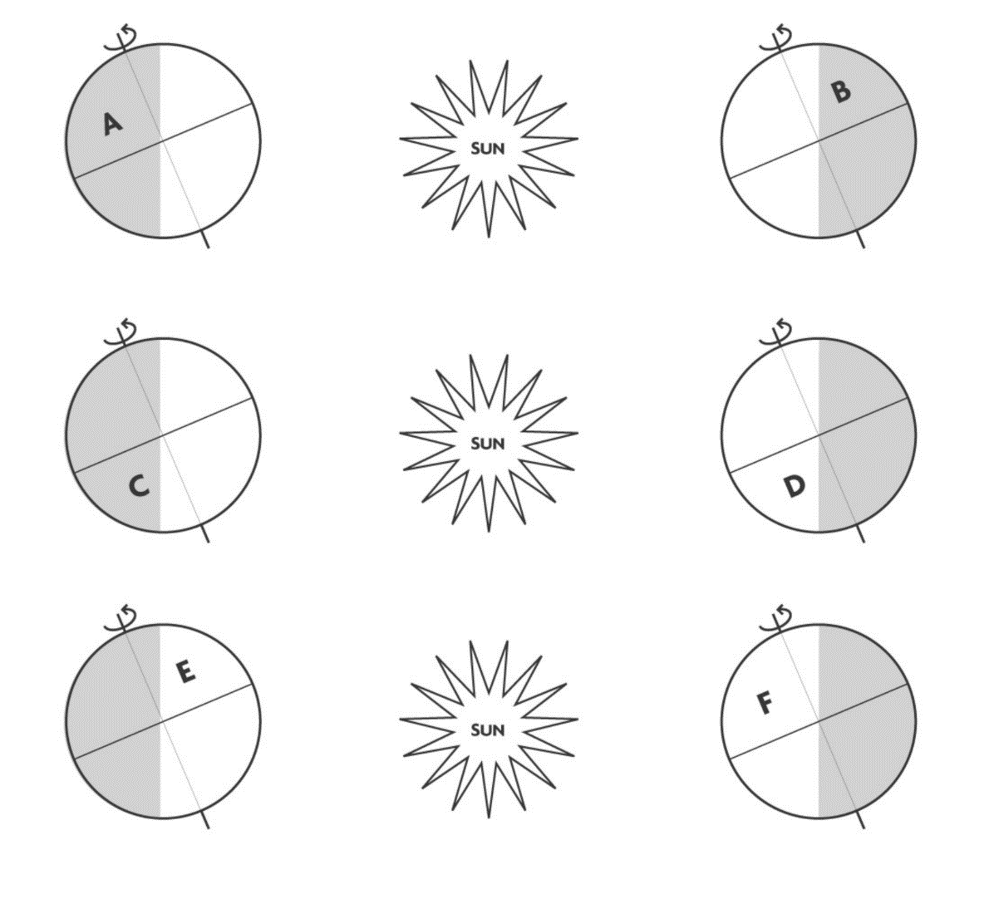

- How many of the locations (A-F) would be experiencing Winter?
- only one
- two
- three
- four
- all the positions are experiencing Winter.

- Under which of the following circumstances will a vertical flagpole not cast a shadow as seen from the continental United States?
  - every day at noon
  - every day at the time when the sun is highest in the sky
  - when the sun is highest in the sky on the summer solstice
  - when the sun is highest in the sky on the winter solstice
  - none of the above

- On which of the following dates is Earth closest to the Sun?
  - March 21
  - June 21
  - September 21
  - December 21

In each figure below a flashlight is shown projecting identical beams of light onto identical pieces of paper (A – D) inclined at various angles.
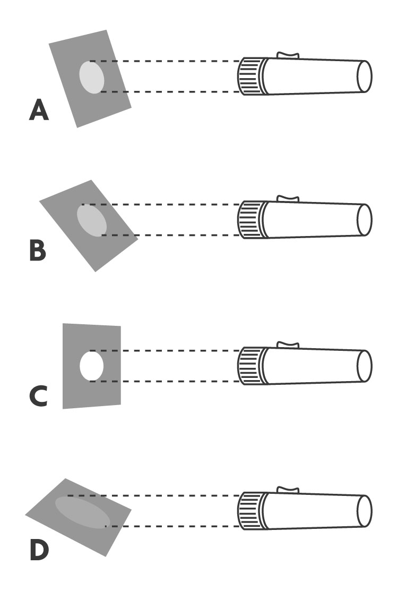
- Using the images above, which piece of paper shows the brightest illuminated area?
  - A
  - B
  - C
  - D

- Using the images above, which piece of paper is receiving the least-concentrated light?
  - A
  - B
  - C
  - D

- In the images above, what causes the difference in brightness on each piece of paper?
  - Some of the flashlights are brighter than the others.
  - The tilt of the paper relative to the flashlight differs in each case.
  - The sizes of the pieces of paper differ from one another.
  - The distance between the flashlight and the paper differs in each case.

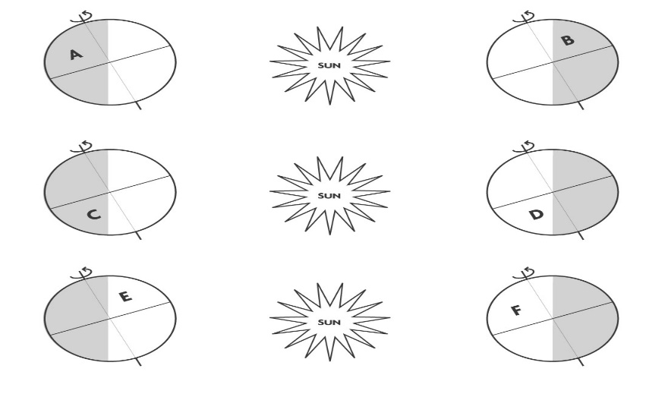

- Use the images above to answer this question. What determines whether a given location (A-F) is experiencing summer or winter?
  - The illuminated portion of each Earth’s surface is experiencing summer and the dark portions are experiencing winter.
  - The locations closer to the Sun are experiencing summer and those further from the Sun are experiencing winter.
  - The locations in each hemisphere tilted toward the Sun are experiencing summer and those in a hemisphere tilted away from the Sun are experiencing winter.
  - None of the above

- Using the images above, how many of the locations (A-F) are experiencing summer and are shown during nighttime?
  - 1
  - 2
  - 3
  - 4
  - It is impossible to have summer on the dark portion of the Earth.

- Which of the following is not a result of the tilt of Earth’s axis?
  - The directness of sunlight hitting the Earth
  - The length of daylight hours on Earth
  - The distance of Earth from the Sun
  - The changing of seasons on Earth

- What are the two main factors that affect the seasons?
  - The length of daylight hours and one hemisphere being closer to the Sun
  - The directness of sunlight received and the distance between the Earth and the Sun
  - The length of daylight hours and the distance between the Earth and the Sun
  - The length of daylight hours and the directness of sunlight received
  - None of the Above

- What is the cause of the seasons?
  - Earth’s axis being tilted causes one hemisphere to be closer to the Sun during certain times of the year.
  - The energy from the Sun fluctuates during the year, causing Earth to experience hot and cold temperatures during certain months.
  - Earth’s axis being tilted causes one hemisphere to receive more direct sunlight and more hours of daylight.
  - Earth is closer to the Sun in the summer and farther away in the winter due to Earth’s elliptical orbit.

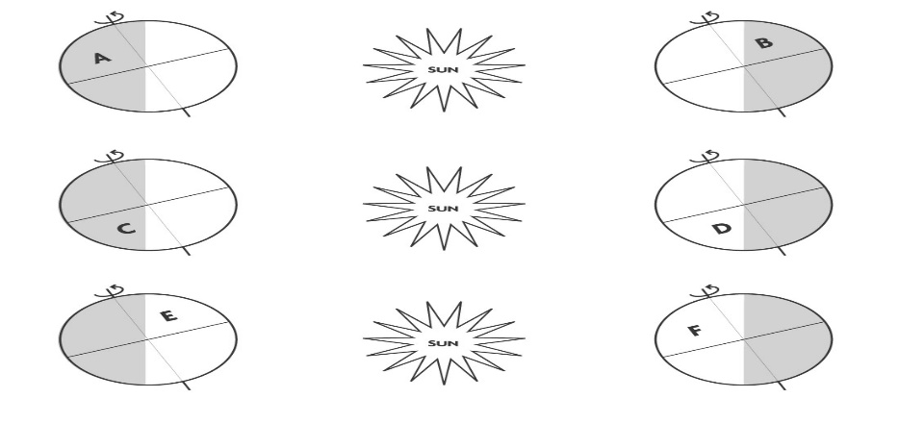

- Use the image above to answer this question. Location F is experiencing summer. It would be experiencing winter if which of the following was the case?
  - If Location F was in the Southern Hemisphere and the Earth was tilted the opposite way
  - If the Northern Hemisphere was tilted more toward the sun
  - If Location F remained in the Northern Hemisphere, but was moved to the dark portion of the Earth’s surface
  - If Location F was moved to the Southern Hemisphere
  - None of the above

Directions: In each figure below a flashlight is shown projecting identical beams of light onto identical pieces of paper (A – D) inclined at various angles.
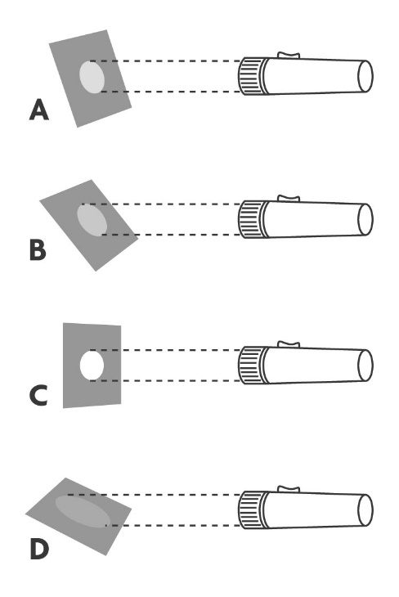
- In the images above, the paper with the smallest illuminated area would:
  - Have the illuminated area with the highest temperature.
  - Have the illuminated area with the lowest temperature.
  - Have an illuminated area with the same temperature as all of the papers.
  - Have an illuminated area with a temperature higher than some of the other papers and lower than some of the other papers.

- Using the images above, how does the flashlight analogy relate to the seasons?
  - The smallest illuminated area is like winter because there is less light.
  - The largest illuminated area is like summer because there is more light.
  - The light creating the smallest area is more direct, making it winter.
  - The light creating the largest area is less direct, making it winter.
  - More than one of the above is correct.

- Using the images above, which image represents how sunlight shines on the Northern Hemisphere during summer?
  - A
  - B
  - C
  - D
  - None of the above

- If the tilt of Earth’s rotational axis was 0 degrees, which of the following statements would be true?
  - Earth would not experience seasons.
  - The Southern and Northern Hemispheres would still experience all of the seasons, but they would have the same season at the same time.
  - When Earth was closer to the Sun, it would be summer, and when Earth was farther from the Sun it would be winter.
  - The Southern Hemisphere would always be warmer than the Northern Hemisphere.

- Every day in May, at noon, an observer in the Northern Hemisphere will see the Sun:
  - In the northern sky, at the highest point it will reach during that day.
  - In the northern sky, at the highest point it will reach during the year.
  - In the southern sky, at the highest point it will reach during that day.
  - In the southern sky, at the highest point it will reach during the year.
  - On the eastern horizon.

- The tilt of Earth’s rotational axis:
  - Shifts throughout the year, pointing 23.5 degrees toward the Sun in summer, 0 degrees at both equinoxes and 23.5 degrees away from the Sun in winter.
  - Shifts throughout the year, pointing 23.5 degrees away from the Sun in summer, 0 degrees at both equinoxes and 23.5 degrees toward the Sun in winter.
  - Is 47 degrees and always points to Polaris.
  - Is 23.5 degrees and always points to Polaris.

- On which of the following dates does Earth receive the most hours of sunlight?
  - March 21
  - June 21
  - September 21
  - December 21
  - None of the above

- At which of the following locations would you expect to have the least amount of change in the number of daylight hours during the course of a year?
  - Alaska
  - Antarctica
  - Costa Rica
  - All of the locations would experience the same amount of fluctuation in daylight hours.

- If Earth’s axis was tilted 90 degrees instead of 23.5 degrees, for how long would the Northern Hemisphere experience winter during one year?
  - 3 months
  - 6 months
  - 9 months
  - 12 months
  - The Northern Hemisphere would not experience winter.
- If the Sun is rising to the south of due east in the Northern Hemisphere, which of the following dates could it be?
  - September 4
  - November 23
  - March 25
  - June 21

