**Astronomy Assessment and TPS Questions:**

**Position and Motion**

1. The Moon orbits around Earth. In which direction does it orbit if observed while looking downward from a point directly above Earth’s North Pole?
2. clockwise
3. counterclockwise
4. either direction
5. What do we call the day(s) of the year when the Sun rises directly in the East and sets directly in the West?
6. Solstices
7. Circumpolar
8. Equinoxes
9. Celestial
10. Stars located near _____ appear to move in circles when viewed from Earth.
11. the Sun
12. Polaris
13. Orion
14. the Moon

**For the next two questions, use the figure provided below.**

1. Which star is most likely Polaris?



1. Which of the lines on the figure indicates the constellation?

For the next four questions, use the two figures provided below. The figure on the left shows the motion of Star B as it moves around the North Star. The figure on the right shows the motion of both Stars A and B**. Note that Star A reaches its maximum height above the horizon at 3:00 pm.**

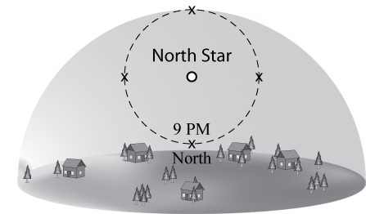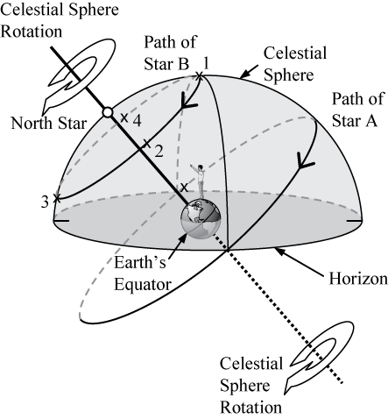

1. At what time will Star B be located high in the Northeastern sky?
2. 11:00 pm
3. 9:00 am
4. 11:00 am
5. 6:00 am
6. 6:00 pm
7. In what direction is **Star B** moving at **3:00 am**?
8. west (to the left)
9. east (to the right)
10. south (out of the page)
11. away from the horizon (up)
12. toward the horizon (down)
13. At what time would you see Star A in the southern part of the sky?
    1. 3:00 am
    2. 9:00 am
    3. 3:00 pm
    4. 9:00 pm
14. At what time would you see Star A in the west?
    1. 3:00 am
    2. 9:00 am
    3. 3:00 pm
    4. 9:00 pm

For the next two questions, use the two figures provided below, which show the motion of stars A and B in the sky.  **Note that Star A reaches its maximum height above the horizon at 9:00 pm.**



1. At what time will **Star B** be located high in the **Northwestern** sky?
2. 11:00 pm
3. 11:00 am
4. 6:00 am
5. 6:00 pm
6. At what time would you see **Star A** in the **west**?
   1. 3:00 am
   2. 9:00 am
   3. 3:00 pm
   4. 9:00 pm

For the next four questions, use the two figures provided below. The figure on the left shows the motion of Star B as it moves around the North Star. The figure on the right shows the motion of both Stars A and B. **Note that Star A is first visible above the horizon at noon.**

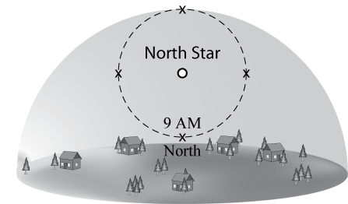

1. At what time will **Star B** be located high in the **Northeastern** sky?
   1. 11:00 pm
   2. 9:00 pm
   3. 11:00 am
   4. 6:00 am
   5. 6:00 pm
2. In what direction is **Star B** moving at **3:00 pm**?
   1. west (to the left)
   2. east (to the right)
   3. south (out of the page)
   4. away from the horizon (up)
   5. toward the horizon (down)
3. At what time would you see **Star A** high in the **southern** part of the sky?
   1. 3:00 pm
   2. 6:00 pm
   3. 9:00 pm
   4. Midnight
   5. 3:00 am
4. At what time would you see **Star A** on the horizon in the **west**?
   1. 6:00 am
   2. Noon
   3. 6:00 pm
   4. 9:00 pm
   5. Midnight
5. Imagine you see Mars rising in the east at 6:30 pm. Six hours later what direction would you face (look) to see Mars?
6. toward the north
7. toward the south
8. toward the east
9. toward the west
10. directly overhead
11. Imagine you see Mars very low in the west at 3am. Six hours earlier what direction would you face (look) to see Mars when it was highest in the sky?
12. toward the north
13. toward the east
14. toward the west
15. toward the south
16. directly overhead
17. Facing ____ you would observe the stars of the “Big Dipper” to trace out _______ over a period of _____.
18. north, half a circle, 6 hours
19. south, half a circle, 12 hours
20. north, one fourth of a circle, 6 hours
21. south, one fourth of a circle, 6 hours
22. none of the above are correct

The figure below shows the evening sky as it would appear for an observer in the northern hemisphere. Notice that Polaris, the North Star, appears fairly high in the sky while other stars (labeled A - E) appear to slowly move around the North Star.

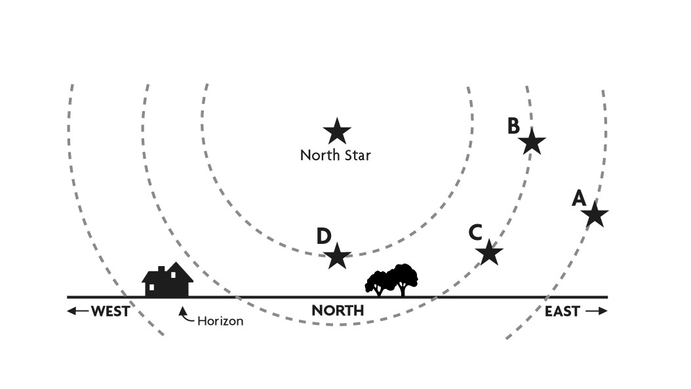

**D**

**E**

1. Which of the following is the best ranking for the amount of time that each of the stars shown above (A - E), will be above the horizon during a 24 hour period, from greatest amount of time to least.

C<A<B<D<E

E<D<B<A<C

B=D<A<C=E

A<B=C<D<E

A=E<C=B=D

1. If you could see stars during the day, this is what the sky would look like at noon on a given day. The Sun is near the stars of the constellation Gemini. Near which constellation would you expect the Sun to be located at sunset?
   1. Leo
   2. Cancer
   3. Gemini
   4. Taurus
   5. Pisces

Leo

Cancer

Gemini

Taurus

Pisces

South

West ⇒

⇐ East

Sun

1. Which constellation will be highest in the sky 6 hours after the time shown in the drawing above?
   1. Leo
   2. Cancer
   3. Gemini
   4. Taurus
   5. Pisces
2. Stars located near _________ appear to move in circles when viewed from Earth.

a. the Sun

1. Polaris
2. Orion
3. the Moon
4. From the United States, stars that rise in the southeast early in the evening…
   1. will pass directly overhead at midnight
   2. will rise and cross to the northeast during the night
   3. will set later that night in the west.
   4. will pass low in the south and set in the southwest
   5. will never set as they rotate around the North Celestial Pole.
5. If you are located in the continental U.S. on the first day of July, how will the position of the Sun at noon be different two weeks later?
6. It will have moved toward the North.
7. It will have moved to a position higher in the sky.
8. It will stay in the same position.
9. It will have moved to a position closer to the horizon.
10. It will have moved toward the west.
11. If you are located in the continental U.S. on the first day of October, how will the position of the Sun at noon be different two weeks later?
    1. It will have moved toward the north.
    2. It will have moved to a position higher in the sky.
    3. It will stay in the same position.
    4. It will have moved to a position closer to the horizon.
    5. It will have moved toward the west.
12. Which of the following statements is true about the location of the Sun at sunset during the middle of winter?
13. It will be near the horizon, north of west.
14. It will be near the horizon, north of east.
15. It will be near the horizon, south of west.
16. It will be near the horizon, south of east.
17. None of the above is correct.

Use the diagram at right to answer the following two questions. In this diagram the motions of Stars A and B are shown as they travel on the celestial sphere about Earth. For each question imagine that you are the observer shown on Earth in the northern hemisphere.

Celestial Sphere Rotation

Celestial Sphere Rotation

North Star

Celestial Sphere

Path of Star A

Path of Star B

Earth’s Equator

Horizon

1. When Star A is just above the eastern horizon, in what direction is Star A moving?
2. up and to the north
3. west
4. up and to the south
5. south
6. Which of the stars will set on the western horizon?
   1. Both Star A and Star B
   2. Only Star A
   3. Neither Star A nor Star B
   4. Only Star B
7. Imagine that from your current location you observe a star rising directly in the east. When this star reaches its highest position above the horizon, where will it be?
   1. high in the northern sky
   2. high in the eastern sky
   3. high in the southern sky
   4. high in the western sky
   5. directly overhead
8. At right is a diagram of a shadow plot on which a small, vertical stick is placed on a large piece of paper or poster-board and casts a shadow from the Sun over the course of the day. You can think of this to be somewhat like a sundial. The very top of the shadow is marked with an “*x”* every couple of hours throughout the day. For an observer in the continental U.S., which of the three shadow plots, shown at right, correctly depicts the Sun’s motion for one day?

***x***

***x***

***x***

***x***

***x***

***x***

***x***

***x***

***x***

***x***

***x***

***x***

***x***

***x***

*NORTH*

*SOUTH*

*WEST*

Shadow

plot A

Shadow

plot C

***x***

***x***

***x***

***x***

***x***

***x***

***x***

***x***

Shadow

plot B

*EAST*

* 1. Shadow plot A
  2. Shadow plot B
  3. Shadow plot C
  4. More than one of the plots are possible, on different days of the year.
  5. None of the plots are possible.

1. Imagine your camera is pointing at Polaris the North Star. If you leave the shutter open for 6 hours, what will the photo look like?
   1. The stars will make straight lines in the photos.
   2. The stars will make complete circles in the photos.
   3. The stars will make half circles in the photos.
   4. The stars will make quarter circles in the photos.
   5. The stars will remain point-like dots of light.

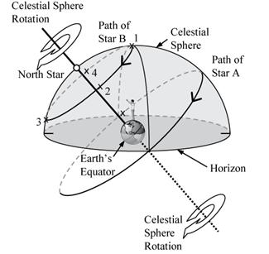

1. In the image above, which direction is the person facing (and pointing)?
   1. South
   2. West
   3. North
   4. East
2. Using the image above, how long does it take for Star A to go from being on the eastern horizon to being on the western horizon?
   1. 24 hours
   2. 6 hours
   3. 9 hours
   4. 12 hours
3. Using the image above, how long does it take for Star B to complete one full circle?
   1. 6 hours
   2. 9 hours
   3. 12 hours
   4. 24 hours

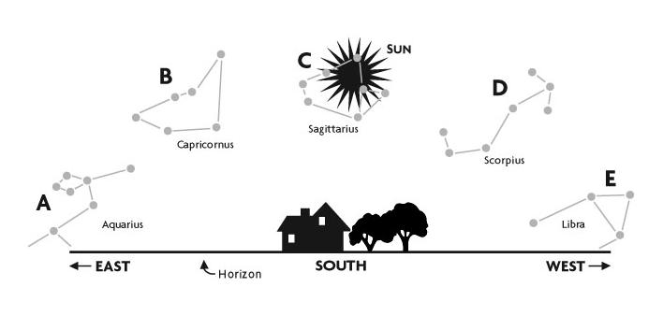

1. Using the image above, imagine you are facing directly south. To the east, the constellation Aquarius is just above the horizon. Six hours later, where will Aquarius be?
   1. In the same position
   2. On the western horizon
   3. High in the southern sky
   4. The constellation will not be visible.

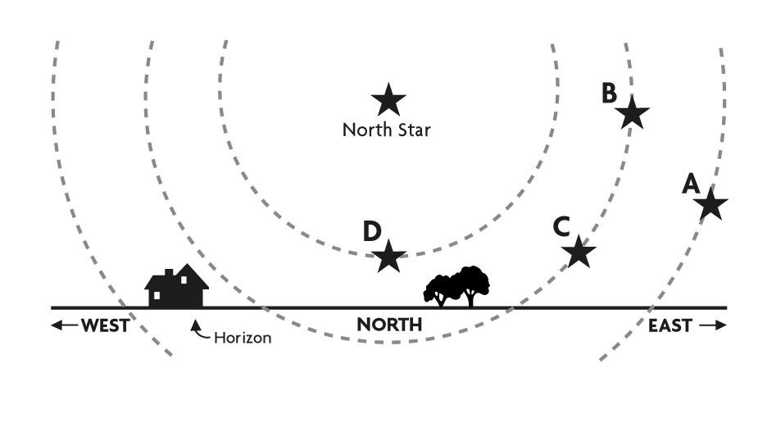

1. Using the image above, define the pattern of movement for stars in the northern sky:
   1. They rise in the east, go high in the southern sky and set in the west.
   2. They revolve counter-clockwise around Polaris.
   3. They rise in the west, go high in the southern sky and set in the east.
   4. They revolve clockwise around Polaris.
2. If a star sets to the north of due west, ______________.
   1. it is a circumpolar star
   2. it rose to the south of due east
   3. it rose to the north of due east
   4. it traveled across the northern sky

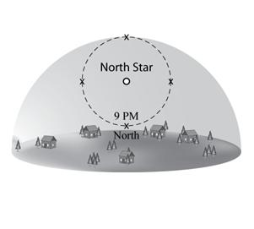

1. Using the image above, imagine that you have watched a star travel a fourth of the circle. For how many hours have you been watching the star?
   1. 1 hour
   2. 3 hours
   3. 6 hours
   4. 9 hours
2. Using the image above, in 18 hours, a star on one of the x’s would have traveled ________.
   1. A full circle
   2. Three quarters of a circle
   3. Half of a circle
   4. One quarter of a circle
3. Using the image above, if a star is low in the northern sky at 9:00 PM, what time will it be when the star is located at the “x” on the right side?
   1. 3:00 AM
   2. 9:00 AM
   3. 3:00 PM
   4. 9:00 PM
4. Why does the Sun rise and set?
   1. The shape of Earth’s orbital path around the Sun causes the Sun to rise and set.
   2. The Moon blocks out the Sun for roughly twelve hours a day, causing Earth to experience night time.
   3. The Moon’s gravitational pull forces Earth to face away from the Sun for about twelve hours a day.
   4. Earth spins on its axis, making one full rotation in about 24 hours.



1. Using the image above, imagine you are facing south, seeing the Sun and the constellation Sagittarius high in the southern sky. Three hours later, what would you expect to see?
   1. The Sun and Sagittarius would still be in the same position.
   2. The Sun would have moved further west, but Sagittarius would remain high in the southern sky.
   3. The Sun and Sagittarius would both have moved further west.
   4. The Sun would have moved further east, but Sagittarius would remain high in the southern sky.
   5. The Sun and Sagittarius would both have moved further east.
2. Using the image above, when the constellation Capricornus is setting on the western horizon, where will the Sun be?
   1. Also setting on the western horizon
   2. High in the southern sky
   3. Rising in the east
   4. Below the horizon
   5. None of the above



1. Using the image above, if Star B rises above the horizon at 6 AM, when might you expect Star C to rise?
   1. 4 AM
   2. 6 AM
   3. 8 AM
   4. Noon
2. Using the image above, how many of the stars (A-D) spend all of their time above the horizon in a 24-hour period?
   1. Only 1
   2. Two
   3. Three
   4. All four



1. Using the image above, if Star A sets at 6 AM, then approximately what time is represented in the picture?
   1. 1 PM
   2. 8 AM
   3. 4 AM
   4. 6 PM
2. Using the image above, which of the following is the correct ranking for the amount of time each star spends **below** the horizon in 24 hours, from least to most?
   1. A, B=C, D
   2. D, B=C, A
   3. A=B=C=D
   4. B, D, A, C
   5. D, B, C, A



1. Use the diagram above to answer this question. Star A will set at 8 AM. Where will it be in the sky when it is directly between rising and its highest point in the sky? What time will it be?
   1. Southeast, 11 PM
   2. Southeast, 2 AM
   3. Southwest, 2 AM
   4. Southwest, 11 PM
   5. None of the above
2. People from the Southern Hemisphere can see the North Star:
   1. In their southern sky.
   2. In their northern sky.
   3. For the half of the year that the South Pole is tilted towards the North.
   4. Only very close to the horizon.
   5. Only if they visit the Northern Hemisphere.