Astronomy Assessment and TPS Questions:
Predicting Moon Phases

- In what phase and location described below will the Moon be when a solar eclipse occurs?
  - New phase and above the plane of Earth’s orbit
  - Full phase and above the plane of Earth’s orbit
  - New phase and crossing Earth’s orbital plane.
  - Full phase and crossing Earth’s orbital plane.
  - None of the above

- If the Moon is in the waxing gibbous phase tonight, approximately how long will it be until the Moon is in the waning crescent phase?
- one day
- one week
- two weeks
- three weeks
- a month

- Which phase of the Moon rises in the east as the Sun sets in the west?
- waxing crescent
- waning gibbous
- full
- third quarter
- new

- Which phase of the Moon is on the western horizon when the Sun is setting?
- waxing crescent
- waning gibbous
- new
- third quarter
- full

- What time is it when the Waning Crescent Moon is highest in the sky?
- morning
- noon
- early afternoon
- evening
- midnight

- What time is it when the third quarter moon is highest in the sky?
- early morning
- noon
- early afternoon
- evening
- midnight
- If the moon is highest in the sky this morning at 6:00 am, what phase will the Moon be in one week from now?
- full
- waxing crescent
- waning crescent
- waning gibbous
- new

- If the moon is highest in the sky this morning at 6:00 am, at what time will the moon be highest in the sky in one week?
- 6:00 am
- Noon
- 6:00 pm
- Midnight
- None of the above.

- Imagine that the moon is highest in the sky at 9:00 pm tonight. What moon phase will be highest in the sky two weeks later?
- waxing gibbous
- full
- waning gibbous
- third quarter
- waning crescent

- Imagine that the moon is highest in the sky at 9:00 am. What phase will the moon appear to be in, two weeks later?
  - waxing gibbous
  - full
  - waning gibbous
  - third quarter
  - waxing crescent

- Which of the following is possible?
  - A waxing crescent Moon on the eastern horizon just after sunset.
  - A waning gibbous on the western horizon just after sunset.
  - A waning crescent Moon on the eastern horizon just before sunrise.
  - A full Moon on the western horizon at sunset.
  - A first quarter moon rising at dawn.

- Which of the following sequences of moon phases will occur one after the other within one cycle of phases:
- waxing gibbous, waxing crescent, new, waning crescent
- full, waning gibbous, first quarter, new
- third quarter, waxing gibbous, full, waning gibbous
- new, waxing crescent, first quarter, waxing gibbous
- waning crescent, first quarter, full, waning gibbous
- Which of the following sequences of moon phases will occur one after the other within one cycle of phases:
  - third quarter, waxing gibbous, full, waning crescent
  - waxing gibbous, full, waning gibbous, third quarter
  - new, waning crescent, first quarter, waxing crescent
  - full, waning gibbous, first quarter, waxing gibbous
  - new, waxing crescent, full, waning gibbous

- Which of the following groups of moon phases can be above the horizon at 5pm?
- Full, Waning Crescent, and Waxing Gibbous
- New Moon, First Quarter, and Waxing Gibbous
- Waxing Gibbous, Full Moon, Waning Gibbous
- Waxing Crescent, Third Quarter, Waxing Gibbous
- None. The moon is only visible above the horizon during the night time.

- Which of the following sets of moon phases can be seen (above the horizon) at 11:00 am?
- Third Quarter, Waning Crescent, and Waxing Crescent
- New Moon, First Quarter, and Waxing Gibbous
- Waxing Gibbous, Full Moon, Waning Gibbous
- Waxing Crescent, First Quarter, Waxing Gibbous
- None. The moon is only visible above the horizon during the night time.

- A lunar eclipse can only occur at which phase of the Moon?
- new
- full
- crescent
- quarter
B.
A.
C.
D.
E.
- You look to the eastern horizon as the Moon first rises and discover that it is in the new moon phase. Later when the moon reaches its highest position in the sky, which of the moon phases shown at right will the Moon look like?

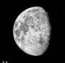
- What time is it when the moon phase shown at right first begins to rise above the horizon?
  - in the evening
  - at noon
  - in the mid-afternoon
  - at midnight
  - in the early morning

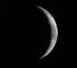
- What time is it when the moon phase shown at right first begins to rise above the horizon?
  - in the evening
  - at noon
  - in the mid-afternoon
  - at midnight
  - in the early morning

- Which phase of the Moon is represented in the figure at the right?
- waxing gibbous
- third quarter
- waning crescent
- full moon
- waning gibbous

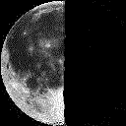
- Which phase of the Moon is represented in the figure at the right?
- waxing gibbous
- third quarter
- waning crescent
- full moon
- waning gibbous

- Which phase of the Moon rises in the east as the Sun sets in the west?
- waxing crescent
- waning gibbous
- full
- third quarter
- new

- In what phase and location described below will the Moon be, when a lunar eclipse occurs?
  - Full phase and below the plane of Earth’s orbit
  - Full phase and crossing Earth’s orbital plane.
  - New phase and below the plane of Earth’s orbit
  - New phase and crossing Earth’s orbital plane.
  - None of the above

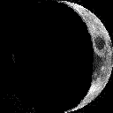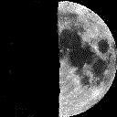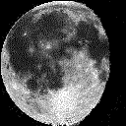
A B C D E

- If the moon is in the new phase today, how many of the moon phases shown above (A-E) would the moon go through during the next 13 days.
              - none
              - only one
              - two
              - three
              - more than three

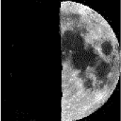
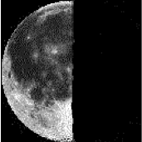
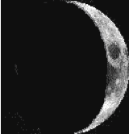
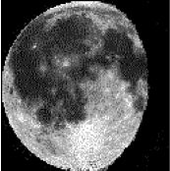
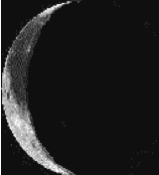
- If the Moon is in the New phase today, how many of the moon phases shown above would the Moon go through during the next 10 days.
              - only one
              - two
              - three
              - more than three
              - none

- If the moon is in the New phase today, how many of the moon phases shown above would the moon go through during the next 10 days.
              - only one
              - two
              - three
              - more than three
              - none

- Which of the four images shown above (A-D) from your homework on eclipses correspond to a solar eclipse?
C
B
D
A

- Where would you look to see the moon phase shown at right 6 hours after it rises above the horizon?
- high in the south
- low in the east
- low in the west
- high in the north
- none of the above
- Which Moon phase is represented in the picture at right?
- Full
- Waxing Gibbous
- First Quarter
- Waning Gibbous
- Third Quarter

- How will a new Moon appear to move across the sky?
  - It will rise in the east, go high in the southern sky, and set in the west
  - It will rise in the west, go high in the northern sky, and set in the west because it orbits the Earth backwards
  - A new Moon means there is no Moon in the sky, so it will not rise or set
  - For half of the year, it will rise in the west, go high in the southern sky, and set in the east; for the other half of the year it will rise in the west, go high in the northern sky, and set in the east

- If the moon is in its first-quarter phase today, how many days until the moon will be in the phase shown above?
  - 24 nights later
  - 18 nights later
  - 9 nights later
  - 6 nights later

- If it is 6 am and the Moon is rising on the eastern horizon, how much of the Moon’s surface is illuminated?
  - Half
  - Less than half
  - More than half
  - None

- When it is the earliest time an observer can see a third quarter Moon on a given day, it will appear to be ________, and the observer will be looking to the _______:
  - Lit on the right side, in the southern sky
  - Lit on the left side, in the southern sky
  - Lit on the right side, rising in the east
  - Lit on the left side, rising in the west
  - None of the above
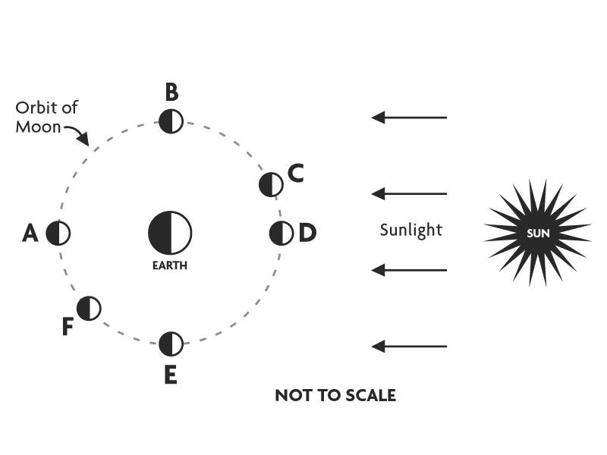
- A person is on Earth, standing where the “R” is in the word “EARTH”. Tonight the Moon is in phase “F”. If the person can see the Moon, what phase does he see and what does it look like?
  - Third quarter, he sees the Moon half lit from the left side
  - Third quarter, he sees the Moon half lit from the right side
  - Waning gibbous, he sees the Moon ¾ lit from the right side
  - Waning gibbous; he sees the Moon ¾ lit from the left side
  - He cannot see the Moon

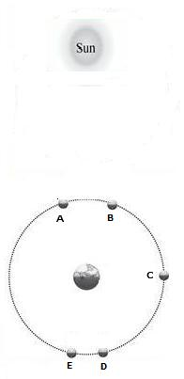
- Using the diagram to the right, which Location (A-E) best represents the location of the Moon when it is in the Waxing Crescent phase?

- Using the diagram to the right, which Moon position (A-E) best corresponds with the Moon phase shown below?

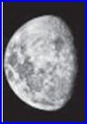

- Using the diagram to the right, if the Moon was in the new Moon phase today, how many of the positions (A-E), shown on the right, would the Moon pass through in 17 days?
  - 1
  - 2
  - 3
  - 4
  - 5

- Tonight, you see the Moon ¾ lit on the right side. Which phase is this, and what phase will the Moon be in seven days from now?
  - Waxing gibbous, waning gibbous
  - Waxing gibbous, waning cresent
  - Waning gibbous, waxing crescent
  - Waning gibbous, waxing gibbous

- If the full Moon is setting on the western horizon, what time of day is it?
  - Noon
  - Midnight
  - Around 6 am
  - Around 6 pm

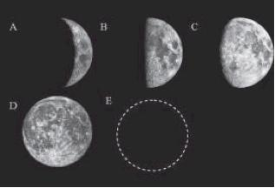

- Tonight, the Moon is in the waning gibbous phase. How many of the phases above will you see in the next 14 days?
  - 0
  - 1
  - 2
  - 3
  - 4

- If the first-quarter Moon is rising in the east, approximately how long will it be until you can see the full moon phase high in the sky?
  - 6 hours
  - 6 days
  - 3 weeks
  - 3 days
  - 3 hours

A B C D E

- The names of the above Moon phases (A-E) in order as they are shown above are
  - Waning crescent, third-quarter, first-quarter, waxing gibbous, waxing crescent
  - Waxing crescent, third-quarter, first-quarter, waning gibbous, waning crescent
  - Waxing crescent, first-quarter, third-quarter, waxing gibbous, waning crescent
  - Waning crescent, third-quarter, first-quarter, waxing gibbous, waning crescent

A
B
C
D
- Starting with the new moon phase, which of the graphs above best represents the amount of the Moon’s illuminated surface that can be seen from Earth (Vertical Axis) over time (Horizontal Axis) for a complete lunar cycle?
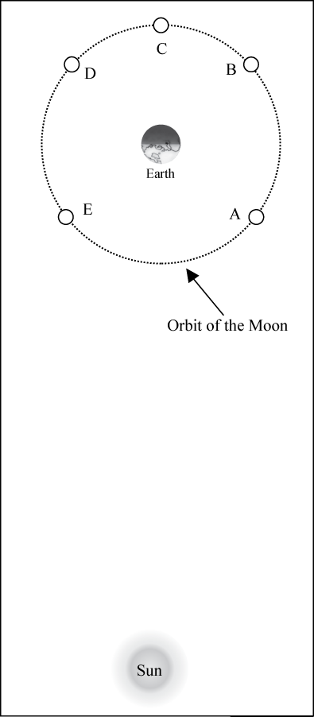
- The diagram at the right depicts various positions of the Moon throughout its orbit around Earth. For positions A through E, in order, the Moon phases observed from Earth would be
  - Waning crescent, waning gibbous, full Moon, waxing gibbous, waxing crescent
  - Waxing crescent, waxing gibbous, full Moon, waning gibbous, waning crescent
  - Waxing crescent, waning gibbous, full Moon, waxing gibbous, waning crescent
  - Waning crescent, waxing gibbous, full Moon, waning gibbous, waxing crescent
  - None of the above

- Which of the following correctly ranks the Moon Positions, from greatest amount to least amount, according to how much of the illuminated portion of the Moon’s surface is visible from Earth?
  - C>A=E>B=D
  - C>B=D>A=E
  - C>B=E>A=D
  - None of the above

