Astronomy Assessment and TPS Questions:
Cause of Moon Phases

- Which Moon position (A-E), shown in the diagram at right, best corresponds with the moon phase shown below?
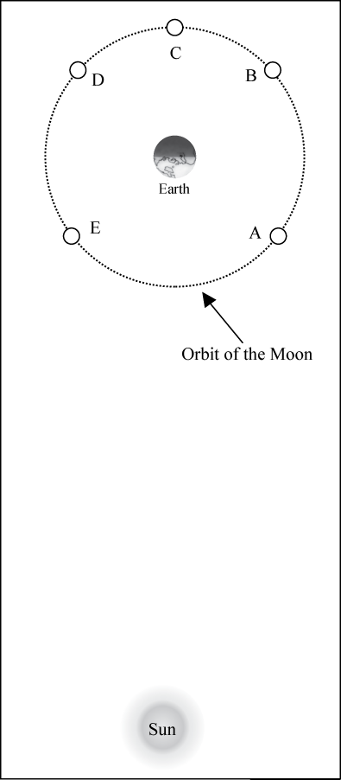
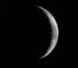

- Which Moon position (A-E), shown in the diagram at right, best corresponds with the moon phase shown below?

- Which Moon position (A-E), shown in the diagram at right, best corresponds with the moon phase shown below?
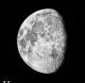

- Which Moon position (A-E), shown in the diagram at right, best corresponds with the moon phase shown below?

- During the full moon phase, how much of the total Moon’s surface is being illuminated by sunlight?
- none
- less than half
- half
- more than half
- all

- During the waxing crescent phase, how much of the total Moon’s surface is being illuminated by sunlight?
- none
- less than half
- half
- more than half
- all

- During the new moon phase, how much of the Moon’s total surface is being illuminated by sunlight?
- none
- all
- less than half
- half
- more than half

- During the full moon phase, how much of the illuminated portion of the Moon’s surface is visible from Earth?
- none
- all
- less than half
- more than half
- half

- During the first quarter moon phase, how much of the illuminated portion of the Moon’s surface is visible from Earth?
- none
- all
- less than half
- more than half
- half

- During the new moon phase, how much of the illuminated portion of the Moon’s surface is visible from Earth?
- none
- all
- less than half
- more than half
- half

- Which of the following best describes why the Moon goes through phases?
  - Earth's shadow falls on different parts of the Moon at different times.
  - Earth’s clouds cover portions of the Moon at various times resulting in the changing phases that we see.
  - We see only part of the lit-up surface of the Moon depending on its position relative to Earth and the Sun.
  - The sunlight reflected from Earth lights up the Moon but is less effective when the Moon is lower in the sky than when it is higher in the sky.

- The diagram below shows Earth and the Sun as well as five different possible positions for the Moon. Which position of the Moon best corresponds with the phase of the Moon shown in the figure at the right?

Sun
NOT TO SCALE
Orbit of the Moon
Earth
A
B
C
D
E

- How often does the “New Moon” phase occur?
- every day/ night
- once a week
- once every two weeks
- once a month
- once a year

- Which one of the following is a reason why we see Moon phases?
  - Earth’s shadow on the Moon
  - The Sun’s shadow on the moon
  - The Moon’s orbit of Earth
  - Earth’s orbit of the Sun

- Approximately how long does it take for the Moon to go from a waning gibbous to the third quarter phase?
  - 1 week
  - 3 hours
  - 4 days
  - 5 months

