Astronomy Assessment and TPS Questions:
Analyzing Spectra

- If Star P is slightly hotter than Star Q, which one of the following statements is true about the dark line absorption spectra for the two stars?
  - There will be more absorption lines at the blue end of the spectrum for the hotter star.
  - There will be more absorption lines at the red end of the spectrum for the hotter star.
  - The absorption lines of the hotter star will be much thicker/more prominent.
  - There will be more lines in the absorption spectrum of the hotter star.
  - None of the above can be concluded.

- Which of the following is true about the star whose spectrum is shown at right.
  - Since the spectrum shows a lot of light being absorbed at the blue end the star will not be giving off much blue light.
  - Since the spectrum shows a lot of light being absorbed at the blue end the star will appear red.
  - Since the spectrum shows a lot of light being absorbed at the blue end the star will be moving toward the observer.
  - Since the spectrum shows more absorption lines at the short wavelengths the star will be hot.
  - None of the above is true.

- Consider the spectra shown below for Star X and Star Z. What can you determine about the color of the two stars? Assume that the left end of each spectrum corresponds to shorter wavelengths (blue light) and that the right end of each spectrum corresponds with longer wavelengths (red light).

Star X Star Z
  - Star X would appear blue and Star Z would appear red.
  - Star X would appear red and Star Z would appear blue.
  - Both stars would appear the same color.
  - The color of the stars cannot be determined from this information.

- Consider the dark line absorption spectra shown below for Star X and Star Z. What can you determine about the relative temperatures of the two stars? Assume that the left end of each spectrum corresponds to shorter wavelengths (blue light) and that the right end of each spectrum corresponds with longer wavelengths (red light).

Star X Star Z

  - Star X is at the higher temperature.
  - Star Z is at the higher temperature.
  - Both stars are the same temperature.
  - The relative temperatures of the stars cannot be determined from this information.

- Shown below are the spectra of stars A and B. How does the temperature of the two stars compare? Assume that the left end of each spectrum corresponds to shorter wavelengths (blue light) and that the right end of each spectrum corresponds with longer wavelengths (red light).

Star A
Star B
- Star A is at the higher temperature.
- Star B is at the higher temperature.
- Both stars are the same temperature.
- The relative temperatures of the stars cannot be determined from this information.

- Imagine that the light from a hot, dense object passed through a cool, diffuse cloud and then through a prism. If the temperature of the hot, dense object were increased slightly, which of the following changes would happen to the resulting spectrum?
  - The lines would move to the blue end of the spectrum.
  - More lines would appear at the blue end of the spectrum.
  - The lines would move toward the red end of the spectrum.
  - More lines would appear at the red end of the spectrum.
  - The lines in the spectrum would not change.

- The three spectral curves shown in the graphs below illustrate the energy output versus wavelength for three unknown stars A, B, and C. Which of the stars has the highest temperature?
- Star A
Wavelength
Energy Output per second

Star B
Energy Output per second

Wavelength
Star A
Energy Output per second

Wavelength

Star C
- Star B
- Star C
- All three stars have the same temperature.
- The answer cannot be determined from these graphs.

- The three light curves shown in the graphs below illustrate the energy output versus wavelength for three stars X, Y, and Z.? Which of the following is the correct ranking for the temperature of the stars, from hottest to coldest.
Wavelength
Energy Output per second

Star Y
Energy Output per second

Wavelength
Star X
Energy Output per second

Wavelength

Star Z
  - X>Z>Y
  - Y>Z>X
  - Z>Y>X
  - X>Y>Z
  - Y>X>Z

- The spectral curve on the graph below illustrates the energy output versus wavelength for an unknown star. Which of the absorption line spectra (a – d) belongs to this unknown star?
Energy Output per second

Wavelength
a.

b.

c.

d.

- If a star’s absorption line spectrum has lots of lines at the blue end of the spectrum, that means
  - the star is blue.
  - the star is hot.
  - the star is far away.
  - None of the above.

- Dips in a star’s spectral curve correlate to
  - the absorption lines in the star’s spectrum.
  - lower frequencies of light emitted by the star.
  - shorter wavelength of light emitted by the star.
  - the emission lines in the star’s spectrum.

- Analyzing a star’s spectrum can tell you which of the following?
  - its color
  - its temperature
  - its energy output
  - its composition

Star A Star B

- Consider the spectra shown above for Star A and Star B. [Assume that the left end of each spectrum corresponds to shorter wavelengths and that the right end of each spectrum corresponds with longer wavelengths.] Which Star is hotter?
  - Star A
  - Star B
  - Both are the same temperature
  - You cannot tell from this information

- Consider the spectra shown on the previous page for Star A and Star B. [Assume that the left end of each spectrum corresponds to shorter wavelengths and that the right end of each spectrum corresponds with longer wavelengths.] Which Star appears blue?
  - Star A because the absorption lines mean there was an abundance of blue light before it got absorbed
  - Star B because the lack of absorption lines means that there is more blue light present
  - You cannot tell from this information

- You are looking at the absorption line spectrum of a star. It has no absorption lines on the high frequency half of the spectrum and many absorption lines on the low frequency end. What does this tell you about the star’s temperature?
  - The star is a relatively hot star.
  - The star is a relatively cool star.
  - There is not enough information to determine the star’s temperature.

- If you observe the spectrum of a star from Earth and then observe the spectrum again using a telescope outside of Earth’s atmosphere, what would you notice?
  - The spectrum taken from outside Earth’s atmosphere has more absorption lines
  - The spectrum taken from below Earth’s atmosphere has more absorption lines
  - The spectra both have the same absorption lines, because they are from the same star

- Which of the following indicates the temperature of a star?
  - The location of the absorption lines in a star’s spectra
  - The height of the peak of a star’s blackbody curve
  - The number of absorption lines in a star’s spectra
  - The wavelength of the peak of a star’s blackbody curve
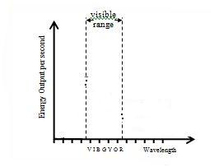
Star A Star B Star C Star D

- Which star, shown above, would appear the bluest?
  - Star A
  - Star B
  - Star C
  - Star D
  - None of the above

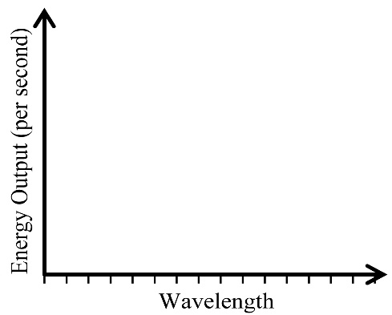

V I B G Y O R

Energy Output per second

Wavelength

A B C

- Of the 3 figures above, which one(s) tell you about the temperature of the object being shown?
  - Only A
  - Only C
  - Both B and C
  - Both A and B
  - A, B, and C

